PURE:

An Experiment / Exhibition

DATA & ANALYSIS
October 14 – November 12, 2006

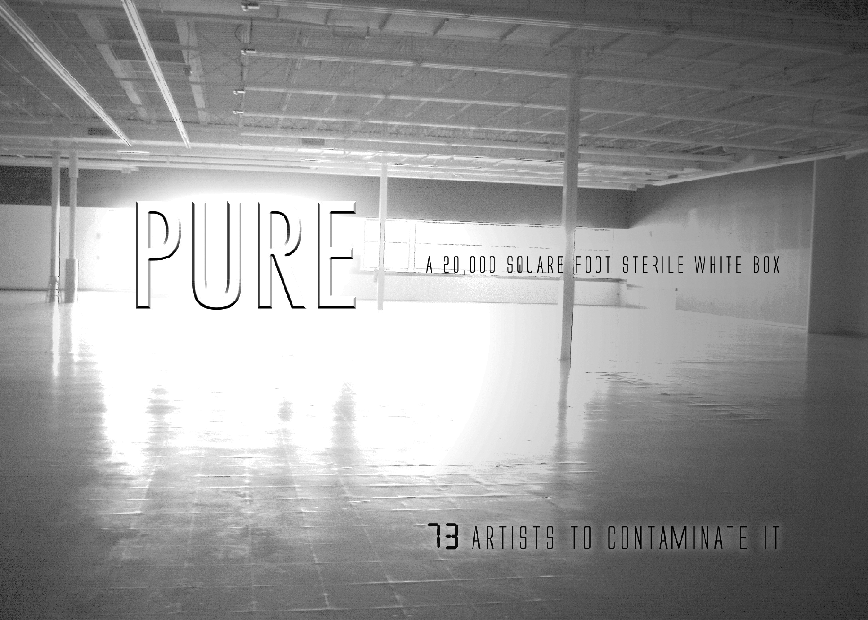

Abraham Schroeder • Adina Teodorescu • Alya Romeos • Andi Sutton, Alex Haynes, M.D. & Andrew Eisenberg • Andrea Dorian Rose • Andrew Anselmo • Andy Siegel • Anna Phylaxis • Ashanti • Barry Maloney • Bebe Beard • Betty Bolivar • Bezreh + Keefe • Blake Courtney • Bob Reese • Bob White • Carol Hanson • Christy Georg • Chuck McNally • The Cloud Collective • L. Corey Hanley • Cris Wagner • Dana Ross • Dave Tree • Debra Weisberg • Doug Ruuska • Ellen Chambers • Ellen Young • Empire S.N.A.F.U. Restoration Project • Eric David Love • Gerald Fallon-Griffin • Gina Kamentsky • iKatun- The Institute of Infinitely Small Things • J'ambiance (Rob Carbone & Joe Moreau) • Jamie Ciocco • Jennifer Cooper • Jen Rosselli • Jerry Russo • Jessica Fenlon • Joe Burgio • Joshua Pablo Rosenstock • Judith Leemann • Juliet Schneider • Karin Webb • Karl Cronin • Kate Pearce • Kevin Van Aelst • Lana Hermann • Laura Arena • Laura Johnston • Leonid Andreev • Lisa Lunskaya Gordon • Liz Shepherd • Luca Zucchi, Anna Elisabetta Zucchi, Chiara Assi • Lydia Eccles • Marilyn Fontenrose • Markus J. Nechay • Maura Cunningham • Melinda Cross • Naomi Sultanik • par-don • Pauline Lim • Piotr Parda • project ruori • Redtail Collective • Robin Cass & Bill Klingensmith • Sanna Sevanto • Sarah Pearlstein • Sean Smith • Tatiana Gelfand • Terra Friedrichs • Timur Bekbosunov & Leanna Primiani • Ven Voisey • Véronique d'Entremont • Vittorio Mezzano • William Thomas Porter

Curated by Lisa Lunskaya Gordon

TABLE OF CONTENTS:

Abstract 7
Acknowledgements 10
Results 11
Appendices– Artist Biometric & Behavioral Data 144

ABSTRACT:
Art, Medicine and Technology all happen in the same type of space: The white room: a sterilized environment.
THIS IS NOT A COINCIDENCE
The Exhibition deals with the concepts of PURITY: Physical, Spiritual, Technological, Ideological, Artistic and its antithesis: CONTAGION: as idea, as meme, as virus -- forces linking and transmitting one thing to another.
PURE embraces the aesthetic of STERILITY: 1) the Operating Theater, 2) the Clean Room in high tech manufacturing and 3) the White Box Gallery.
1) Surgeons undergo a highly meticulous purification ritual. Upon entering the operating room, protective masks are donned. These barriers prevent contagion from infecting the patient, but also protect the surgeon from potential contagion from the patient.
2) PURE embraces the aesthetics of technology as well as technology itself in its quest to employ the most elegant (pure) solutions to technical problems. Technology is increasingly incorporating itself into the medical arena, so much so that it is becoming difficult to tell where the human and the technological elements begin and end, concepts which both delight and frighten us. It is the same situation with technology's influence on art.
3) PURE questions the relevance of Art’s placement in the constructed sterility of the white box gallery. Art becomes the patient, subject for dissection and intense scrutiny. But, like the patient, Art is also the vehicle of contagion. It is the idea or inspiration, which the viewer takes out of the gallery, and transmits to others.
PURE deals with the intersection of art, technology and medicine beginning at the common environment where these discipline exist: the sterile white room. The show explores the concept of Purity and Sterility, and how societal ideals have been both enhanced and compromised by our almost cult-like belief and dependence on Progress and the increasing interconnectedness within art, technology and medicine. That our PURE environment is a Big Empty White Box Store injects the volatility of Economics into the mix, forcing us to ask; Is Art being sterilized?

2)
PURE is a mixed media interactive exhibition / laboratory-- a collaborative effort of artists and performers exploring the concepts of Sterility and Contagion. Media includes installation, drawing, painting, sculpture, sound, song, poetry, photography, video, electronics, and performance with many improvisational and collaborative crossovers.

PURE is a loaded word. At once its connotations are positive and negative in the extreme. Consider spiritual purity. Consider racial purity. Consider a pure (clean) environment. A lake. A laboratory. A hospital-- a place of both healing and contagion.

3)

Upon entering the PURE exhibition, viewers must go through a purification ritual- much as a surgeon does before entering the operating room. The viewer becomes the physician exploring, discovering, diagnosing the different symbiotic elements which make up PURE.

Unlike other white box spaces the walls of PURE remain bare. The art huddles in the middle, a wide swath of empty space separating the pieces from the walls. Though the scale of the space is large, many of the works are small. Even when full, PURE is empty- minimal, forcing the viewer to come in closer—to examine and study the works more closely.

PURE questions whether art can be seen in a pure context. Within this “sterile” environment, art is mixed with artifact. Artworks infect each other, seeking to challenge the rigid borders– the comfortable distance which physically separates individual pieces in most galleries or museums. The result is that in the process of assembling an exhibition of 73 artists, a group installation has been created from individual works. This collaborative process between the artists is the backbone of PURE.
PURE ART is White, Black, Metallic or Clear by design. Though whether this Purified and desaturated aesthetic embodies sterility or contagion becomes the question.

4)

PURE’s location in Boston is very apropos with the announcement of plans to develop a number of high profile institutions dedicated to medical and scientific research. The exciting pace of discovery continues to revolutionize our lives. The artists in the exhibition explore how such advances have both enhanced and challenged our society and how we define ourselves within it.

The artists working in this collaborative effort are local, national and international. They are career artists, doctors, scientists, and technologists, a number of whom are from Boston’s academic community. They are seasoned professionals, famous names, unknowns, art students, collectives, professors, and first time artists.

PURE is pleased to host an exhibition-within-an-exhibition of relics from the Empire S.N.A.F.U. Restoration Project.

-Lisa Lunskaya Gordon, Curator
October 2006
Many Many THANKS to:

Abby Goldberger
Abe & Kait SCHROEDER
Ajda Sneider
All the Purists
Abraham Schroeder
Adina Teodorescu
Al Taylor
Alan Nidel & The Zeitgeist Gallery
Andrew Anselmo
Andy Siegel
Barry Maloney
Blake Courtney
Carol Hanson
Carolee Hill
Chris Curtis
Chyle Crossley
Darryl Whittemore
Dana Ross
Dave Tree
Doug Ruuska
E. Stephen & the Empire S.N.A.F.U. Sleepless Crew
Ellen Young
Emily Fredrick
Fairchild Semiconductor
Harvard University
Harvard Facilities Management & Rick Wilkins
Jamie Ciocco
Jennifer
Jen Roselli
Jim Gray
Jim from Harvard Recycling
Joe Tetrick
Juliet Schneider
Karen Boutet
Karen Mills
Katie Hazard
Laura Arena
Larry Rowe
Lisa Sweezey
Lydia Eccles
Marcus Nechey
Maura Cunningham & Hombre the Truck
MIT
Naomi Sultanik
NJ Ukata
Novellus Systems, Inc.
Piotr Parda
Redtail Collective
Rob Gogan & Harvard Recycling
Rob Acheson
Ronnie Preciedo
Sanna Sevanto
Simone Johnson
Steven Maurer Design
Tanya Gelfand
The Breakfast Club
The Gordon Family
Yolanda Thomas

RESULTS:
The Artists & Their Findings
Abraham Schroeder:
Specimens and Braces
abrahamarama@yahoo.com

Underwear, flowers, hair, animals, plastic plants, a butt plug, birthday balloons. These are things I find on the streets around town, or find myself about to throw away. Rather than ignore them, block them out of my sight, walk by, or let them fall into the garbage, I prefer to confront them, re-examine them. When they are dirty or make me uncomfortable, I know there is something deeper inside. I can put them in jars to examine them without getting contaminated. Preserved memories, frozen gestures, sealed evidence, captured moments, old things in new contexts, gross dead things given new life, or at least slowed decay. Before I can put them in the jars, sealed away at more comfortable distance, I have to pick them up and bring them home. I learn about my boundaries.

The braces come from a similar impulse to pause and look, or slow things down, to see how things can be rearranged and shaped. I test my boundaries, and examine the edges and shapes of my body and other bodies. We are objects as well.

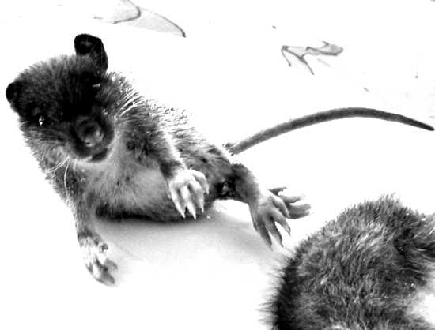
Fig. 1
I found the rats on a snow bank the morning after a particularly cold and windy storm. They were frozen in mid step, struggling to climb the shifting mountain ridge to find shelter from the blizzard.

Fig. 1
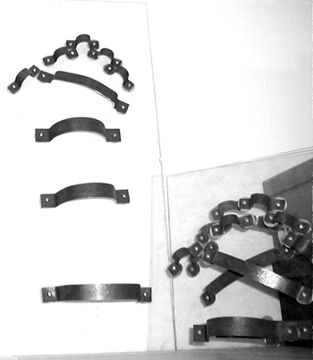
Fig. 2
The braces are inviting, designed for a hand or arm, but as soon as you have one on, you are stuck. The body is held in position, a frozen gesture.
Fig. 2

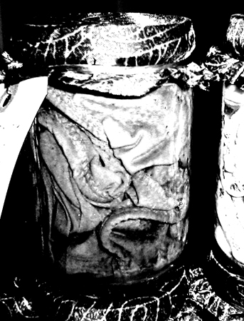
Fig. 3
I am amazed at how often I find underwear on the street or sidewalk, this most personal of garments out for the world to see. Sometimes they are quite dirty, mashed into the muddy gutter. Sometimes they have fallen from a clean basket of laundry. In a jar of alcohol and water the details are magnified and the fabric resembles folds of flesh.
Fig. 3
Adina Teodorescu
adinatheo@yahoo.com
857-998-1644

I like to draw inspiration from a wide variety of fields and subjects in order to express the more general ideas that preoccupy me at a certain moment. An ordinary element from nature or history takes on a whole new meaning and becomes important because it offers a visual solution to my state of mind. I see my work as that of a medieval scholar who puts together references (sometimes hidden, often times futile), creating thus a labyrinth for the viewer mind.

Penicillium Aequivocus is a series that reflects the difficulty in differentiating right and wrong. The four drawings represent four species of Penicillium (mold), out of which three are toxic and the fourth one is used for making penicillin. Their effects are opposite, still they share the same name and almost the same shape, making it impossible to judge them by their appearance. This occurrence from natural life contradicts the tendency to generalize characteristics of a group (usually by bringing the members to the lowers common denominator). Another meaning of the piece is related to the current medical practices, where chemical substances (e.g. antibiotics) are used as cure-all. As we can see at the origin of these substances the line between cure and intoxication is very fine.

Adina Teodorescu was born in Bucharest, Romania. She holds a B.A in Political Sciences at the University of Bucharest and a M.A in Human Factors at the University of Brussels. After moving to Boston, she began taking classes at the School of the Museum of Fine Arts in 2005 and is currently enrolled in a certificate program in Illustration.

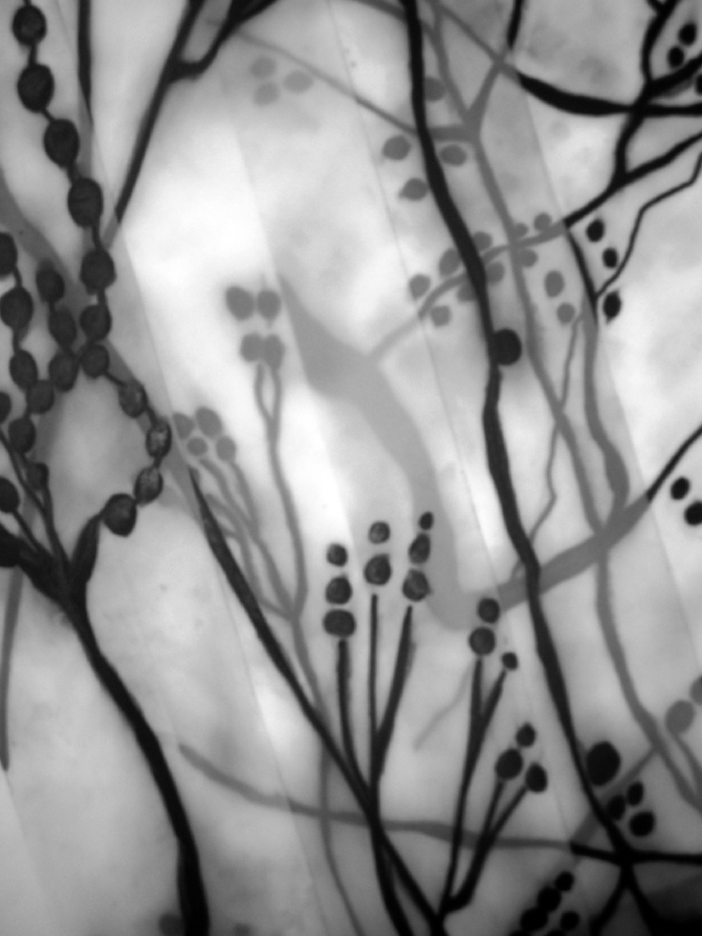
Penicillium

ALYA ROMEOS
978-394-2623
alya@mindspring.com
_____________________________________________________________________

Alya Romeos’ drawings, paintings, collage, mixed media sculpture, performance art and installations have been exhibited in solo and group exhibitions in galleries in the Boston area, San Francisco, East Bay and New York. Alya is best known for her mixed media work combining natural materials, microscopic imagery, boxes, and books as metaphors for social, political, ecological, and environmental concerns. Her work is in private collections in Boston, Cambridge, New York, San Francisco and Germany.

Alya received the Berkeley Civic Arts Commission Grant, to create a public installation, “Pneuma; Where do the visible and invisible worlds meet?” in downtown Berkeley, CA. She is the recipient of the MHFA-TAP Arts Outreach Grant, Boston, MA for six years working in various at risk communities.

Alya holds a BFA from Massachusetts College of Art, Boston, MA and a MFA from California College of the Arts, San Francisco, CA.

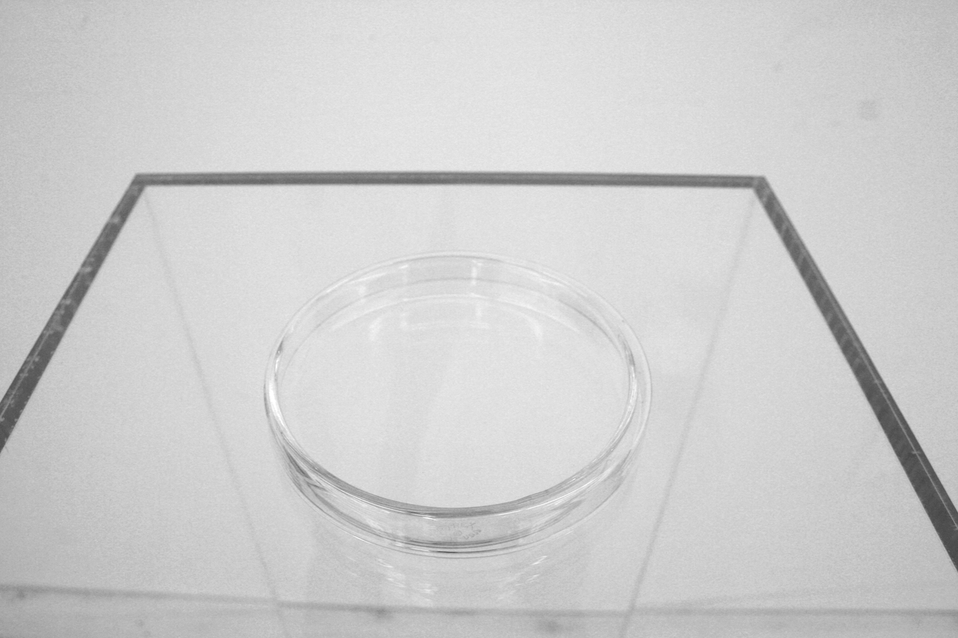
Apogee (detail)
Andi Sutton, Alex Haynes,M.D. & Andrew Eisenberg

Time Based Medium
Including:
Plastic
Plexi
Aluminum
White
Light
Blood
Latex
Rubber
Vaseline

Clean. Bend. Duck. Look. Insert. Touch. Probe. View. Feel. Separate. Settle. Pull. Peer. Clot. Ferment. Probe. Touch. Move. Decay. Feel. Clean. Repeat.

Concept/Design/Fabrication
Alex B. Haynes, M.D. is a senior Surgical Resident at a major Boston teaching hospital whose work includes surgical care for general and subspecialty patients in the pre-, intra- and post-operative settings. Schooled in Cell and Molecular Biology, African Diaspora Studies, Sociomedical Sciences as well as the study of Medicine, he is also one mean candlepin bowler.

Concept/Design/Fabrication
Andi Sutton is a performance artist whose art/life projects reflect her devotion to notions of public, of dialogue, and of access. She is currently pushing these and other ideas through her work in the National Bitter Melon Council. Other curatorial and performance projects include the Berwick Research Institute’s Public Art Incubator Program (co-curator 2004-2006), Slots for Security (2002-03) and Toast for Boston (2003). Her collaborative and solo work has been shown in New York and Boston in such locations as the Anthology Film Archives, the MFA, Art Interactive, the Mills Gallery at the BCA, as well as at CSA farms, in gardens, street corners, on adventurous tongues and inside hungry bellies.

Design/Fabrication
Andrew Eisenberg: From a very young age Andrew showed interest in taking things apart. Recently he has started putting them together.

Andrea Dorian Rose
redarose@gmail.com

h-influenced artist
Dancer
Yogini
Yoga Instructor

Pure Facts:
5'6"
female
red hair
blue eyes
lean athletic build

Impure Facts:
2 root canals
2 crowns
adnoids removed
tetanus vaccination
rabies vaccination
hep c vaccination
anxiety/depression disorder
myopic
hemorrhaged brain tumor
childhood allergies

Purifixation:
Health and disease are not opposites, they are closely related. Notions of what is healthy as opposed to diseased in regards to human behavior and the emotional/mental body change from culture to culture and over time. These notions are mutable, and change subtly as well as markedly.

Health of the body appears to be more clearly defined and fixed, but is this so? Our (Western culture) addiction to cleanliness in the microbial sense has spurred a rate of allergy and asthma increase in our population unseen in less developed nations. Our overuse of antibiotics has begun to backlash with co-evolution of the "superbug" or antibiotic-resistant strains. Is this addiction to the hyper-sanitary dangerous? Do we need a Cure for Pure?

Ablution:
I will cleanse my dirty, filthy body with distilled water and hospital-grade soaps as I stand in a wash-bin where the dirty wash water will collect. This highly sensory experience will be followed by my bottling of my bath water which will be available for the taking.

Andrew Anselmo
andrew@flappingbird.com

Andrew Anselmo is a mechanical engineer by training, and by day works trying to make photovoltaic panels better, cheaper and faster. He has been a collaborator, technician, and technical advisor/director on many art and performance art projects in the Boston area. He has also created a variety of temporary art cars. In addition, he works regularly as a street performer, creating origami at the public art installation "Waterfire" (in Providence, RI) and at other locations in the Northeast.

Please turn to Appendix A to reference his analysis of biometric and behavioral correlations of his fellow PURISTS.

2 | 1 | 9 | 8 | 7 | 8 | 4 | 2 | 8 | 2 | 1 | 8 | 2 | 4 | 1 | 7 | 9 | 3 | 4 | 9 | 4 | 1 | 0 | 0 | 4 | 4
8 | 5 | 3 | 9 | 0 | 5 | 8 | 6 | 3 | 2 | 3 | 0 | 6 | 3 | 5 | 1 | 0 | 4 | 0 | 4 | 6 | 6 | 0 | 1 | 4 | 0
8 | 2 | 2 | 7 | 9 | 8 | 9 | 8 | 7 | 6 | 6 | 6 | 5 | 2 | 8 | 1 | 0 | 8 | 2 | 0 | 9 | 4 | 4 | 1 | 7 | 0
7 | 5 | 1 | 5 | 3 | 1 | 4 | 1 | 9 | 7 | 1 | 8 | 7 | 4 | 5 | 7 | 3 | 7 | 3 | 1 | 9 | 9 | 1 | 5 | 8 | 5
6 | 9 | 8 | 0 | 0 | 4 | 1 | 1 | 0 | 5 | 9 | 2 | 2 | 6 | 5 | 1 | 9 | 0 | 8 | 9 | 7 | 1 | 7 | 9 | 5 | 8
2 | 2 | 4 | 6 | 6 | 4 | 2 | 7 | 8 | 4 | 6 | 8 | 6 | 6 | 7 | 7 | 0 | 3 | 3 | 0 | 0 | 4 | 7 | 0 | 7 | 5
5 | 4 | 4 | 8 | 2 | 4 | 7 | 8 | 9 | 9 | 9 | 9 | 9 | 8 | 7 | 1 | 3 | 4 | 3 | 0 | 8 | 7 | 9 | 8 | 2 | 5
6 | 2 | 4 | 3 | 2 | 3 | 9 | 5 | 5 | 8 | 2 | 9 | 8 | 7 | 5 | 3 | 2 | 5 | 3 | 4 | 4 | 6 | 4 | 7 | 0 | 2
0 | 5 | 4 | 3 | 9 | 6 | 2 | 0 | 7 | 6 | 2 | 0 | 6 | 7 | 5 | 0 | 5 | 4 | 7 | 9 | 8 | 8 | 3 | 9 | 0 | 5
4 | 7 | 0 | 3 | 1 | 7 | 6 | 8 | 3 | 7 | 4 | 7 | 4 | 0 | 8 | 1 | 1 | 0 | 8 | 1 | 1 | 7 | 2 | 9 | 7 | 0
4 | 5 | 9 | 0 | 8 | 9 | 7 | 6 | 7 | 8 | 6 | 0 | 9 | 2 | 6 | 0 | 2 | 0 | 0 | 5 | 6 | 6 | 2 | 8 | 8 | 3
6 | 2 | 2 | 0 | 8 | 2 | 6 | 6 | 2 | 0 | 4 | 0 | 4 | 1 | 5 | 0 | 1 | 7 | 0 | 6 | 2 | 1 | 9 | 0 | 5 | 6
5 | 2 | 4 | 8 | 9 | 4 | 0 | 1 | 3 | 6 | 5 | 7 | 2 | 4 | 7 | 9 | 6 | 9 | 0 | 1 | 7 | 0 | 0 | 3 | 3 | 9
0 | 6 | 1 | 7 | 7 | 2 | 1 | 0 | 2 | 5 | 0 | 9 | 4 | 2 | 0 | 3 | 7 | 6 | 8 | 6 | 1 | 2 | 9 | 8 | 0 | 7
6 | 7 | 3 | 6 | 5 | 0 | 1 | 6 | 0 | 8 | 1 | 7 | 7 | 3 | 4 | 6 | 3 | 1 | 4 | 1 | 8 | 4 | 0 | 9 | 5 | 7
7 | 6 | 5 | 0 | 1 | 2 | 2 | 8 | 2 | 0 | 6 | 8 | 1 | 4 | 7 | 2 | 2 | 0 | 2 | 7 | 7 | 0 | 0 | 8 | 3 | 1
3 | 4 | 9 | 2 | 1 | 5 | 7 | 9 | 3 | 0 | 6 | 9 | 4 | 6 | 3 | 7 | 3 | 1 | 6 | 2 | 7 | 5 | 2 | 7 | 2 | 1
9 | 8 | 9 | 5 | 1 | 3 | 8 | 8 | 8 | 1 | 5 | 8 | 3 | 6 | 4 | 7 | 5 | 9 | 8 | 9 | 5 | 6 | 1 | 8 | 6 | 2
9 | 6 | 5 | 5 | 8 | 1 | 7 | 4 | 2 | 3 | 6 | 3 | 6 | 8 | 7 | 6 | 8 | 9 | 5 | 6 | 9 | 4 | 8 | 6 | 1 | 6
7 | 0 | 6 | 6 | 2 | 9 | 1 | 9 | 9 | 3 | 9 | 4 | 7 | 3 | 1 | 3 | 1 | 4 | 2 | 8 | 7 | 6 | 9 | 7 | 7 | 9
9 | 2 | 6 | 7 | 1 | 0 | 8 | 6 | 5 | 0 | 4 | 4 | 8 | 7 | 8 | 7 | 1 | 2 | 1 | 4 | 1 | 8 | 5 | 8 | 9 | 1
4 | 9 | 0 | 4 | 2 | 9 | 5 | 8 | 5 | 6 | 9 | 1 | 0 | 6 | 3 | 1 | 1 | 1 | 3 | 7 | 9 | 7 | 2 | 6 | 0 | 8
6 | 6 | 6 | 5 | 3 | 3 | 3 | 5 | 8 | 1 | 8 | 7 | 8 | 1 | 7 | 3 | 1 | 7 | 0 | 9 | 5 | 9 | 8 | 6 | 0 | 2
7 | 8 | 6 | 0 | 5 | 1 | 8 | 1 | 1 | 0 | 4 | 3 | 6 | 7 | 0 | 4 | 7 | 9 | 1 | 2 | 7 | 1 | 4 | 5 | 6 | 6
4 | 1 | 8 | 1 | 2 | 6 | 4 | 4 | 1 | 5 | 6 | 0 | 3 | 9 | 3 | 8 | 8 | 8 | 4 | 5 | 4 | 8 | 7 | 3 | 2 | 3
1 | 8 | 8 | 4 | 2 | 1 | 6 | 8 | 1 | 9 | 8 | 8 | 1 | 5 | 7 | 0 | 1 | 3 | 2 | 9 | 9 | 1 | 9 | 6 | 8 | 3
6 | 3 | 8 | 8 | 2 | 2 | 0 | 6 | 6 | 8 | 4 | 5 | 5 | 7 | 9 | 6 | 3 | 8 | 5 | 4 | 4 | 1 | 4 | 8 | 9 | 3
0 | 0 | 3 | 9 | 5 | 7 | 9 | 4 | 2 | 2 | 8 | 9 | 0 | 9 | 4 | 5 | 4 | 0 | 5 | 1 | 6 | 2 | 1 | 1 | 0 | 9
2 | 0 | 4 | 6 | 7 | 7 | 0 | 9 | 5 | 9 | 9 | 6 | 8 | 0 | 4 | 7 | 8 | 0 | 0 | 7 | 0 | 2 | 7 | 3 | 5 | 1
9 | 1 | 5 | 7 | 0 | 8 | 3 | 5 | 5 | 0 | 8 | 5 | 9 | 7 | 5 | 8 | 4 | 6 | 2 | 4 | 6 | 2 | 9 | 4 | 9 | 7
6 | 1 | 6 | 3 | 3 | 6 | 0 | 2 | 8 | 8 | 0 | 2 | 8 | 7 | 5 | 0 | 5 | 8 | 7 | 7 | 6 | 6 | 4 | 5 | 6 | 0
5 | 6 | 0 | 4 | 3 | 8 | 1 | 2 | 3 | 5 | 5 | 7 | 4 | 7 | 9 | 7 | 3 | 3 | 2 | 6 | 0 | 6 | 2 | 7 | 4 | 0
0 | 2 | 3 | 5 | 2 | 3 | 5 | 2 | 3 | 6 | 8 | 4 | 1 | 7 | 7 | 0 | 3 | 3 | 1 | 2 | 6 | 5 | 5 | 2 | 5 | 2
0 | 8 | 1 | 0 | 5 | 8 | 3 | 3 | 9 | 4 | 9 | 9 | 1 | 5 | 6 | 8 | 1 | 0 | 3 | 8 | 2 | 5 | 0 | 5 | 3 | 2
1 | 3 | 5 | 4 | 1 | 9 | 5 | 2 | 5 | 5 | 5 | 7 | 6 | 8 | 1 | 9 | 7 | 8 | 9 | 6 | 6 | 5 | 5 | 5 | 0 | 3
2 | 9 | 7 | 0 | 1 | 2 | 9 | 5 | 1 | 9 | 2 | 7 | 9 | 7 | 9 | 7 | 3 | 9 | 3 | 5 | 4 | 0 | 4 | 6 | 3 | 2
4 | 6 | 1 | 3 | 1 | 7 | 7 | 3 | 2 | 6 | 3 | 8 | 6 | 4 | 7 | 9 | 8 | 6 | 8 | 7 | 5 | 8 | 8 | 6 | 4 | 3
9 | 2 | 8 | 5 | 9 | 0 | 4 | 1 | 2 | 0 | 4 | 7 | 2 | 0 | 4 | 7 | 8 | 0 | 3 | 0 | 7 | 2 | 2 | 4 | 5 | 5
1 | 6 | 9 | 6 | 9 | 1 | 8 | 1 | 2 | 4 | 4 | 8 | 1 | 0 | 4 | 2 | 5 | 7 | 8 | 3 | 1 | 5 | 7 | 2 | 4 | 6
6 | 3 | 5 | 8 | 7 | 7 | 3 | 8 | 1 | 3 | 7 | 9 | 7 | 6 | 2 | 4 | 7 | 8 | 7 | 4 | 8 | 2 | 3 | 9 | 1 | 6
8 | 2 | 0 | 6 | 7 | 8 | 7 | 7 | 2 | 8 | 6 | 9 | 3 | 8 | 9 | 9 | 5 | 0 | 6 | 7 | 4 | 0 | 8 | 5 | 7 | 4
0 | 5 | 1 | 0 | 2 | 9 | 5 | 7 | 7 | 2 | 3 | 7 | 3 | 5 | 5 | 9 | 3 | 6 | 9 | 0 | 2 | 7 | 6 | 9 | 5 | 7
0 | 7 | 5 | 2 | 1 | 1 | 6 | 8 | 9 | 6 | 9 | 6 | 4 | 8 | 7 | 0 | 9 | 9 | 1 | 6 | 5 | 9 | 6 | 0 | 7 | 0
5 | 0 | 9 | 1 | 9 | 1 | 7 | 7 | 0 | 0 | 8 | 6 | 2 | 4 | 5 | 1 | 7 | 1 | 4 | 9 | 2 | 8 | 3 | 4 | 9 | 2
4 | 1 | 6 | 0 | 6 | 6 | 3 | 6 | 5 | 2 | 4 | 2 | 2 | 3 | 8 | 4 | 6 | 9 | 9 | 4 | 6 | 6 | 3 | 4 | 5 | 2
0 | 8 | 2 | 9 | 5 | 2 | 8 | 0 | 1 | 2 | 1 | 4 | 0 | 0 | 3 | 1 | 1 | 8 | 1 | 4 | 8 | 7 | 0 | 2 | 7 | 3
0 | 4 | 8 | 4 | 9 | 4 | 2 | 4 | 9 | 9 | 4 | 2 | 7 | 5 | 5 | 5 | 9 | 0 | 4 | 7 | 0 | 1 | 4 | 7 | 2 | 0
4 | 7 | 8 | 3 | 3 | 8 | 8 | 2 | 5 | 7 | 8 | 4 | 5 | 3 | 1 | 9 | 0 | 3 | 2 | 8 | 0 | 9 | 0 | 8 | 2 | 2
5 | 9 | 7 | 8 | 7 | 7 | 1 | 4 | 8 | 9 | 1 | 3 | 2 | 6 | 6 | 4 | 1 | 4 | 3 | 5 | 4 | 8 | 9 | 9 | 4 | 7

The Illusion of Juvenile Innocence in the Parental-Neonate Commensal
Andrew M. Siegel

Abstract: The hypothesis that purity of thought and deed (i.e. innocence) correlates strongly with the inability to survive in the “real world” was examined. I discovered that in order for an organism to become a self-sufficient entity, it must surrender false illusions, carefully modulate generosity, defend one’s physical and emotional space, and occasionally perform selfish acts – all of which indicate the lack of innocence. Yet it is precisely these behaviors which enable all creatures to survive. This paradox is discussed, with reference to the parental-neonate commensal as a model for the misattribution of innocence to neonates and children, while ignoring the fact of their existence as being only an incomplete and inseparable component of a more complex organism.

Introduction: For millennia, humans have admired and valued the purity of neonates and juveniles. By assumption, all neonates are born without any precognitive understanding of the trials and tribulations of survival in a competitive environment, and thus they represent the highest degree of moral purity that humans can achieve. However, as a refrigerator does not a thermodynamically closed system make, neonates must be viewed as only one part of a unit, here termed the parent-neonate commensal (PNC). When the PNC is viewed as a distinct organism, it exhibits all of the necessary survival attributes of any other adult organism, and the perception of the “purity of the neonate” is revealed as incomplete, and thus incorrect.
Experimental Procedure: A human primate PNC, consisting of an adult male (Father), an adult female (Mother), and a young sub-adult (Child), was examined. Each were queried, in turn, for their responses to a verbally-administered questionnaire. These data were then used to assess the purity of thought and degree of innocence of each of the subjects.
Regulatory Compliance: As all risks to the subjects were at or below those normally experienced on a daily basis, no IRB approval was sought. Furthermore, all data and personal identifying information were anonymized in order to comply with current HIPAA requirements. No animals were harmed by the collection of this data.
Results and Discussion: The results of the three questionnaires, which are not shown here, clearly support the aforementioned conclusion. This is illustrated in Figure 1 below.
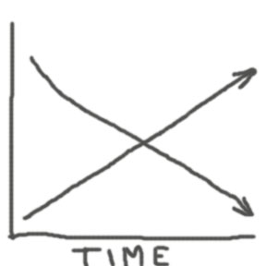
Developmental Age
MATURITY
INNOCENCE

Figure 1. A diagram depicting the loss of innocence accompanying the rise in maturity with an increase in developmental age. Therefore in a fundamental sense, maturity and innocence are mutually exclusive states.

Conclusion: In order for a juvenile human to become an independent self-sufficient entity, it must surrender false illusions of infinite love and acceptance. It must also carefully modulate generosity by spending its emotional resources primarily on those whom provide the greatest “return” on its investment. It must also defend its physical and emotional space from those wishing to do bodily harm, to mislead or deceive, or to take its possessions. It must also occasionally perform selfish acts, such as stealing food, in order to survive. All of these behaviors, albeit considered normal adaptive behavior for an adult, when present in a juvenile, indicate a loss of innocence.
References:
The Social Role of Infants in Human and Non-Human Primates. Valerie Borey. [http://www.suite101.com/article.cfm/topics_in_anthropology/108990]
Primate paradigms: Sex roles and social bonds. Linda Marie Fedigan. Montreal: Eden Press. (1982).
Reciprocity in Parent–Child Relations Over the Adult Life Course. Merril Silverstein. 2002.
[http://psychsoc.gerontologyjournals.org/cgi/content/abstract/57/1/S3#search=%22social%20relationship%20parent%20pro%20life%22]
Helping Children Cope: Advice in the Aftermath of the Terrorist Attacks on America. Joanne Cantor.
[http://joannecantor.com/terror_adv.htm]

About the Author: Dr. Siegel has a Ph.D in Biomedical Optics, and has published peer-reviewed papers in the fields of biomedical optics and electronics. He has also presented material at numerous technical and trade conferences, however he is a lousy geologist and he is not a very good artist either. It is his fervent hope that since his serious attempts at effecting non-violent social change (voting) was woefully overlooked and ignored by the majority of society, he will still be able to effect meaningful social change via his artistic endeavors. This is doubtful, as can be seen from the depiction of the author in Figure 2 below:
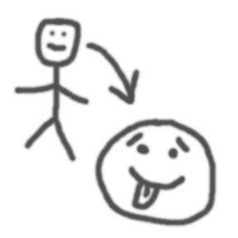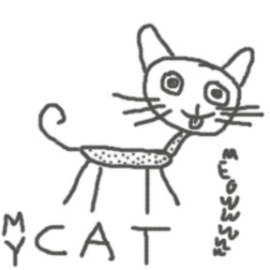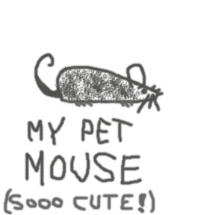

Figure 2. A portrait of the author. His feline and murine living companions are also included. Evidence of residual youthful innocence is partially visible in the image.

_____________________________________________________________________________________________

Title of Piece Moral Purifier

Materials: Metal, plastic, electronics, faith.

The connection between digital hygiene and moral rectitude is explored using intense light as a metaphor for the cleansing power of faith. Impure thoughts and deeds, manifest as visible stains (stigmata) and their modern equivalent (germs), are cleansed safely and effectively by this simple device. The cost is high (25 cents) and the wait is long (15 seconds), but the reward - restoration of moral purity in the blink of an eye - is well worth it.
Anna Phylaxis
781.391.0523
anna.phylaxis@gmail.com
Womb Room: An Installation & Collaboration

art • ist
n.
- One, such as a painter, sculptor, or writer, who is able by virtue of imagination and talent or skill to create works of aesthetic value, especially in the fine arts.
- A person whose work shows exceptional creative ability or skill: You are an artist in the kitchen.
- One, such as an actor or singer, who works in the performing arts.
- One who is adept at an activity, especially one involving trickery or deceit: a con artist.

[French artiste, from Old French, lettered person, from Medieval Latin artista, from Latin ars, art- art. See ar- in Indo-European Roots.]

state • ment
n.
- The act of stating or declaring.
- Something stated; a declaration.
- Law. A formal pleading.
- An abstract of a commercial or financial account showing an amount due; a bill.
- A monthly report sent to a debtor or bank depositor.
- Computer Science. An elementary instruction in a programming language.
- An overall impression or mood intended to be communicated, especially by means other than words: Glass, exposed beams, and antiques were combined to create a strong decorative statement.

womb
n.
- See uterus.

  - A place where something is generated.
  - An encompassing, protective hollow or space.
3. Obsolete. The belly.

[Middle English, from Old English wamb.]

The American Heritage® Dictionary of the English Language, Fourth Edition, Houghton Mifflin Company, 2004.
This page left intentionally blank.

Ashanti
sonicsoulfusion@gmail.com
conflictedmedia.com

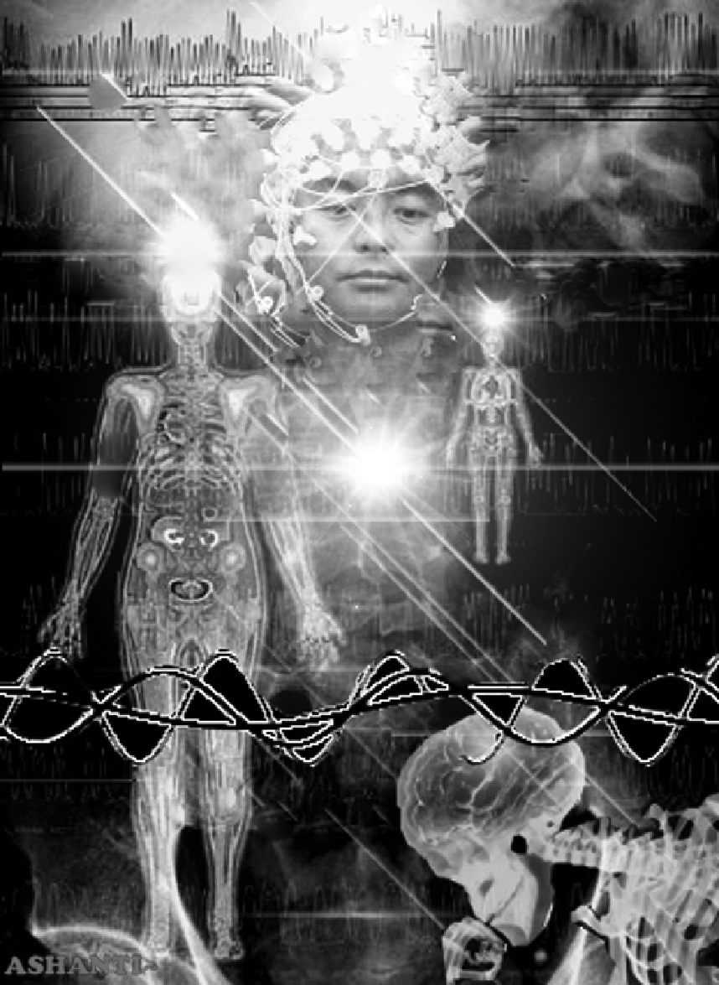

. : Artists Statement : .

“Thanks to the video artists, we see what we can't see.”

-Kedy, UGC Cinema, Hong Kong

My art is a healing tool, a spiritual synthesis, a transformative process, and a way of being. For the past seven years I have been facilitating healing art and meditation workshops at the Women’s Center in Cambridge, MA. As a teacher I have seen how influential meditation and various visual media can be. Inspired through my student’s experiences, I created various projects to teach others the importance of meditation. Expressing this through video, animation, VJ & DJ performance, and interactive installations. In my five-year thesis project, EKTA, I have collaborated with computer programmer Chris Korda to enable my ideas to be fully executed. The result was a multimedia environment that generated biofeedback meditation. As in a mirror, this enabled the user to immediately see feedback of their state of being by having their shifting brainwaves change the light and sound in the room. This installation has opened the eyes to many who have experienced its environment.

There is a pulse that exists and vibrates within each and every one of us. There are a vast array of influences that trigger our minds and hearts in the everyday flow. The sensory environment around us feeds into our beings, shifting our physiological state as well as psychological state. We live in a time where scientific research is constantly investigating these issues. In my multimedia pursuit I explore ways to connect this realization. My goal is to show the similarities of an energy that drives rhythm, and an emotion that drives movement. With the use of video and audio, this is expressed in a stream of consciousness. It is my intent to demonstrate that meditation is a state of awareness that can radically transform us and can be experienced anywhere. I strongly feel it is important to integrate spirituality in every thing we do. In a time where we are bombarded by media images of disaster, war and world suffering, it is important to seek inner calm and balance.

Shifting our state of awareness can be a powerful tool. In many Asian cultures this observation is still practiced in daily life. It is in the study of different cultures through video art I seek to explore as a tool for teaching. I seek to understand what influences one another and how our actions are connected. By weaving together the everyday and the sacred I look to generate examples from my travel footage. This is executed through experimental documentary montage. My emphasis is on showing the juxtaposition of meditative acts in temple life to transitions of everyday city life. I have captured footage of a monastic and city life in India, Thailand, and Cambodia. While also including rhythmic scenes from the streets of American life I represent a comparable thread that may unite the pulses of daily activities to a sacred intentional force. These images explore an interconnectedness of consciousness from around the globe.

ashanti is a sacred soul whose devotion to spirit transcends all bounds. she is a profoundly connected thinker who works hard to push the boundaries of art into the future. thank you, ashanti, for keeping the frequency. i am confident future generations will recognize your efforts.

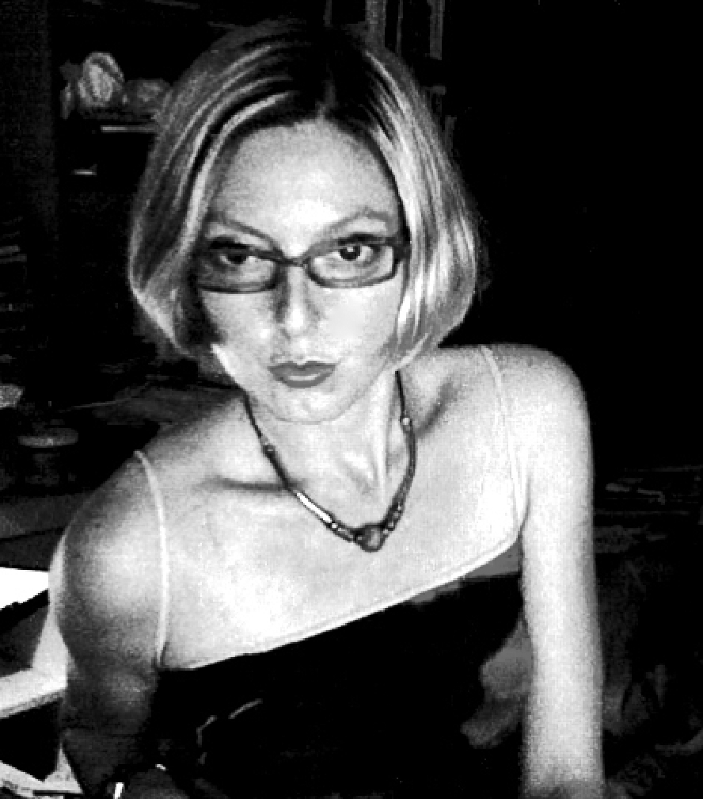
Barry Maloney
barrymaloney.com
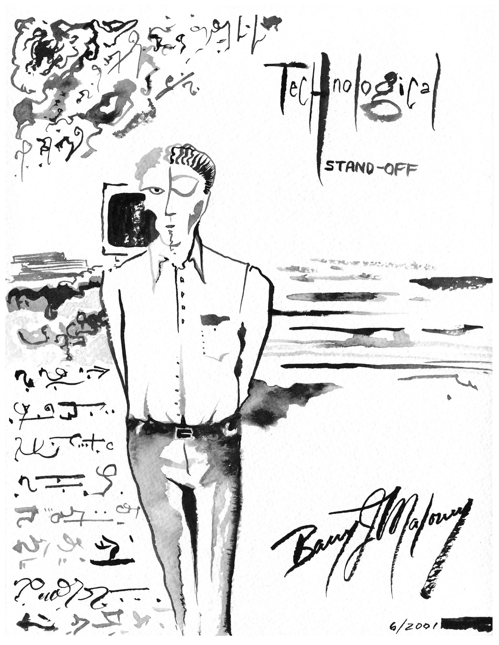

At the nadir point of my technology-based, computer-generated professional career, I spent countless hour working and thinking in the computer’s terms. Most of my work-based interpersonal communications came to me via the internet as text; jokes were "sent" not "told," people didn't drop by and chat, but zapped you an e-mail, very few people even said "good morning" or made eye contact. My co-workers were reserved, withdrawn, and cubicle-bound – huddled up before the ambient glow of their silicone masters – absorbed with the needs of the machine. Over time, my brain had begun to merge with the software programs I used so extensively, taking on some of their traits. I began to identify others by the level to which they had been absorbed by technology, which I defined in downwardly spiraling stages of loss of spirit as:

Stage 1: The Worker Stage 2: The Drone Stage 3: The Pod
...and finally, when the person had not one spark of humanity left, a waxy pallor and a hollow look in the eye, came the last and final stage from which there was no return...
Stage 4: The Husk

It began to prey on my mind; my general unhappiness and the awareness of how this machine was infecting my mind. One day at lunch, I went to a nearby park and did an inkwash painting. Upon reflecting on the finished work, I felt terrified for my spiritual safety. My art is honest and intuitive, and I trust it, but what came out from within was a man slowly being taken over by the machine. Yes, I too was the unwilling victim of the insidious “Borg” of technology, and I didn't like it. Soon I began to plan my escape. I quite that job in August 2003, and have not worked a straight job since.

Biographical
Artist Barry Maloney has followed a career long tendency to pursue fresh and changing concepts in fine art and the understanding of life, amassing a large catalog of work in many styles and media. Exhibiting regularly in many venues, both large and small, he is unenthusiastic about conventional measurements of artistic success. Barry considers his paintings to be a form of visual philosophy. His work is represented exclusively by an online gallery at www.barrymaloney.com.

_______________________________

Bebe Beard
URL: bebebeard.com
bebebeard@gmail.com
617-348-9206

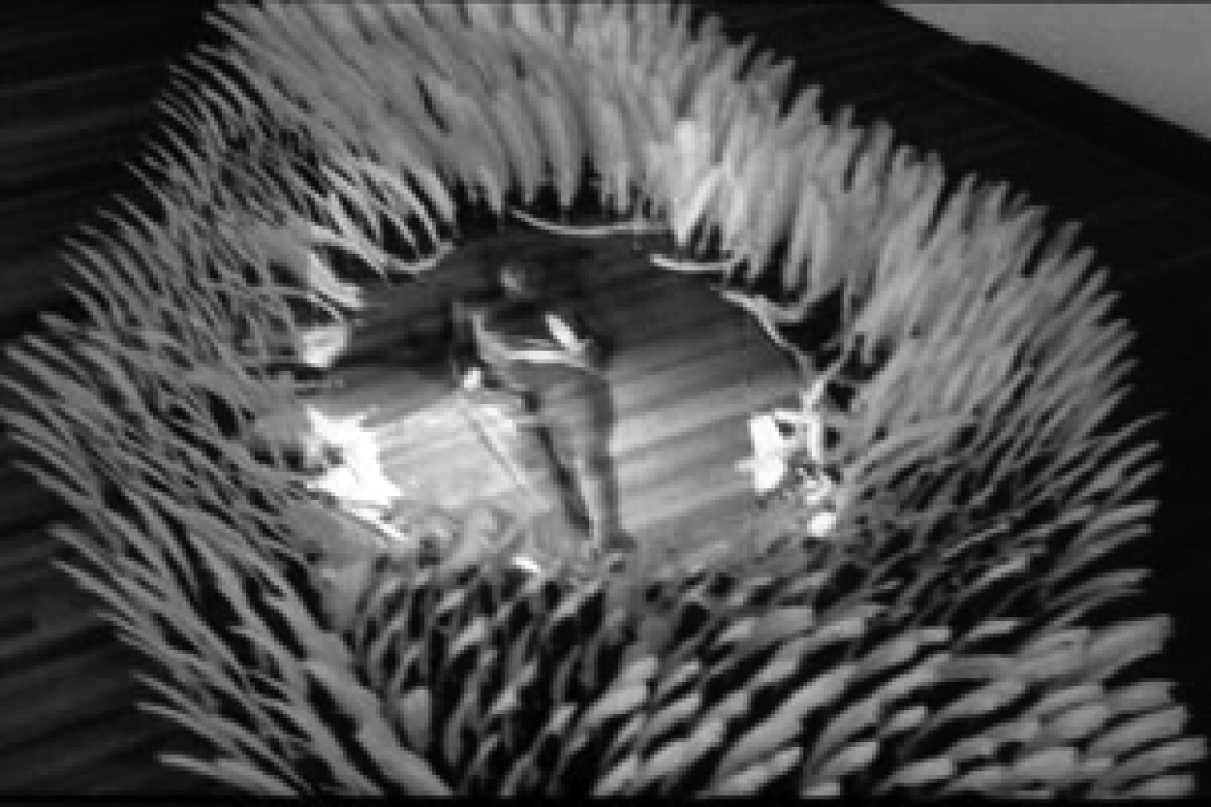

Change Field at PURE

Change Field uses feathers to startle and sensitize sight then the imagination. The drift sweeps through space framing the motions of a female figure at its center. The human form – a spirit barely materialized through silent video projection – is transformed by its context. She becomes the lady-in-the-lake of childhood stories inviting us once again to dream.

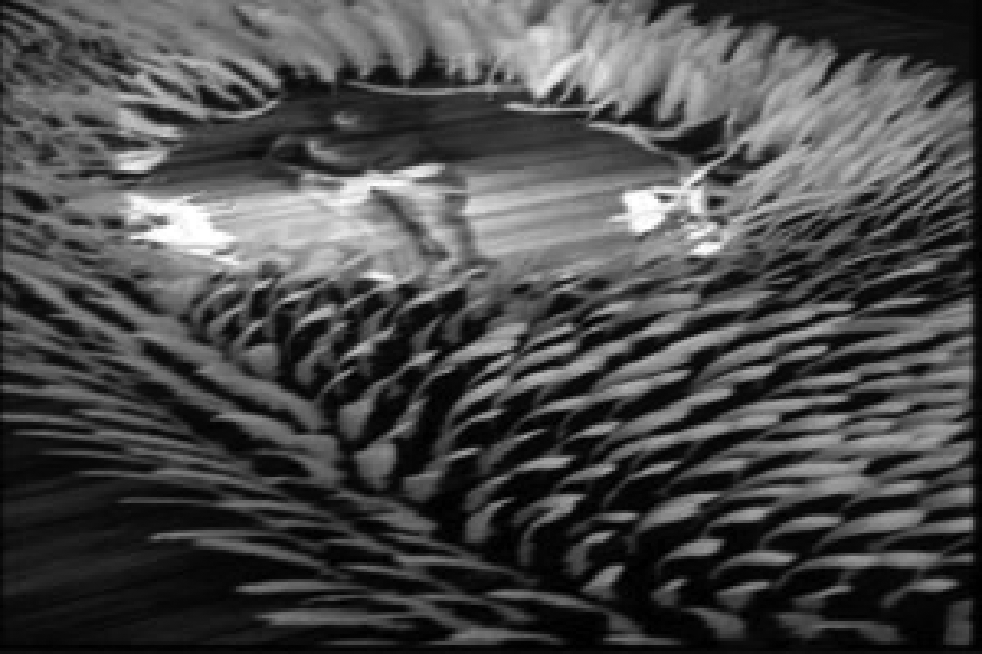

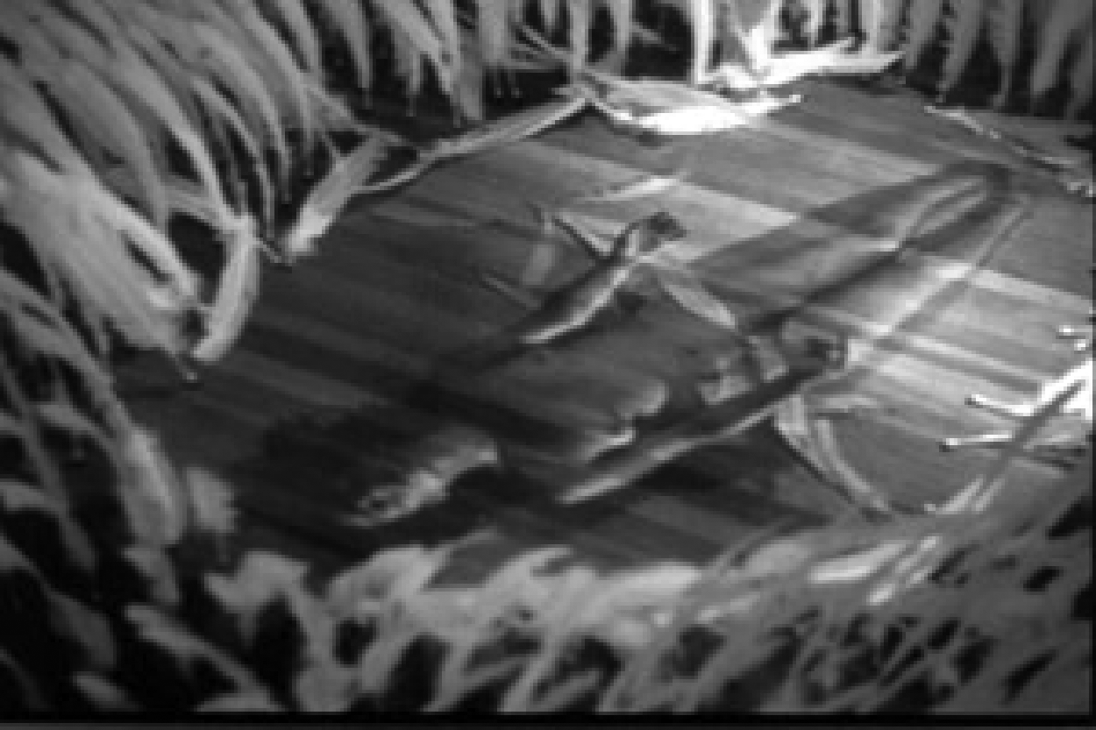

Bebe Beard earned her BFA in 1976, her MFA from Mass College of Art’s Studio for Interrelated Media in 1996. In recent years she has received grants from the Massachusetts Cultural Council, St Botolph’s Club Art Foundation and the Gottlieb Foundation Emergency Assistance; held residencies at Djerassi Resident Artists Program, MacDowell Colony and the Experimental Television Center in Owego, NY. She has exhibited in a wide variety of venues – alternative spaces, galleries, and theaters throughout New England and New York.

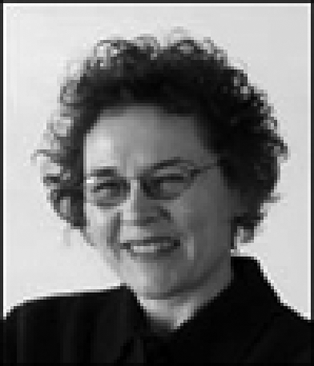

BETTY BOLIVAR
Bettybolivar.com

Betty Bolivar was born in Richmond, VA, resides in Cambridge, MA and has a studio in Somerville, MA. Betty is a 2004 graduate of the School of the Museum of Fine Arts Diploma program and 2005 graduate of the same institution’s Fifth Year Certificate program. Betty has studied painting, design and visual merchandising. She has worked as a window dresser, color consultant and space stager. She is also involved with the maintenance and design of printed materials and websites for a local university. Betty has shown her work in many gallery and university shows throughout the US and her paintings are in numerous private collections.

Process
I work in both 2-D and 3-D. I am inclined to work in one style for a period of time and then switch to another. I make mixed media paintings, assemblages with ordinary objects, and small works on paper using repetitive text. Most of the work is fueled by curiosity and purpose. Creating for me is about surrendering to the process; I like to investigate the tension between working and reworking materials. I think my work often suggests an element of contrasting appearances. Some of my pieces start with an idea but most just evolve, allowing my instinct to take it one way or another. A common element in my work is based not around a particular aesthetic, but rather represents an obsession with the process and a desire to test my limits. Art is a vehicle that allows me to communicate and to learn more about myself.

BETTY BOLIVAR
• COTTON = Yarn, strand, filament, cord line
• TIP = point, end top, apex, head
• CLEAN =

adj
1. free from dirt or impurities
2. containing no foreign matter or pollutants
3. not infected or diseased
4. freshly laundered or washed after use
5. taking pains over personal hygiene or grooming
6. containing nothing at all (informal)
7. morally pure and upright
8. just and fair
9. not rude or obscene
10. without anything on it, especially anything written
11. having or showing no record of convictions or penalties, for example, for driving offenses
12. without problems or difficulties
13. without rough or jagged edges
14. simple and flowing in design, without projections or additions
15. complete and unqualified
16. used to describe a gemstone that is free of flaws
17. cleared of weeds and unwanted undergrowth
18. containing relatively few mistakes or corrections
19. precisely performed and in accordance with the best technique
20. played, fought, or won by strict compliance with the rules
21. producing the least possible pollution
22. producing the least possible radioactive fallout or contamination
23. not carrying concealed weapons (slang)
24. not containing or possessing illegal drugs (slang)
25. free from addiction to narcotic drugs or other substances (slang)
26. not guilty of a particular crime (slang)
27. used to describe somebody who is ritually undefiled according to Jewish law
28. used to describe food that may be eaten according to Jewish law
29. spiritually pure or purified
v
1. to rid something of dirt or impurities
2. to remove or eradicate unwanted dirt, stains, or marks
3. to become free of dirt, chiefly because of a content or structure that easily repels it
4. to free something of dishonest practices
5. to prepare a dead animal for cooking by removing its entrails
6. to use up the contents of something
n
a spell of removing unwanted dirt or marks
adv
1. so as to make something free from dirt
2. so as to rid something of incriminating evidence
3. directly, especially without having any obstruction
4. in a clean way
5. completely or utterly (informal)

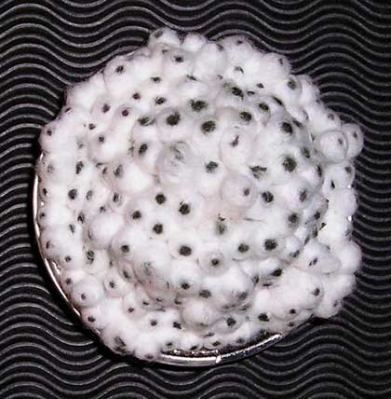
Fairy Tale (top)

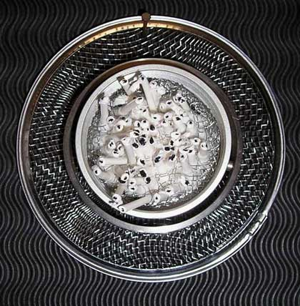
Fairy Tale (bottom)

Bezreh + Keefe

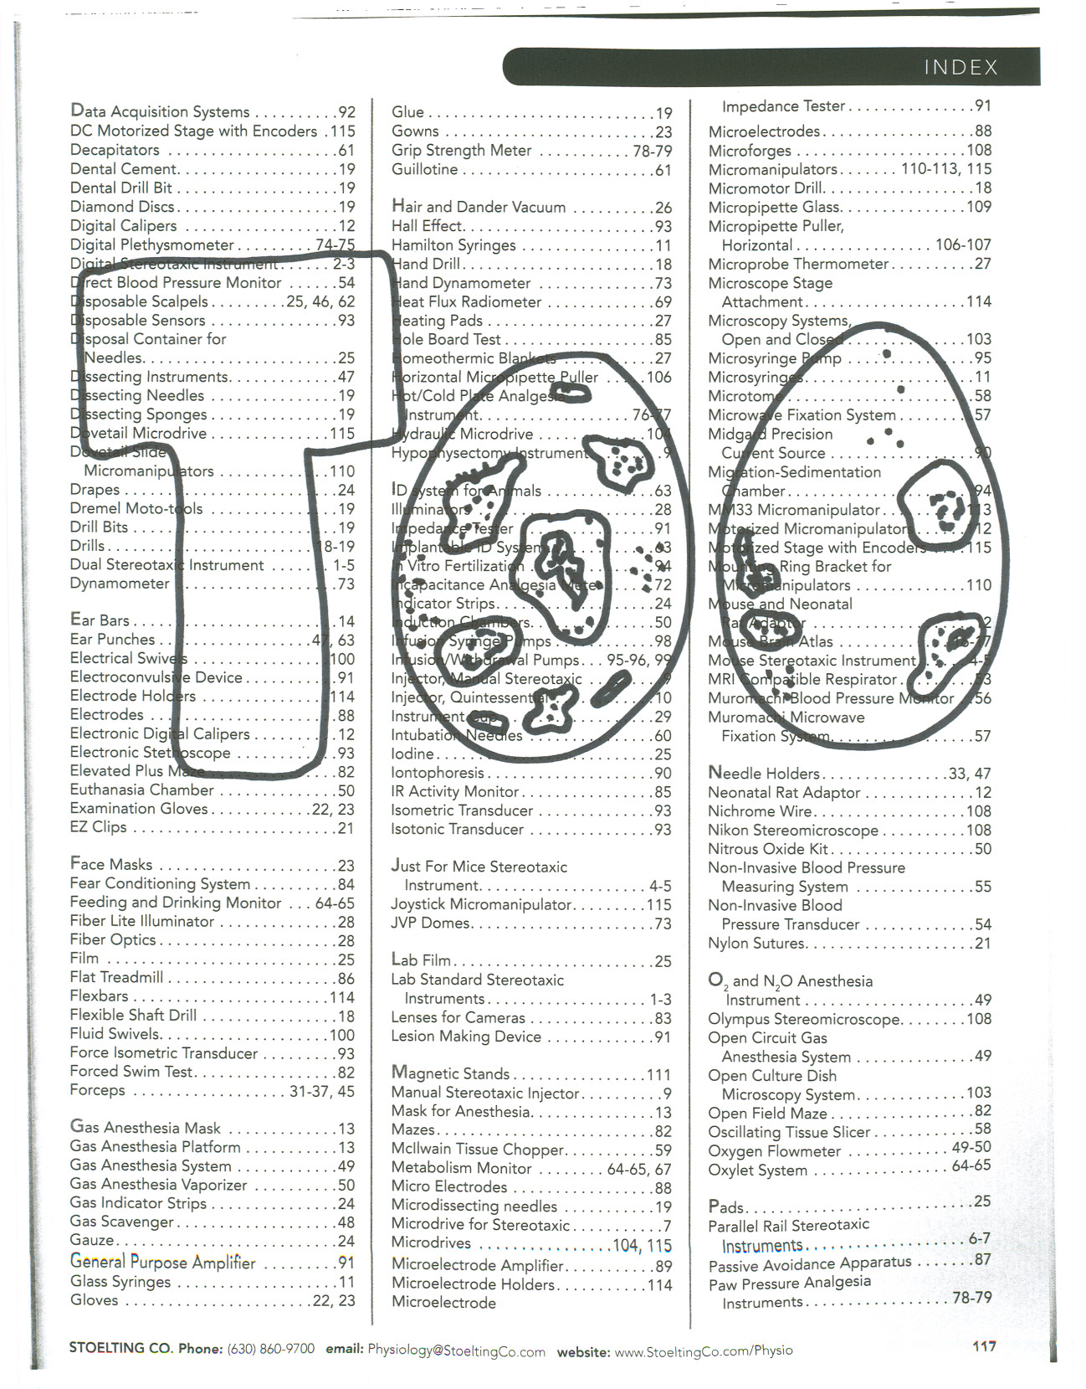

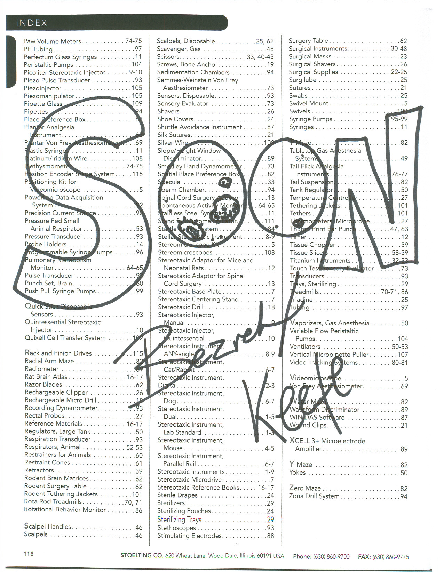
Bill Klingensmith & Robin Cass

www.mydarndest.com & www.robincass.com

Bill Klingensmith is in his fifth year as Assistant Professor of Design at the Rochester Institute of Technology. He holds two degrees, a BFA in painting 1995 from Youngstown State University in Ohio and a MFA in painting 1998 from University North Carolina, Greensboro. In addition to teaching, Klingensmith is an active member in the American Institute of Graphic Arts (AIGA), Upstate New York chapter, in which he holds the position of Education Chair. Beyond academia, Bill is a professional designer and runs a freelance design business, "mydarndest". You can see his print and web design projects at http://www.mydarndest.com.

Robin Cass has been a faculty member in the Glass Program at the Rochester Institute of Technology since 1998. She also serves on the Board of Directors of the Glass Art Society. Cass received her BFA from the Rhode Island School of Design and her MFA from Alfred University and has been invited to teach, demonstrate glassblowing and lecture internationally. She has received a fellowship from the Creative Glass Center of America as well as several grants from the New York Foundation for the Arts and a residency at the Glass & Ceramic Center of Seto, Japan. Cass has taught workshops at venues including the Pilchuck Glass School, the Studio at the Corning Museum of Glass, and the Haystack School for Crafts. Her recent shows include Sculpture: Cast, Carved, & Constructed" at the Schwienfurth Art Center, "Compelled by Content II" at the Fraser Gallery, and “20/20 Vision” at the Museum of American Glass. Last summer she taught at Pilchuck Glass School again and made work during an Artist's Residency at the Tacoma Museum of Glass and Center for Contemporary Art. Her current work can be seen at Habatat Gallery in Boca Raton, Florida. She was also included in a new book published this year by the Corning Museum of Glass, "25 Years of New Glass Review", edited by Tina Oldknow. This summer, Cass mounted a solo show at the Tittott Museum in Taipei, Taiwan.

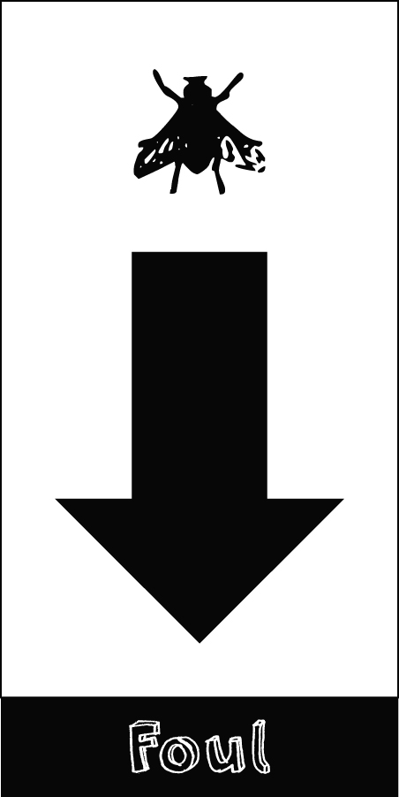

Blake Courtney
Supablake@hotmail.com

I AM...
A self taught jack of all trades and master of some.

My piece is pure crap.
If it inspires it is purely by accident.

This page left intentionally blank.
Bob White
Animation: The Bite
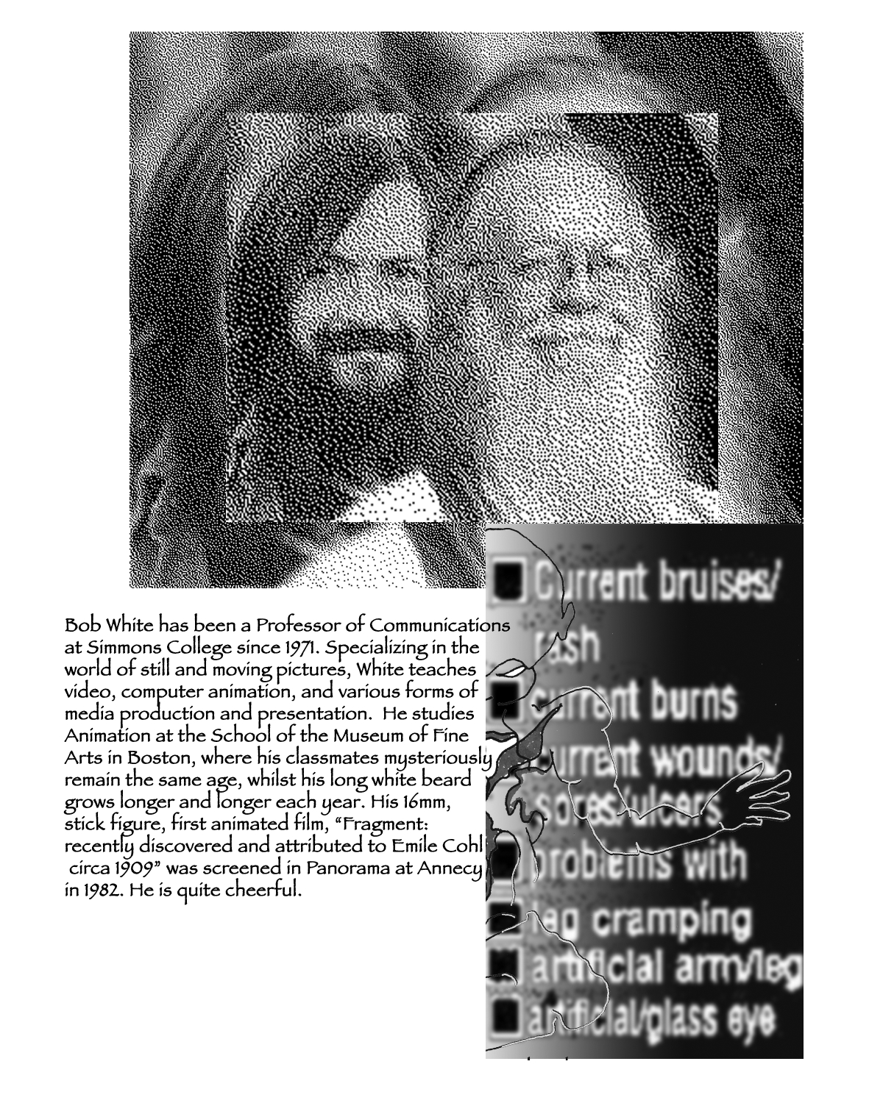
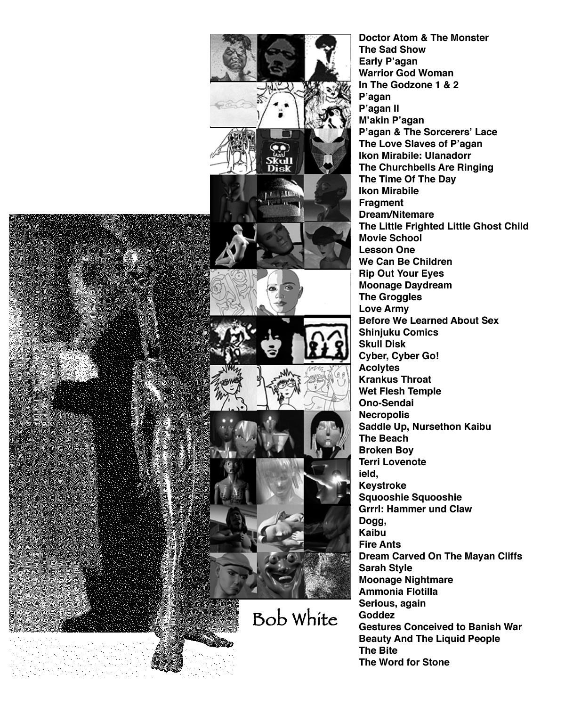

Christy Georg
www.christygeorg.com

Christy Georg has been called “a sculptor of wit and ingenuity, clearly in the tradition of Jean Tinguely and Bruce Nauman” by Rob Fisher. She has exhibited widely, received awards for her kinetic sculpture, and attended residencies at the Vermont Studio Center, Boston’s Berwick Research Institute, the Roswell AIR program, and the MacDowell Colony. Solo exhibitions include the Contemporary Artists Center in North Adams and the Roswell Museum, with upcoming shows at Gettysburg College and U Mass Lowell. She is a 2006 recipient of a Sea Grant from the University of Rhode Island. Raised in Houston, she received a BFA from the Kansas City Art Institute, and a MFA from Massachusetts College of Art.

I build devices which function either actually, or metaphorically. The collaboration between user and tool results in an experience/experiment; the duo act as a machine. The object may be seen without its user; it’s obfuscated intention existing as mere possibilities, in the mind. Is it any different than viewing 17th century devices, inventions and innovations far removed from our digital world in the 21st? Upon examination they may reveal information which is certainly obscure and perhaps esoteric.

The work is a “collection,” classified, ordered, and displayed as a museum. Its construction reveals the speculative and subjective nature of ontology, undermining the authority of ‘science’. What can we truly ascertain about reality? As modern museums dispense with outmoded taxonomic disciplines and “can mount displays which turn artifact into art objects, to be savored more than studied,” I turn art objects into artifacts, their function apparently expired, their curious intentions to be studied.

The ‘present moment’ has always evinced a fascinating, modern world at the height of technology. It is an uncanny thing viewed with the benefit of hindsight.

Quote from John Pickstone, “Objects of Modern Medicine” in the book Medicine Man: The Forgotten Museum of Henry Wellcome

-Christy Georg

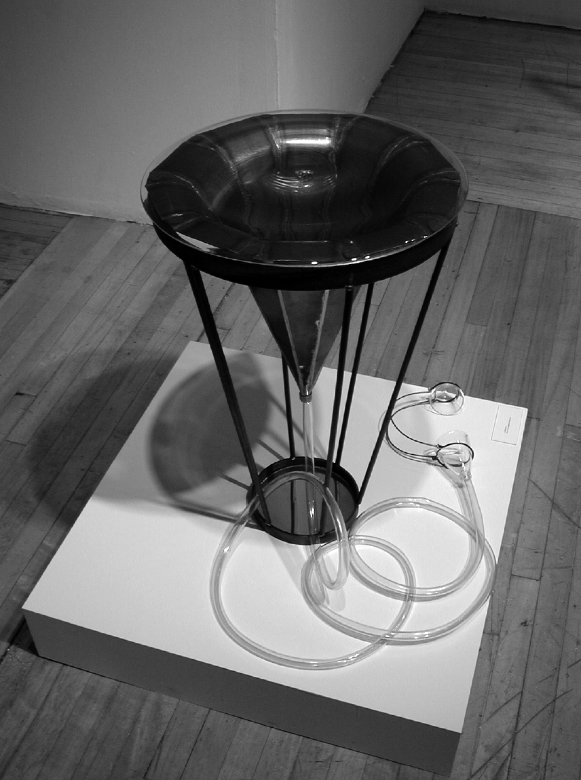 Collector – part of the “Transistor Triumvirate”
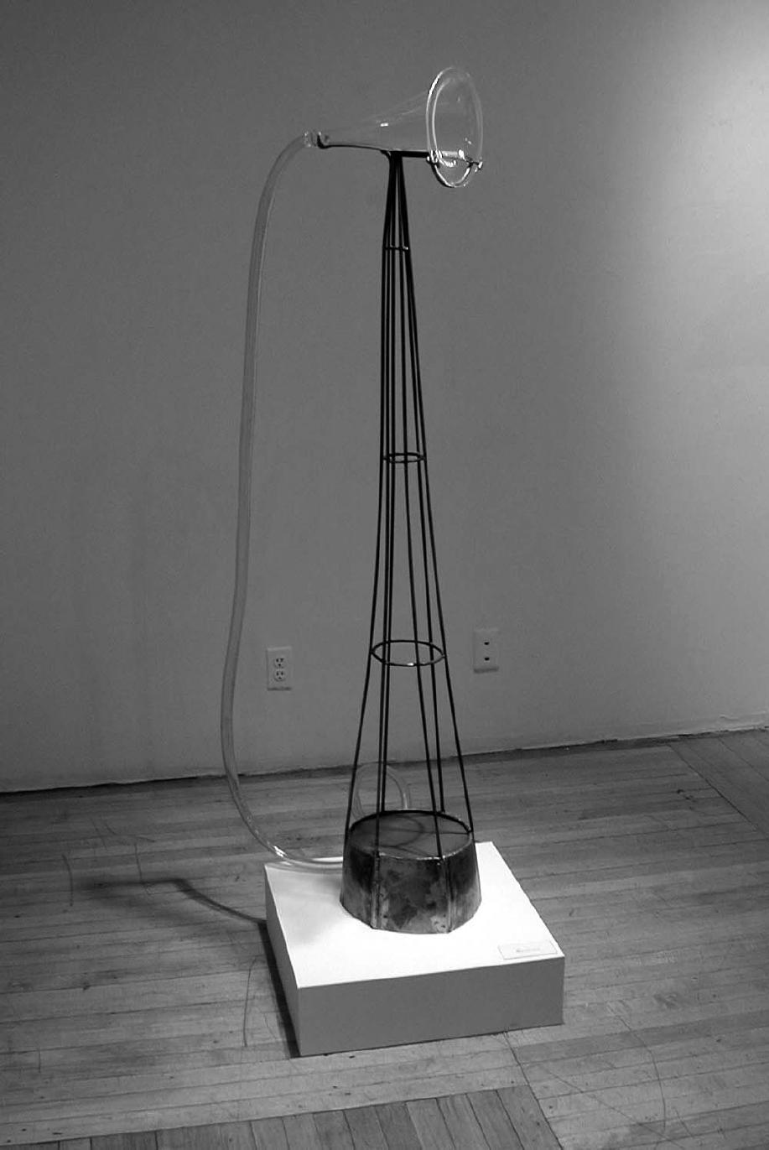 Base - part of the “Transistor Triumvirate”

Chuck McNally
508.947.3236

I was born in 1959, a product of a parochial school where nuns who freely practiced corporal punishment. My miseducation continued at the Museum School, where I began printmaking.

Art is about making.

The making of the art - the doing - is its own reward. It's useless. It has to be. Otherwise it's no fun to do.

Chuck’s work in drawing, painting, printmaking, performance, artist's books, mixed media & t-shirts deal with a variety of subjects, including religion, art history, autobiography and baseball.

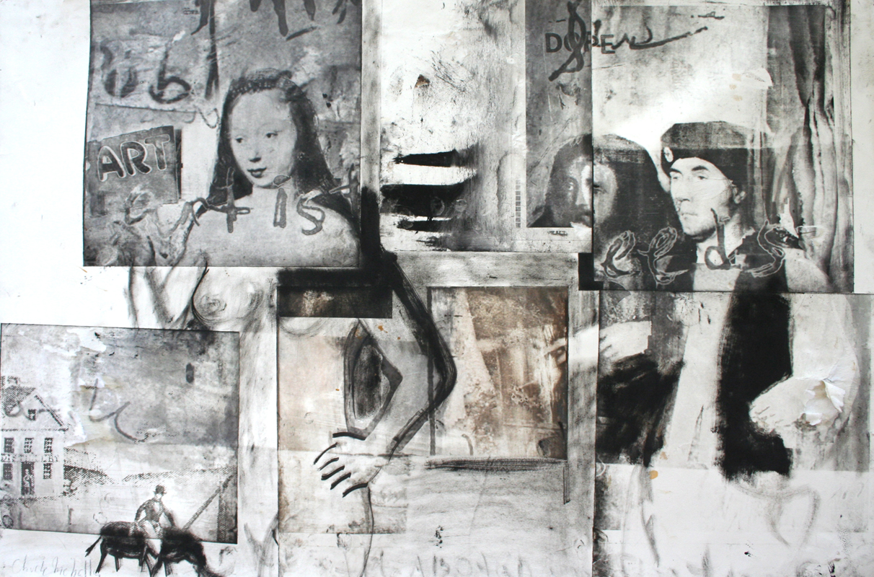

In addition to his mixed media prints, PURE will also feature a performance where Chuck, as a Jesus figure, will wash the feet of willing patrons.

L. Corey Hanley

I am a pathologist in training. I look into scopes a lot-- see a lot of slides. It's my job.

These are images taken of tissue samples slides. In this photographic series, there is no tissue represented – there is no disease, only the typically ignored, processing artifacts at the slide’s edge- where the mounting medium meets the air –

These artifacts are transient - resolving or fading within a few days.

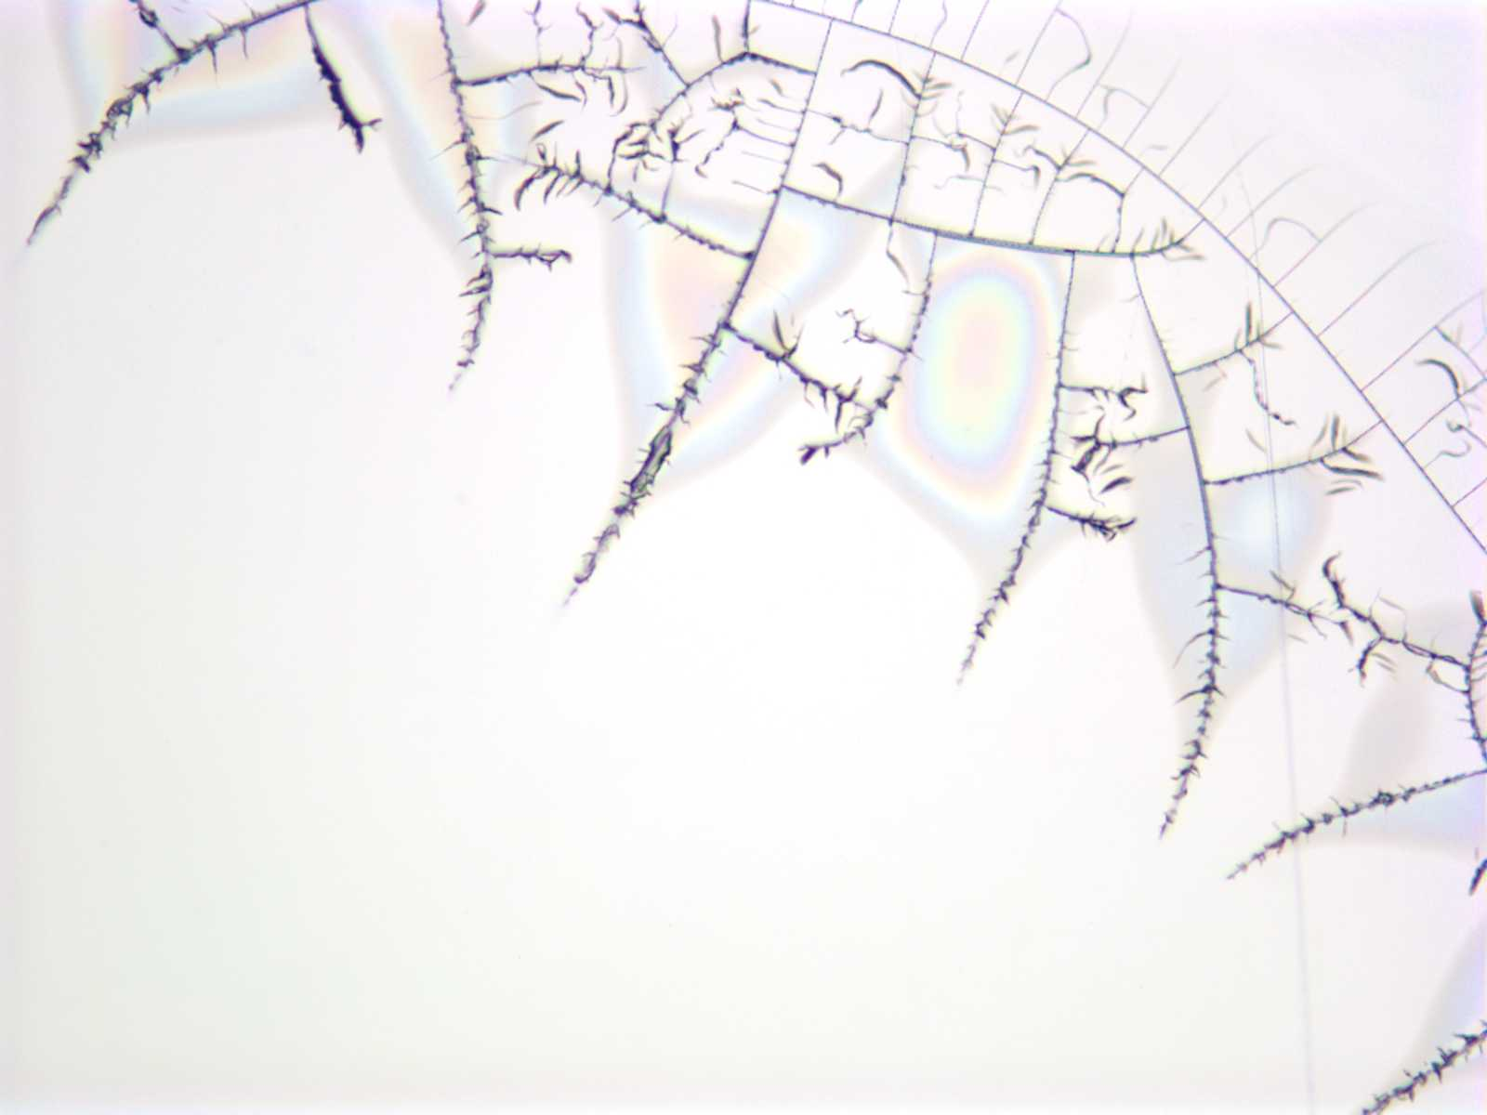
untitled

Dana Ross
www.fleshandbeauty.com
A collaborative photo installation with musicians Timur Bekbosunov & Leanna Primiani

Dana Ross's large-scale photographic images are kaleidoscopically recombined shots of plastic surgery operations. They explore the construction of beauty in the flesh and in our culture. His photoscapes show views of breast and body surgery. The details of cutting stitching, burning, skin and blood are woven together into geometric patterns that appear benign at a distance but troubling close up.

"I am investigating the paradigm of beauty in our culture. I capture images in the operating room where women are striving to attain an ideal. Often they are trying to achieve in the flesh what they have seen in photographs that are shot in the best circumstances and then retouched. I take this extreme manipulation of the flesh and explore classic constructions of
beauty in print by playing with repetition and symmetry. The kaleidoscope is the extreme working of these formal devices. By putting the two together I can play with what tantalizes us and scares us about our own thinking about beauty."

Dana gives thanks to plastic surgeon Dr. Robert Rey and these patients for supporting his vision and trusting him to photograph their surgeries. "The environment in the operating room is one of complete collaboration, trust and skill and I am honored to have been included in the team".

I am a photographic artist born, living and shooting in L.A. 50 years old. I lived as an Artist and Fashion Photographer in Paris for over 5 years. I was mentored by many Photographers and Artists including;

Eric Orr, Antonin Kratochvil, Phil Jones, Bob DeYoung and Tom Fresh.

My artwork has been seen recently in shows at;

Red House Gallery March 2006
drkrm Gallery October 2005
Focus on Aids, 2005
drkrm Gallery group show October 2005
Focus on Aids, 2004
Korean Cultural Center, Juried Group Show 2003
Frances Howard Goldwyn Gallery, LAGP Show 2003
Gascon Gallery, Solo Exhibition 2002

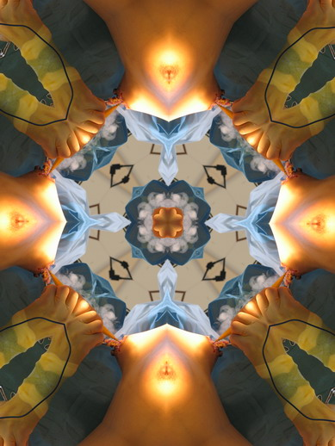
Debra Weisberg
debramon@gis.net

My work explores this issue: the tension to hold the center still before it appears to break apart into controlled disarray. It is about shapes shifting, appearing to be on the brink of morphing into another state by breaking down or rising up, a kind of entropy. I have created a series of "Constructed Drawings" using archival tape on mylar, The natural linear movement of the tape when repeatedly layered creates a tactile, sinuous weave, a bas relief effect changing shape and texture as it travels across the drawing: fixed and liquid, frenzied and tranquil. The result is psychologically reminiscent of the sedimentary layers of the earth that build up or gradually decompose over time.

Debra received her BFA from the Tyler School of Art, Temple University, Philadelphia, PA. She has shown her work in a number of solo and group exhibitions, including shows at the DeCordova Museum, Trustman Gallery, and Mills Gallery. Debra has been a MacDowell Colony fellow, recipient of a Mass Cultural Council Artist in Residence grant and several Somerville Arts Council grants. She also received first place from the Boston Art Critics for best museum installation. She lives and works in the Boston area.

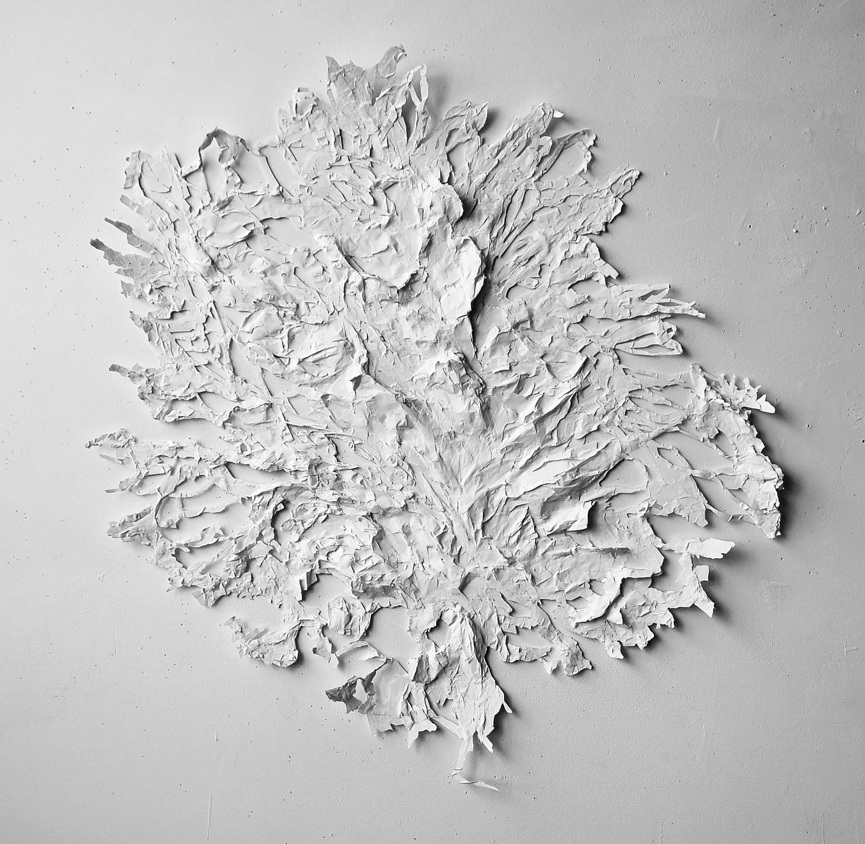
Untitled: Archival Tape on Mylar

Doug Ruuska
Ruuskado.com

The hidden aspects of the world intrigue me; there is so much of interest in the details and unnoticed beauty of the world all around us. I wish to bring these hidden aspects of our world into the light and surface so that we can look at then and perhaps think more about what there is that makes up the world beyond the surfaces that we perceive on a daily basis. Sometimes the subject is the purity of wonder regarding the natural world while at others my fancy is captivated by the beauty inherent in the forms from human interaction/contamination with the raw materials of the world around us

Mr. Ruuska has been photographing & sculpting representations of the world around him for 20 years. His first exposure to the darkroom was in the old basement labs of the Massachusetts College of Art. He has supplemented his trove of landscape photography technique by learning from world-class photographers at the Maine Photographic Workshops in Rockport, Maine coupled with extensive field work. All of the photographs were taken using a Nikon FM-2 manual SLR, supplemented by an Olympus C-2040Z digital camera. He most enjoys climbing into, over & under things in the quest for the perfect image to represent in one manner or another.
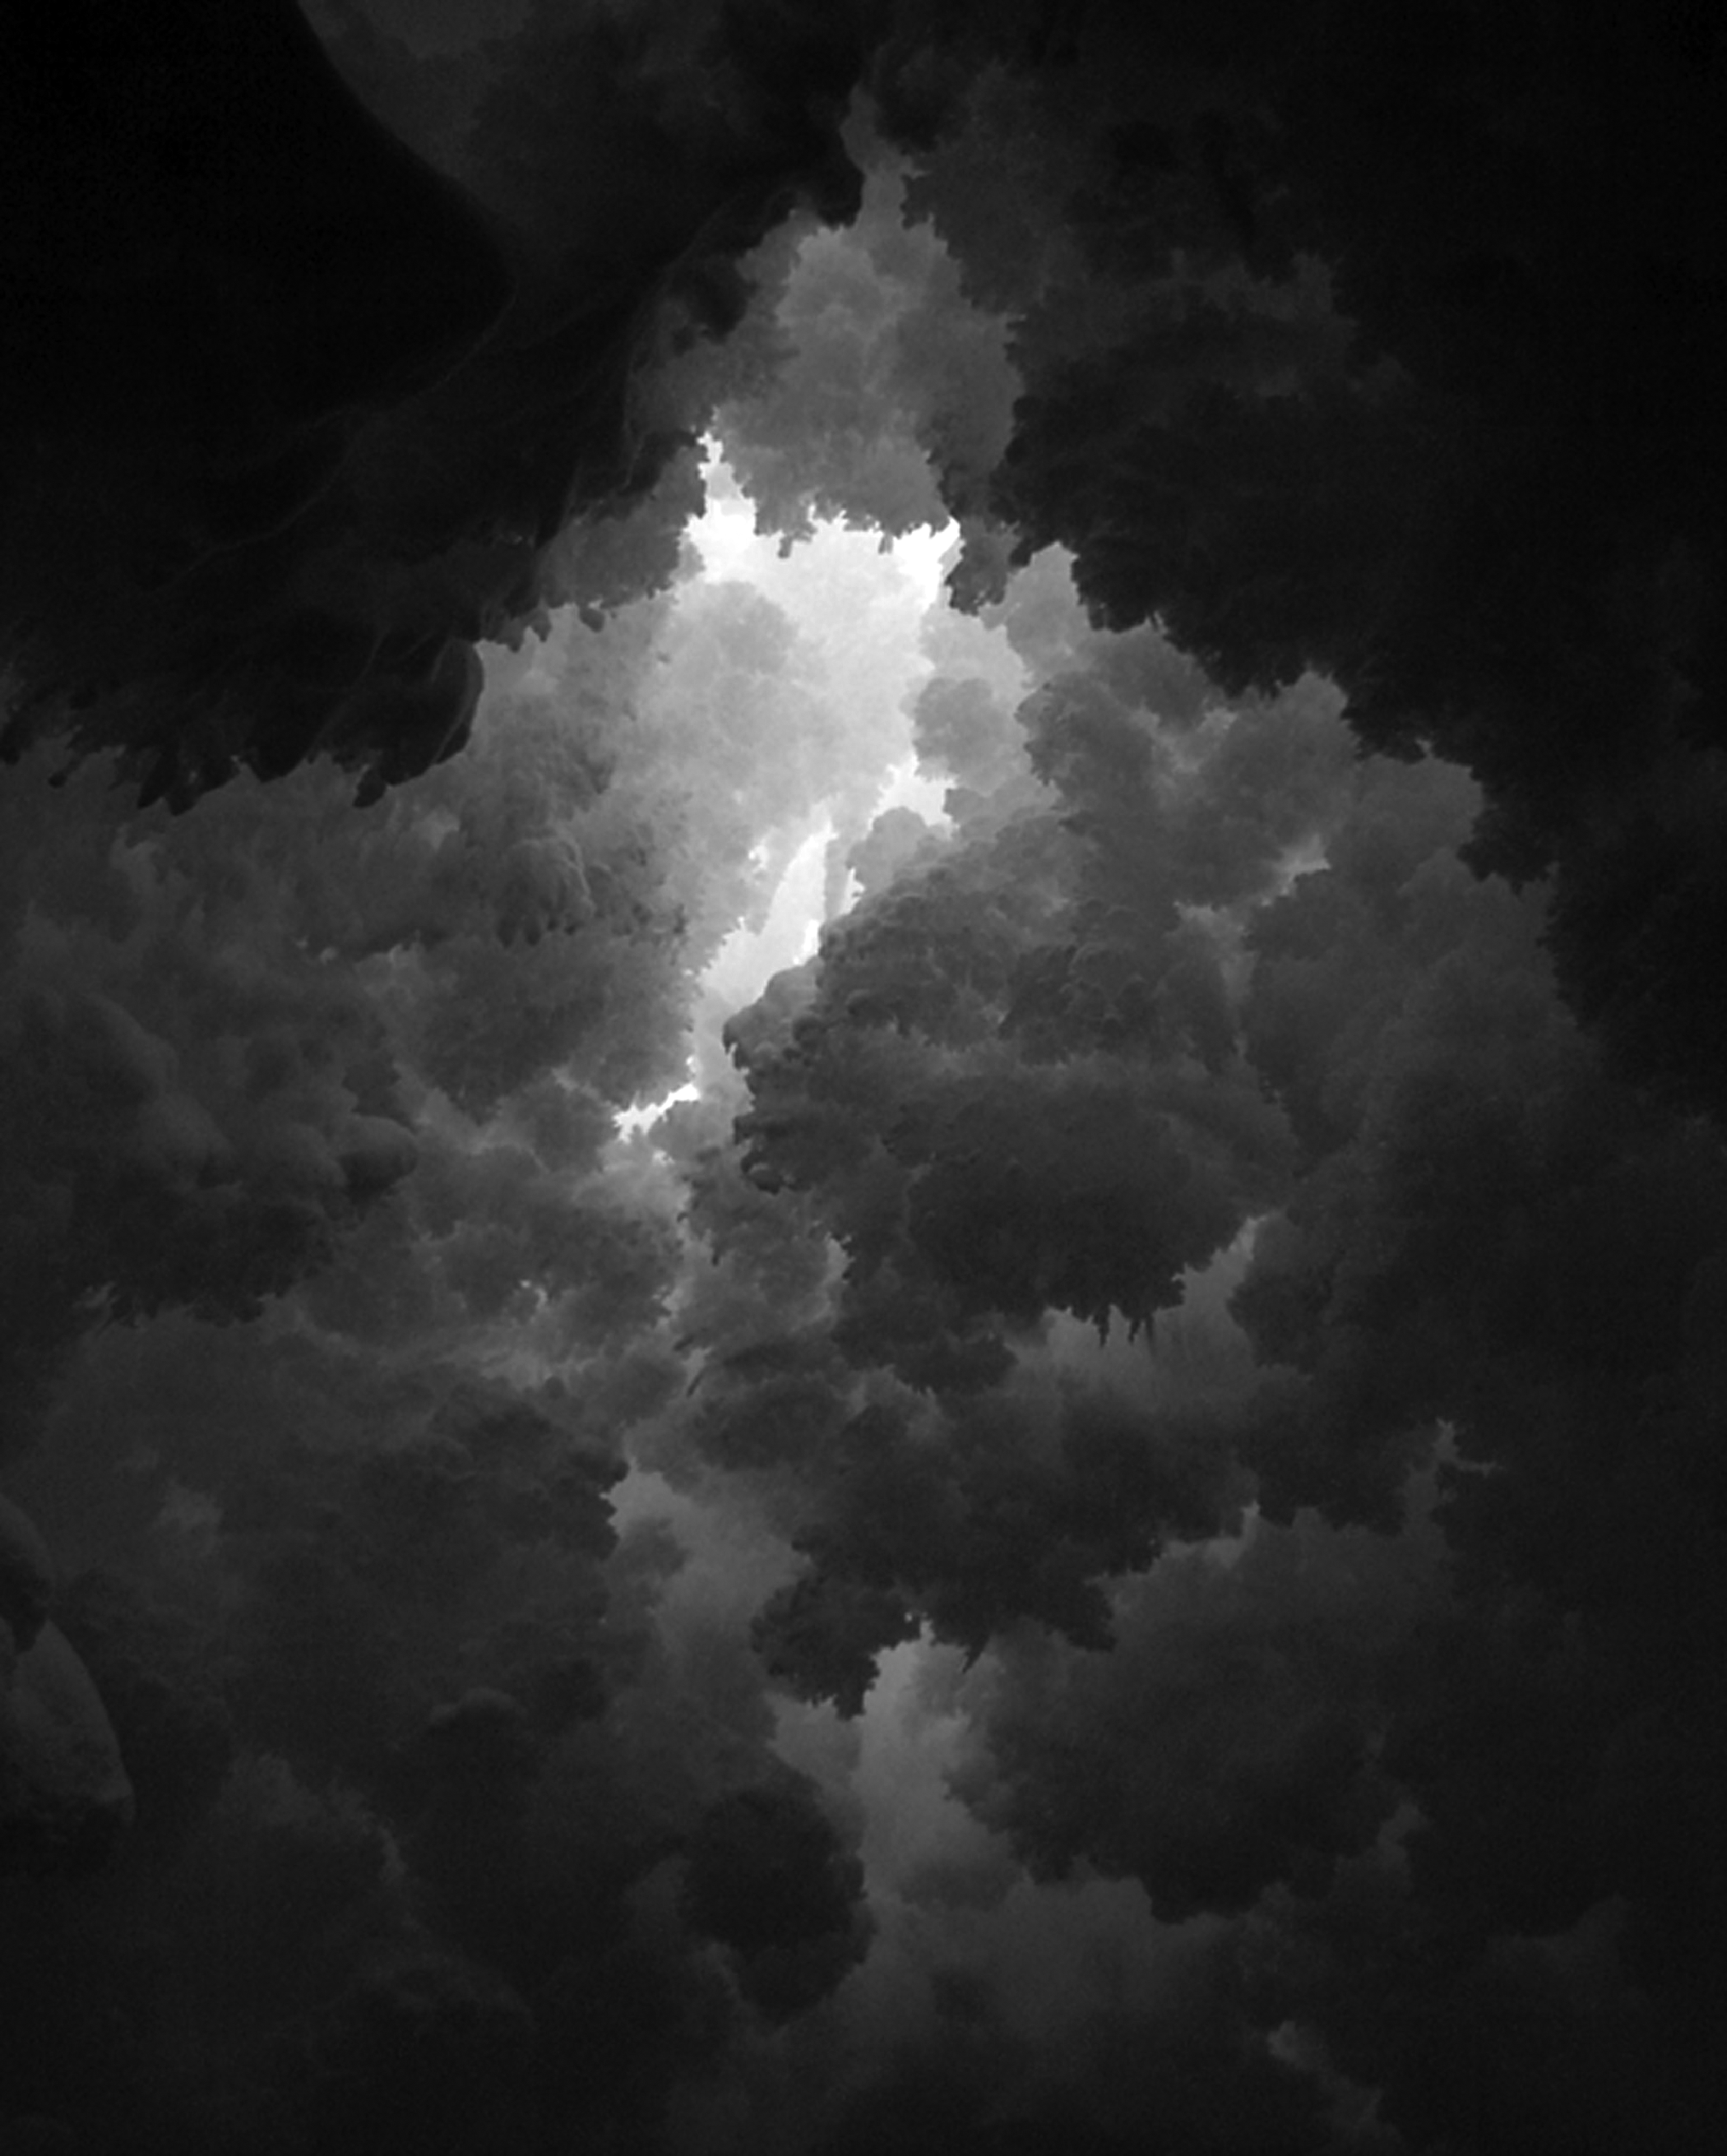
Ellen Chambers
gonetoofaragain@hotmail.com
PO Box 408, Homer, AK 99603

Regardless of the medium (print, sculpture, drawing) my work describes the degenerative (or memory) phase of the creative cycle as form approaches or reaches formless.

Ellen Chambers teaches printmaking at the University of Alaska Anchorage, has an MFA from Tufts/School of the Museum of Fine Arts, and has been an acupuncturist for over 20 years.

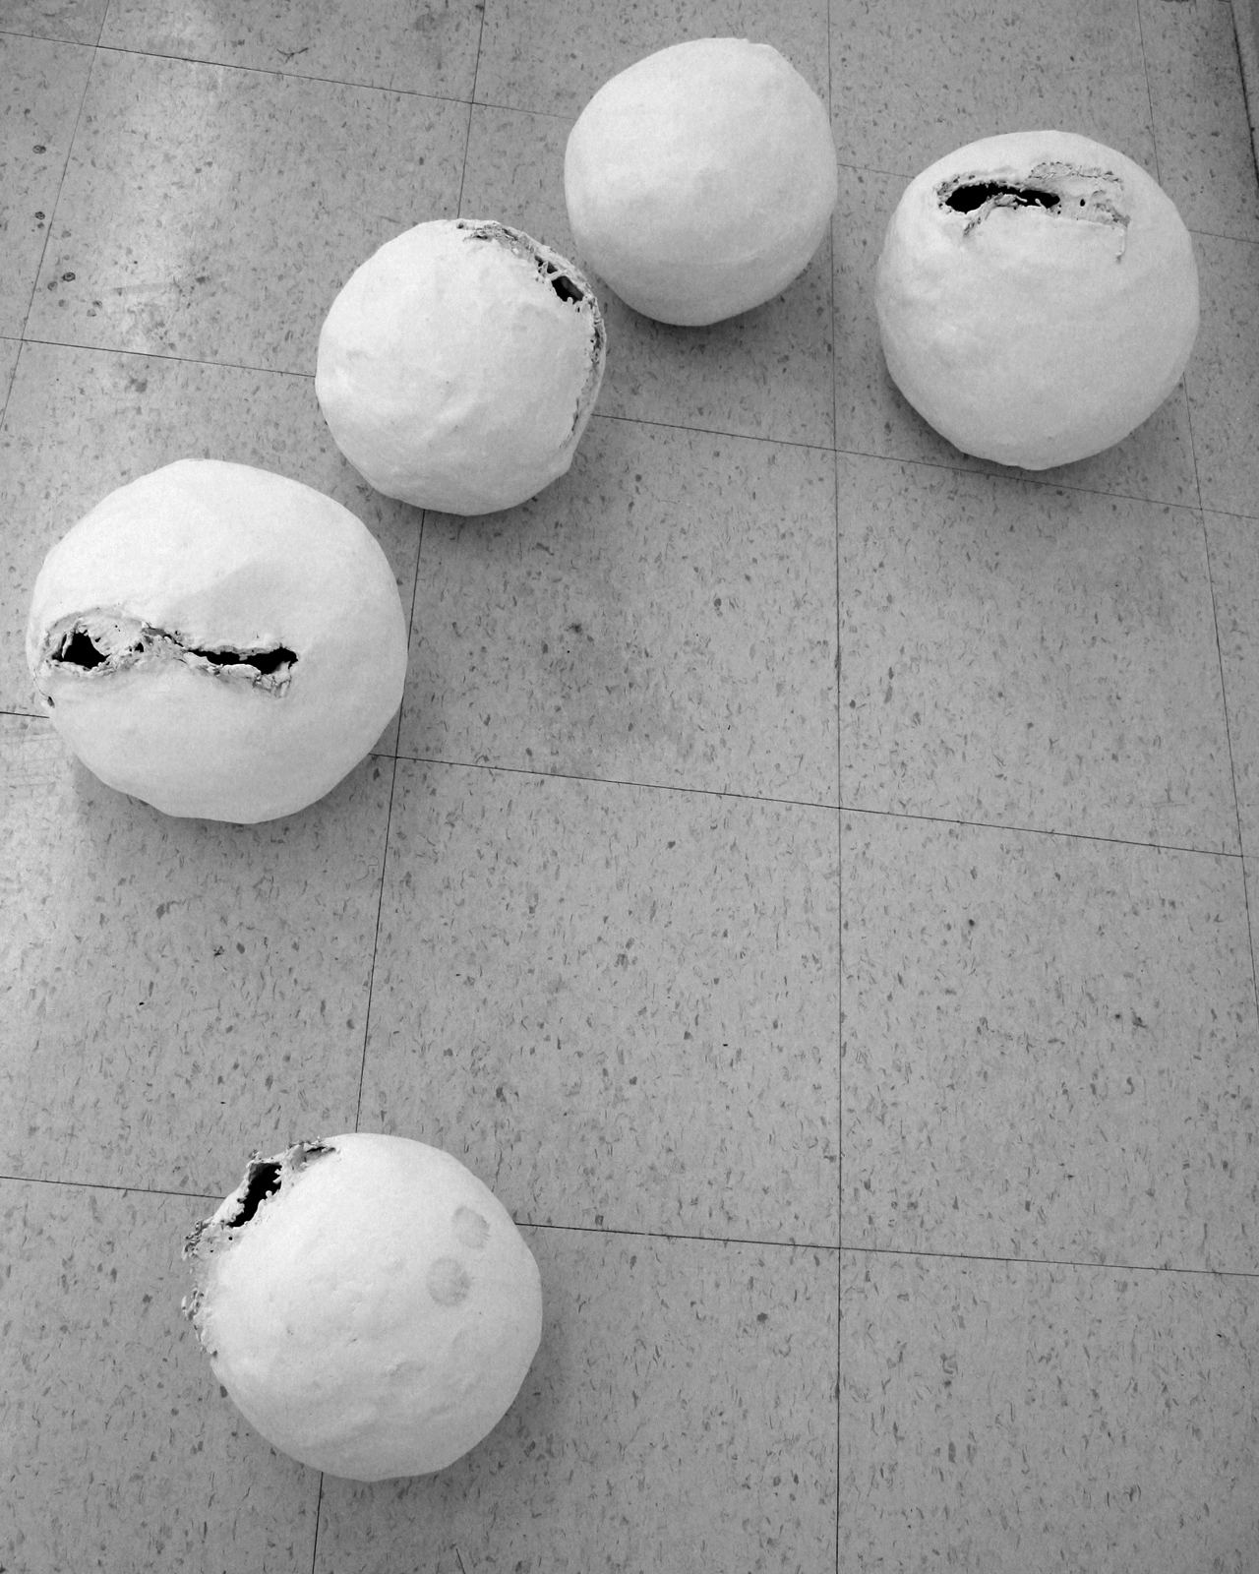
Untitled
Ellen Young
lnyoung@rcn.com

I often look at surfaces, indoors and out, and mentally clean them. I doubt that men suffer much from this affliction; I imagine they just mentally shoot things. Or maybe blow them up.

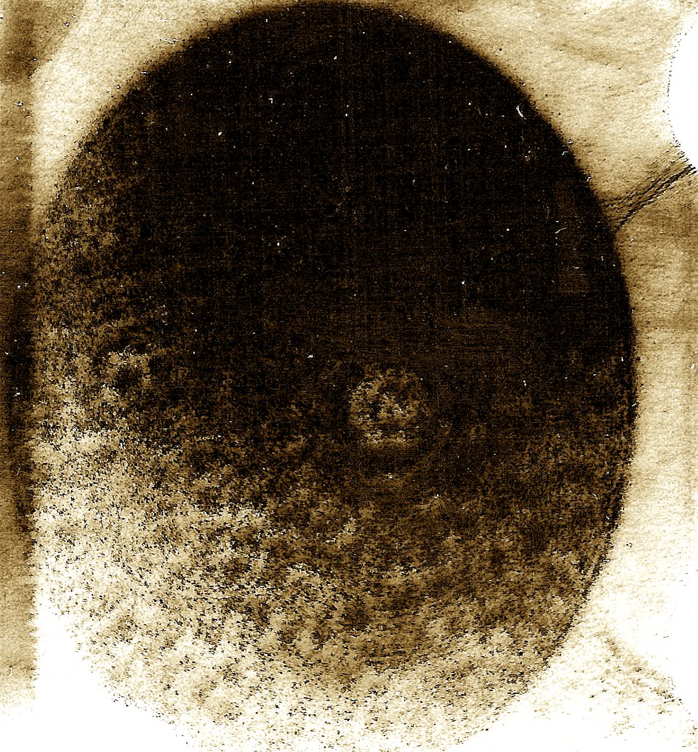

Empire S.N.A.F.U. Restoration Project
www.empiresnafu.org

S.N.A.F.U.'s constructions are a feverish mélange of dystopian technology, sexual obsolescence, & implied religion painstakingly assembled from dead animals, obsolete military hardware, broken toys and human excrement.

For a period of nearly twenty years, S.N.A.F.U. (who preferred to be referred to by the gender neutral pronoun “IT”) roamed the continental U.S., creating apocalypse shrines in abandoned buildings.

S.N.A.F.U. regarded the late 20th century as a great purging time; a time when the icons and taboos from all eras of human history, must be confronted and distilled into a single, all-inclusive, aesthetically cohesive spiritual temple of facilitated healing by way of inoculation.

More than a decade has passed since S.N.A.F.U.'s death. In that time The Empire S.N.A.F.U. Restoration Project has labored to restore S.N.A.F.U.'s work, ideals, and legacy.

S.N.A.F.U.’s work has been compared to that of Hieronymus Bosch, Francisco Goya, William Blake, Joseph Cornell, The Brothers Quay, Ed Kienholz, Mathew Barney, and Henry Darger.

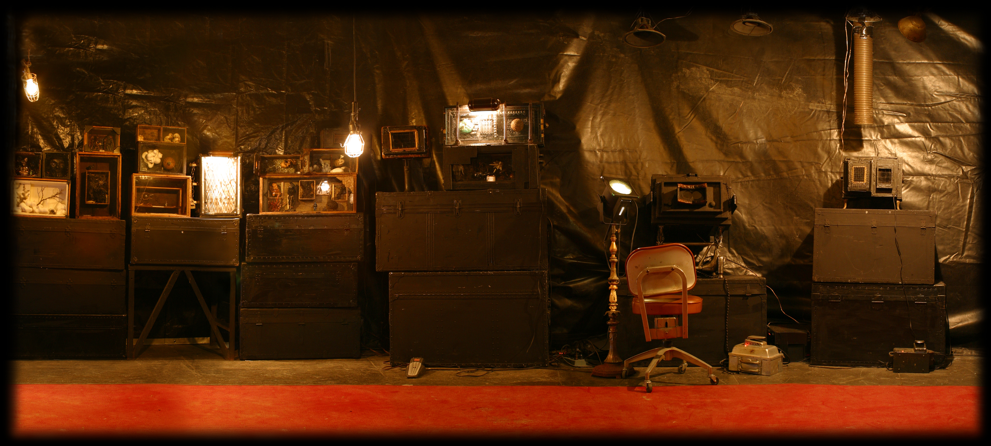
Installation at CVB Gallery 2003 Photo by Bibiana Medkova

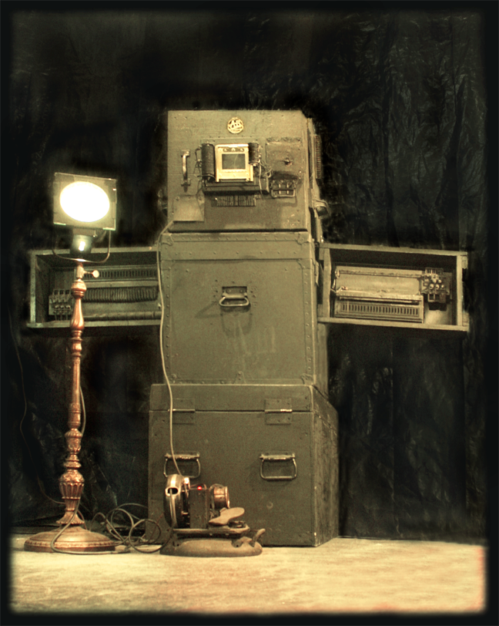
# 07088.086 [reticulation follicle] - roentgen equivalency stigma
Photo by Bibiana Medkova

Eric David Love
ericdavidlove.com

Love was born in 1977. In the early years it was clear by the skeletons and zombies drawing in crayon, primary black, and the lush colorful landscapes of battling sea monsters that Eric Love was cut out for something other than portraits and garden landscapes. Even in his preteen years we start to see the influence of renowned Swiss surrealist H.R. Giger in Love’s work. Most of Love’s portfolio pre 1996 consisted of monsters, creatures, super villains and heroes. It wasn't until the release of the Book of the Black Worm that we began to see a more emotionally driven content emerging in his work. Struggling with love, death and transformation, Love began to emerge from the dark shadows of humanity by reaching to incorporate metaphysics and occult influences into his art. This began a shamanic process to embrace what is now called Mystical Art. We began to see this in his series Zodiac Illuminus where we see images of the zodiac interfusing classical astrology, tantra, alchemy, cabala, numerology and tarot.

After ten years, the artist reaches back into the shadow and bring forth a new creation for the PURE exhibit. Something inspired by a grotesque dream/fantasy/nightmare. Facing humanities deepest instincts and desire fused with man’s paramount technological achievements. Addressing a future that is not only horrible but indeed soon to come if it hasn't already behind closed doors.

09/29/2006

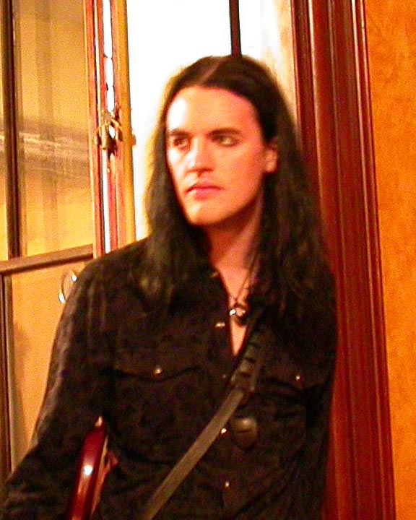
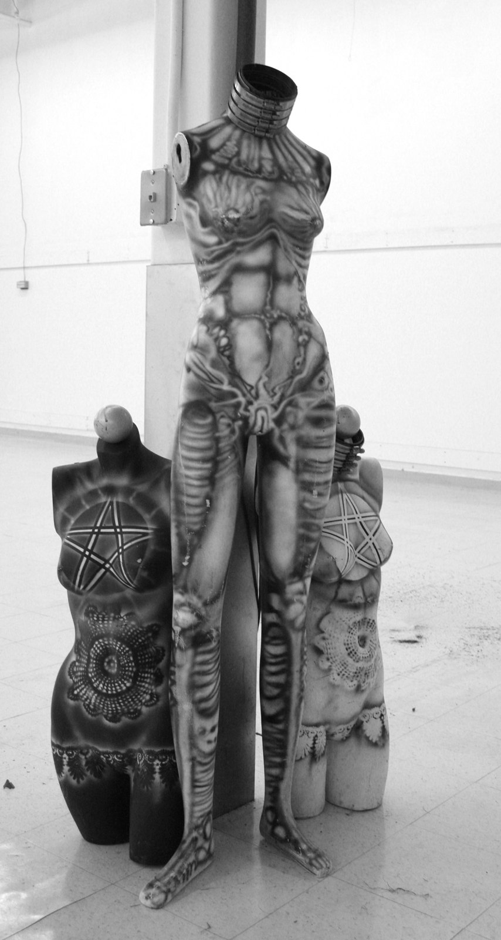
A.A. Amotorius Artificium
Gina Kamentsky
ginak@pixeltoon.com
www.pixeltoon.com

Gina Kamentsky is an artist who creates kinetic motorized sculptures in the somewhat chaotic and messy real world and animated films for the screen where gravity is a bit less of a concern. She has been an artist since 1959.

My work is not really pure, it's the opposite of pure, it's chaotic!

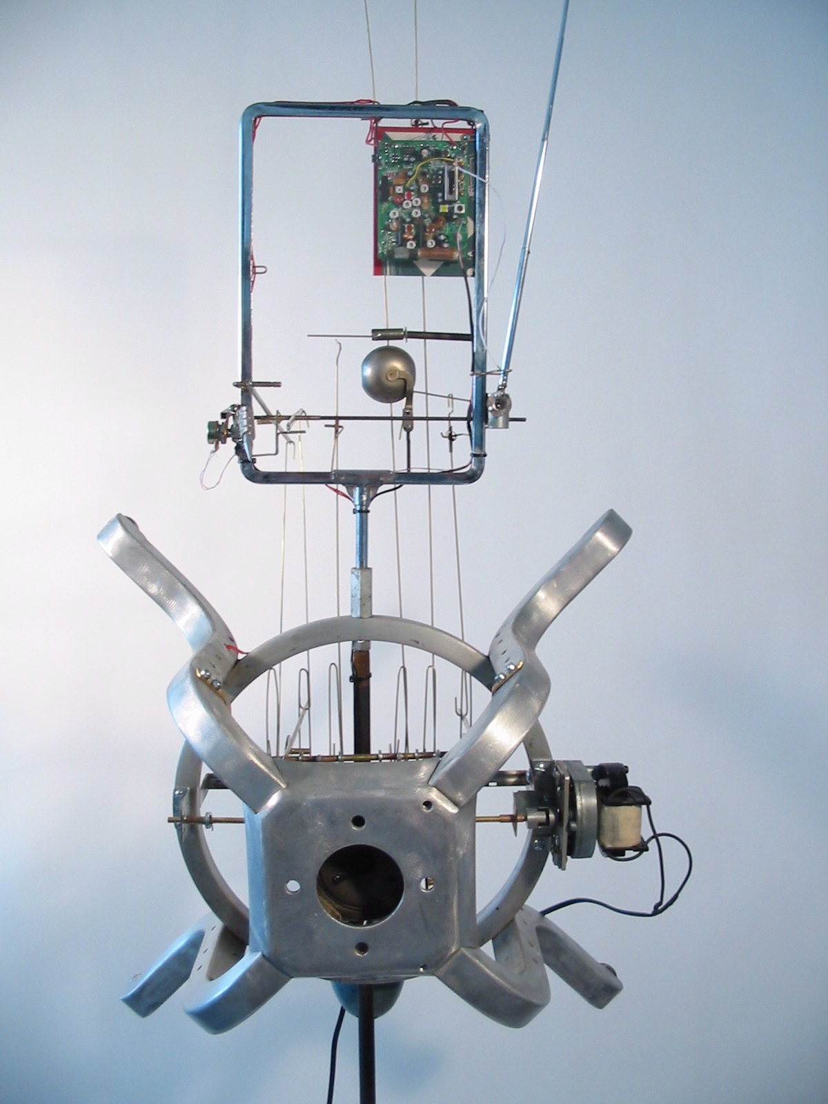
Radio Man

The Institute for Infinitely Small Things
www.infinitelysmallthings.net

A performance research organization whose mission is to invent and distribute new practices of political engagement in everyday life. Current research interests include: performing corporate language in public space, creating definitions of cartography, destabilizing consumer architectures, hacking maps and lying to people about art.

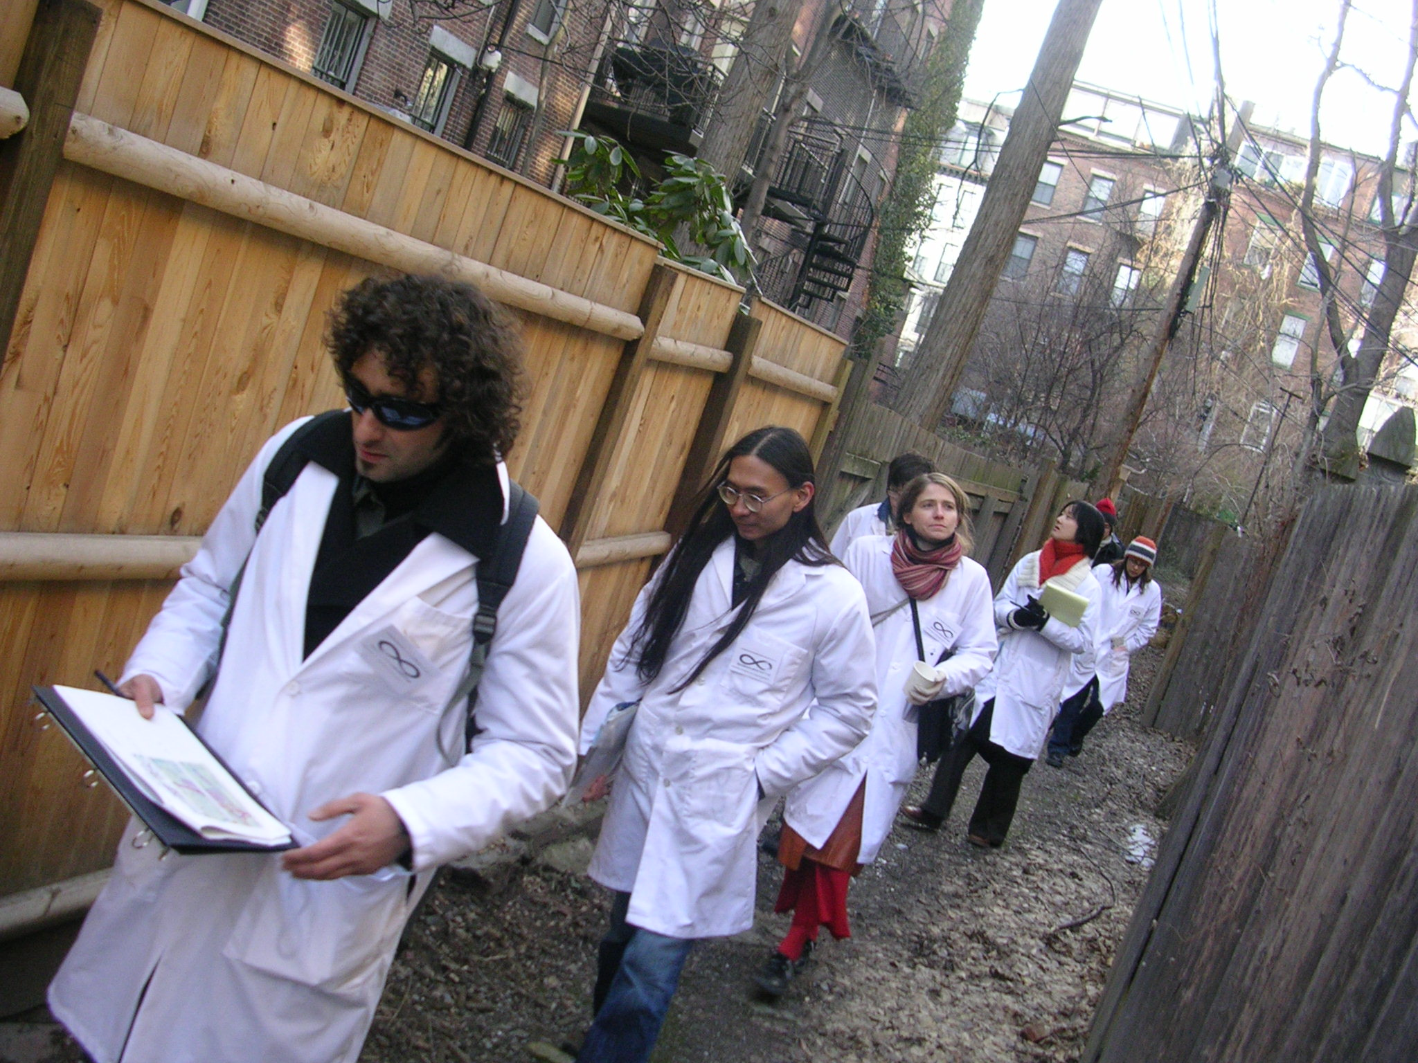

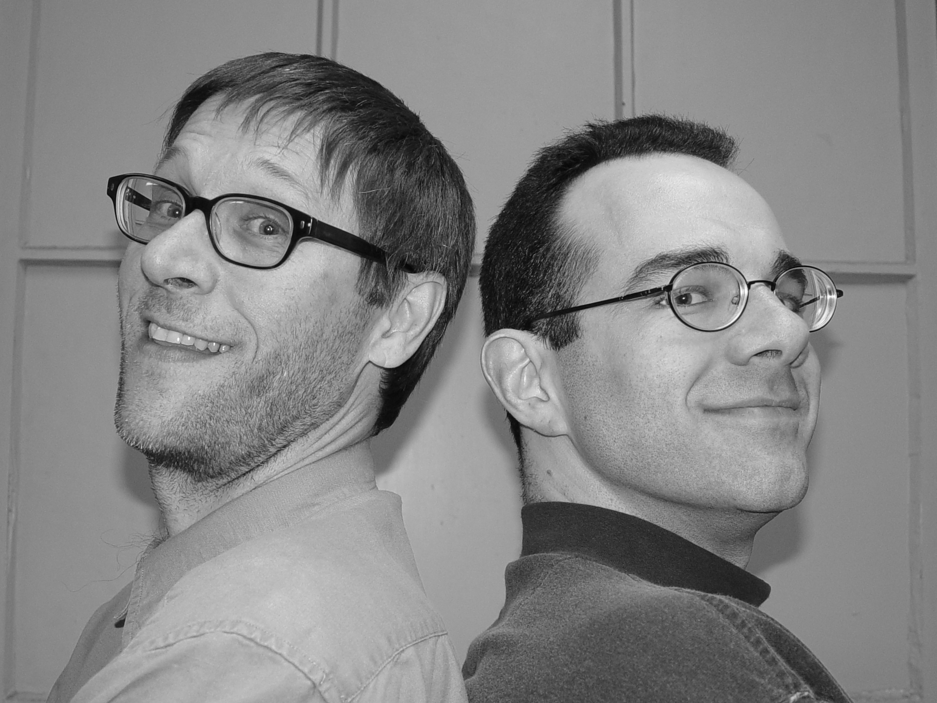

J’ambiance

J’ambiance is Rob Carbone on guitar & Joe Moreau on keys.

We will explore the Purity/contagion continuum via sonic performance.

We will start with a contaminated miasma of contemporary pop memetics; and, through a series of metamorphic sonic shifts, gradually find our tonal purity.

Our initial sonic bedlam will represent the state of cultural contagion that we all are subjected to on a daily basis. We will then settle down to a PURE soundscape of ambience.

Our premise is that the pop (i.e. commercial) world is interested in cleaning up "germ-ridden, contagious" memes that artists introduce to the culture at large.
Although our art may be seen as being not commercially viable, we argue that we present a higher purity than most commercial entities.

J’ambiance:
Add water- makes its own:

• water
- bilateral frequency differential
- symbiotic fortitude
- benign subversion
- passive aggression
- consciousness
- axiomatic ingenuity
- gaping psychic portal
- defense initiative
- entropy
- syllogistic synergy
- bedtime snack
- pelvic gyrations
- dormant conviviality
- thermodynamic induction
- metaphysical discourse on the pleasure principle
- localized portable epistemology
- solipsistic certitude
- filtered bits of reality (flavored to perfection)
- irrational agent of change
- whimsical irreverence
- fundamental scrutiny of delirium & euphoria
- hierarchical catalog of human desire
- memory-enhanced monologue (aided & abetted by your willful engagement)
- childlike exuberance
- better mousetrap
- mental mapping for inner journeymen (women too, of course!)
- calculus of sound
- Dadaist sense of responsibility
- pinheaded witticisms
- circumspective precipice
- flavor crystals
- dichotomy of competing sensations
- mirth-laden trance of wonder
- conceptual quandary
- ponderous path of curious meandering
- parthenogenesis
- Zen-like state of immersion
- bicameral fixation
- unsolicited flourish of emotion
- candied mental perturbation
- tantric diversion
- shiftless snap-on superiority
- telescopic pidgin of the mysteries swirling within
- mandibular displacement
- sensory cloak
- shifting planes of auditory reality
- parallel paths to lasting impressions
- phase-shift fantasies
- illustrious visions of the ideal you
- (________________) your concept here
- actual results may vary

Jamie Ciocco

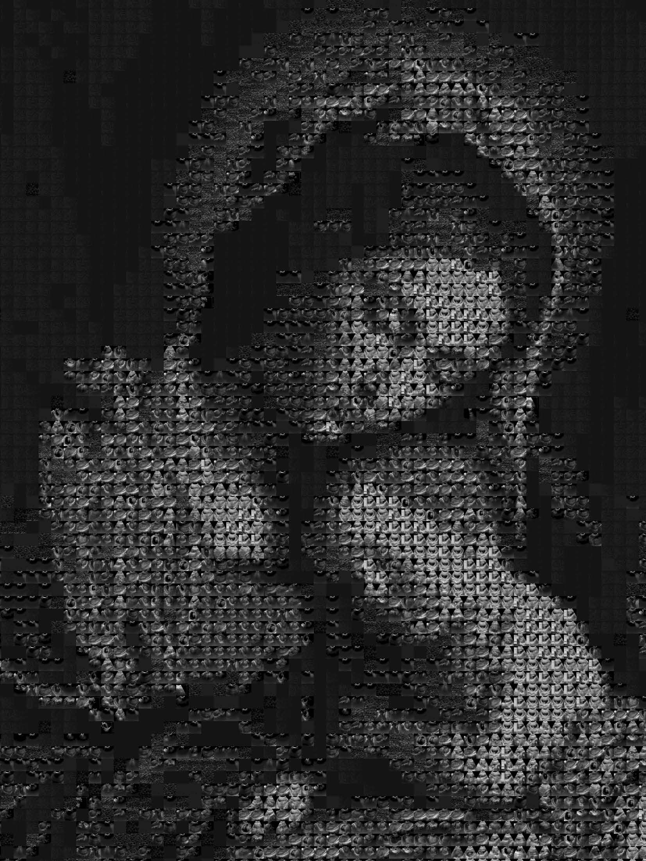
Mother and Sonogram

The image of the Madonna and child is an ideal of purity: maternal love, religious piety, and childhood innocence. During the Renaissance, artists began portraying the child in these paintings more realistically as an infant, and less like the “little man” of Medieval works, partly because of the very human associations and emotions that image evokes in the audience. Part of what gives the image its power is the nostalgic sense of the purity of youth that is gradually lost over time. The infant is the ideal of innocence, but is steadily corrupted by an imperfect world from the moment of birth onward.
Today, we can do the Renaissance painters one better by actually imaging the fetus before it has had any contact with the outside world: sonograms from ultrasound machines give us a stark, grainy view of this point of perfect purity. Yet these images no longer exist in the realm of religion or art, but instead at the intersection of medicine and technology. The fluidity of brushstrokes is replaced by the rigidity of pixels, and all natural color is removed. It’s not pretty.
This piece reconceptualizes a Madonna and Child, this one from the Renaissance painter Gentileschi (15631639), into a pixel-based image. Each pixel that makes up the image is itself a prenatal ultrasound sonogram. Clinical purity is overlaid onto religious purity, and technology replaces artistry, even in the production of the piece itself; computer algorithms were used to analyze and place each sonogram within the final image.
The result explores a truth about technology: it is what it is, which is always less than what we make of it.

About the Programmer/Artist
Jamie Ciocco got his undergraduate degree in English Literature with a focus on contemporary American poetry and Shakespearean drama, then promptly moved on to a position as lead multimedia programmer for a company that produced medical education CD-ROMs and websites. Jamie quit his job after getting a position as resident drama tutor at Harvard, where he spent seven happy years overseeing a couple hundred different shows, writing ridiculous songs for such provocative events as Drag Night, and designing an on-line facebook nine years before he realized he should have turned it into a billion-dollar company. He also soon found himself freelancing by programming medical education courses for a second company. After he left Harvard and finished his freelance job, he spent some time developing his website (http://trendy.com) with absurd games and yet more ridiculous songs, then began freelancing for yet another company, producing medical education CD-ROMs and websites. For the first time, for the sake of this piece, medicine, technology, and art have finally decided they can all get along.
artist: phi [ in collaboration with jennifer e. rosselli ]

age: 1.618

birthdate: NA

birthplace: pre-eternity

height: [ ref. age ]

weight: [ ref. height ]

shoesize: 1+1+2+3+5+8+13

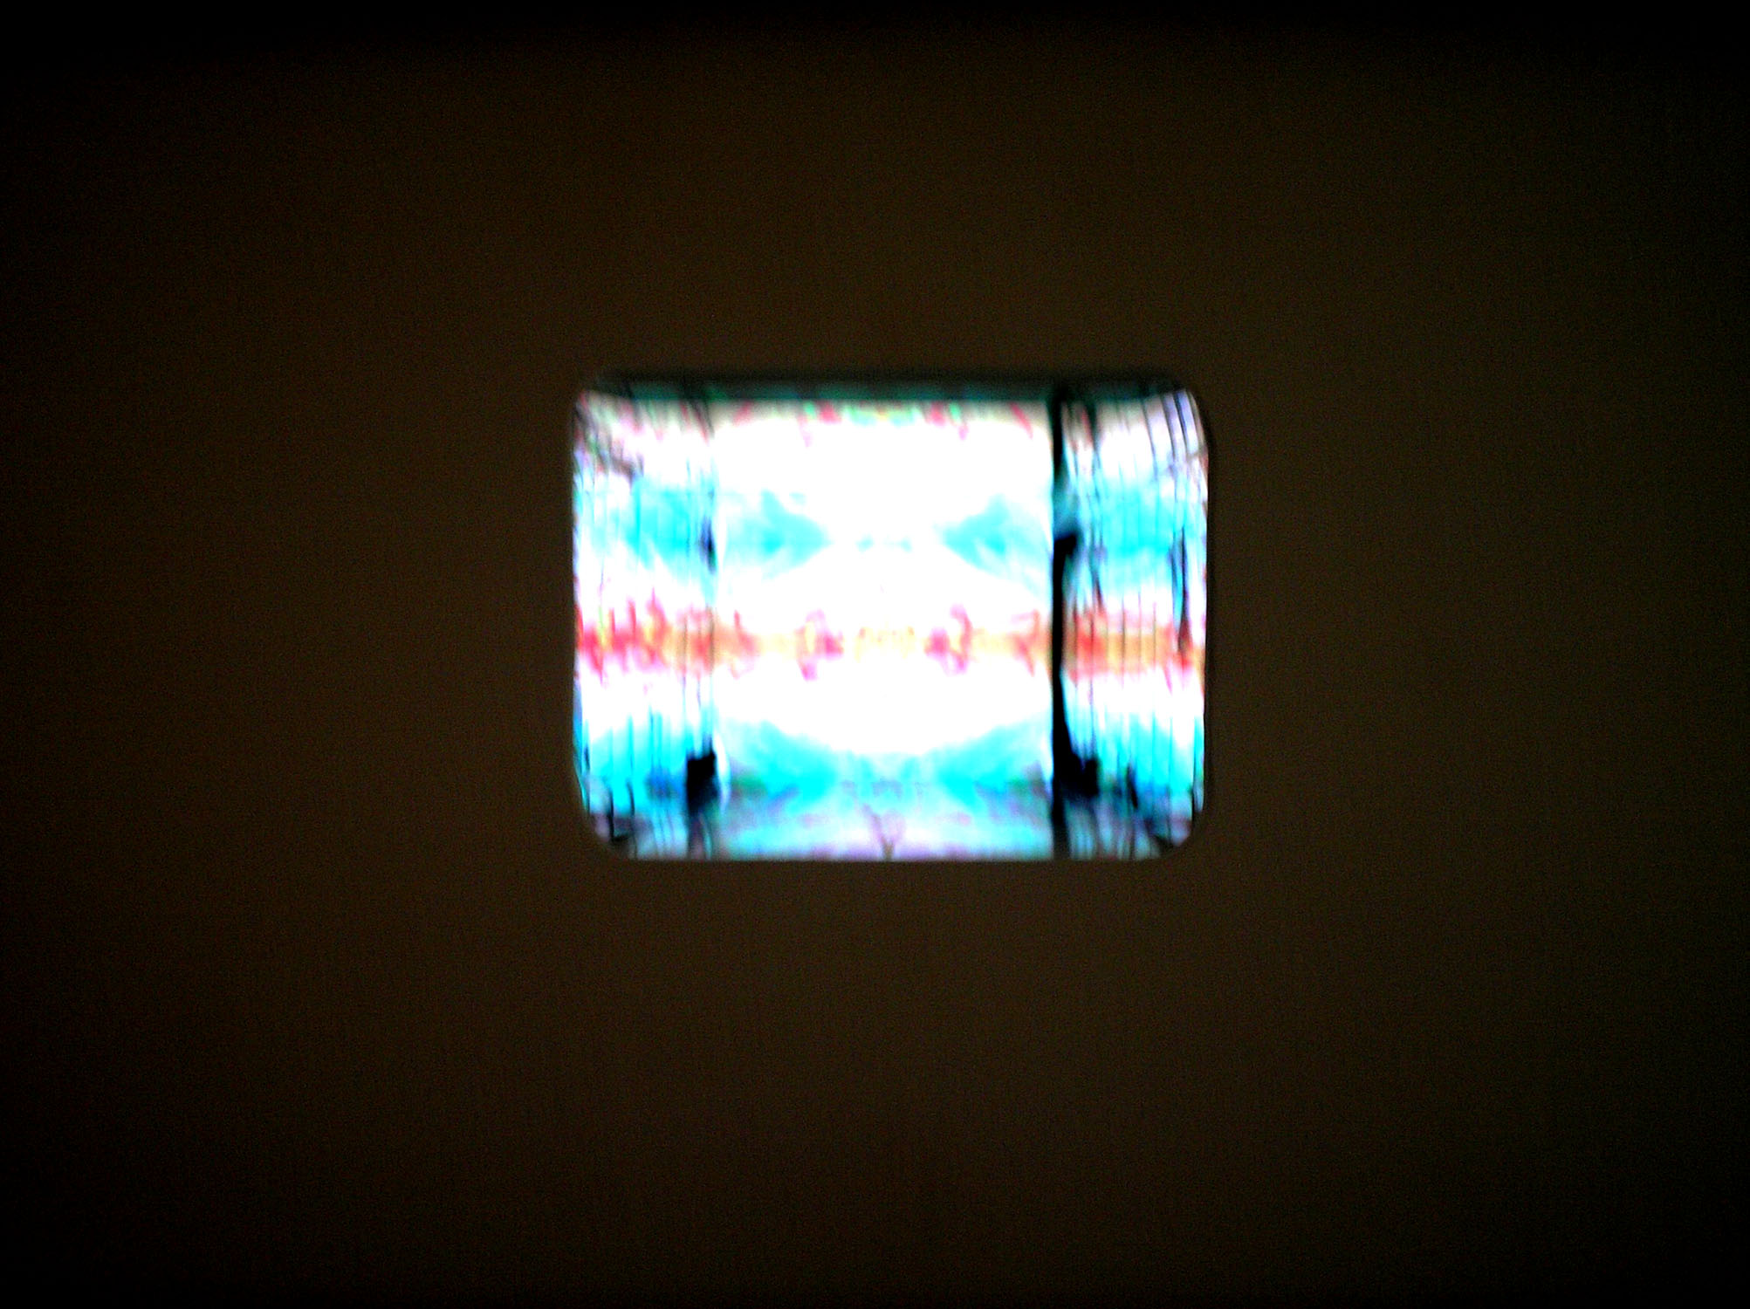

bio:

visible but rarely seen, phi inhabits all that is hidden and revealed. viewed by scientists, phi embodies a measurement encompassing all that we see with our eyes. some truth claims that phi is a veil that spreads over an immeasurable taste of inconceivable existence which was born before birth and lives on after everything dies. The secret of phi is that phi is the Secret.

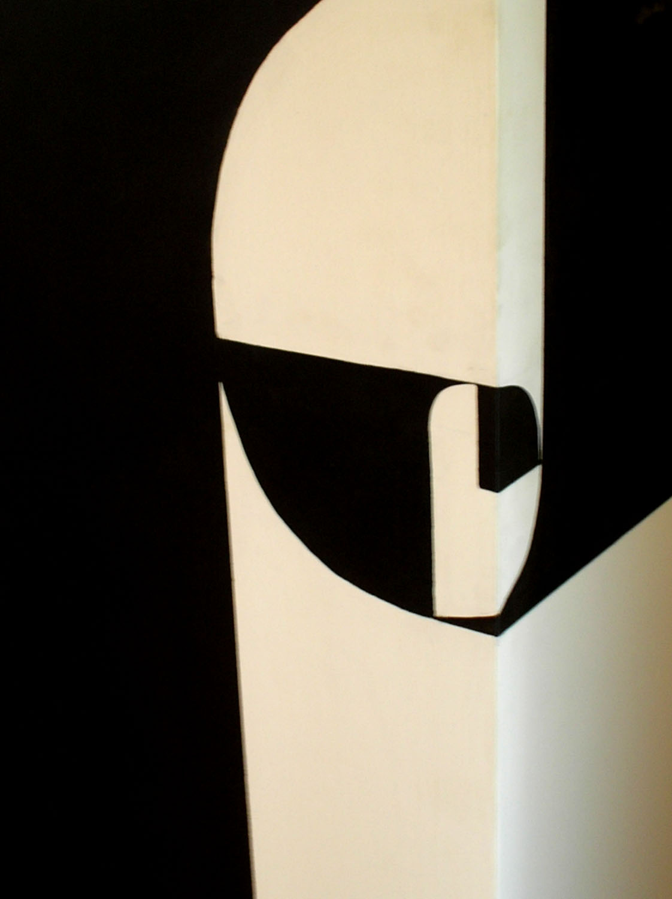
Jennifer Cooper

If Jennifer Cooper were a deity:
- New York City / its environs would be the heavens
- jennifermailbox@yahoo.com would be the power of prayer

[ ]
The relationship between the individual and society as one of fear, mistrust, and mutual self-protection.
Implicit and explicit barriers to self-expression.

DRAFT:
The HPV Vaccine and You:
Frequently Asked Questions
Explores protectiveness towards children and the difficulty of establishing a consensual prioritization of dangers.
A celebration of democracy and community.

Jerry Russo
617.327.7907
www.jerryrussophoto.com
russo@jerryrussophoto.com

White Cube Project

The White Cube Project is an investigation of space, transformation, isolation, and expectation. It is an examination of the relationship between art and exhibition space in which an attempt is made to reveal a unique and unseen moment in the life cycle of the gallery. Not when art is being displayed but when empty and between exhibitions is where I have discovered an energy that is inherent to the gallery space itself. It has become a time when all of the pretensions, traditions, codes and aesthetics of the gallery are challenged.

When I am viewing an exhibition in a gallery, the space is clearly defined: where I stand to look at the work, the art on the wall, the white space around the art that allows me to see where one piece ends and another begins. The lighting, freshly painted walls, and aura of the preciousness of the artwork enhances the calculated drama of the experience. In some cases, the grandeur of the space endows the artwork with greatness. Clearly, the gallery is transformed by each exhibit, malleable and forever changing, defining and defined by the artwork within. This is the experience of the public; this is our knowledge of the gallery. I have had the opportunity to capture a rare moment of transformation and to reveal exhibition spaces in a brief bare-bones state. An experience that feels like peering in on a secret ritual that has been, up to now, hidden from public view. The empty gallery, void of artwork, reveals a distinct vulnerability. The feeling of isolation and loss in this empty place where feelings and memories linger like a phantom limb struggles with the feeling of expectancy, a rebirth about to happen at the moment when a new exhibition is installed. There exists a very different sense of grandeur, of preciousness defined by the architecture itself.

Ultimately the gallery demands to perform its function; and you and I enveloped in the space, become the art and are thus forced to examine ourselves. It is in this moment between one body of work being removed and another installed that is most illuminating. It is a time of contemplation, introspection, and raw beauty when the gallery returns briefly to its inherent self; it is during this time that I photograph.

EDUCATION
Tufts University, BFA 2002
School of the Museum of Fine Arts Fifth Year Program 2002
School of the Museum of Fine Arts Studion Diploma 2001

Exhibitions

Faces of Boston, City Hall, Boston, MA 2006
Borowsky Gallery, Philadelphia, PA 2004
Museum of Fine Arts, Boston, Traveling Scholars Show 2003
EADS Symposium, Munich Germany 2002
Polaroid International Photography Exhibition 2002
School of the Museum of Fine Arts Fifth Year Shoq 2002
Contemporary Arts Colelctive Gallery, Las Vegas Nevada 2002
Copley Society of Boston 2002
Boston Architectural Center 2001
Yamawaki Gallery, Lasell College, Newton 2001
Tufts University Gallery, Medford 2000
Oni Gallery, Boston 1999
First Expressions Gallery, Boston 1998
Thread Waxing Space, NYC 1997

PUBLICATIONS
“P” Magazine, Polaroid Corporation 2002
Preview Magazine, Museum of Fine Arts, Boston 2000
John Singer Sargent Catalog, Museum of Fine Arts, Boston 1999
Art News Magazine 1999
Institute of Contemporary Art, Boston 1997

Collections
Polaroid Collection
Singer Editions
Wellington Management
John Kane III, New York

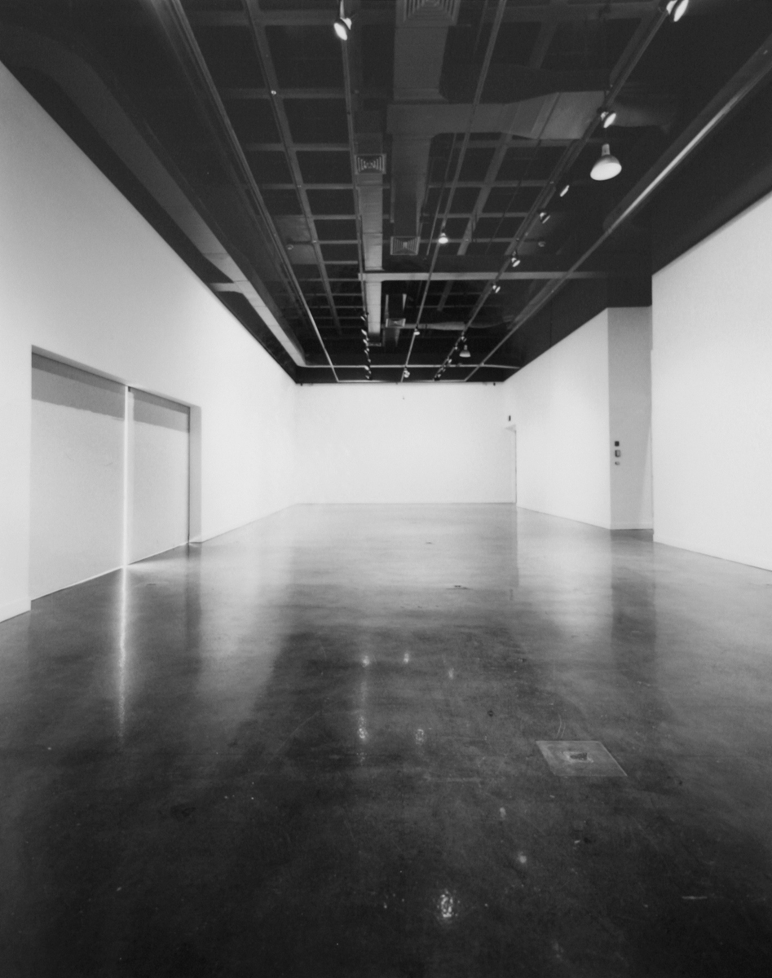
List Gallery, MIT
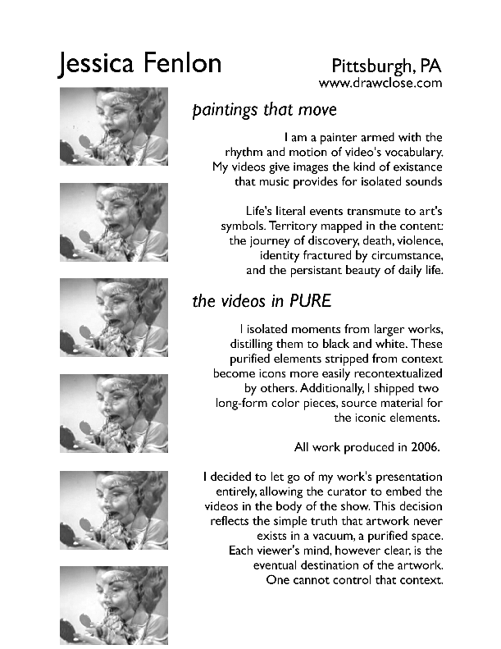
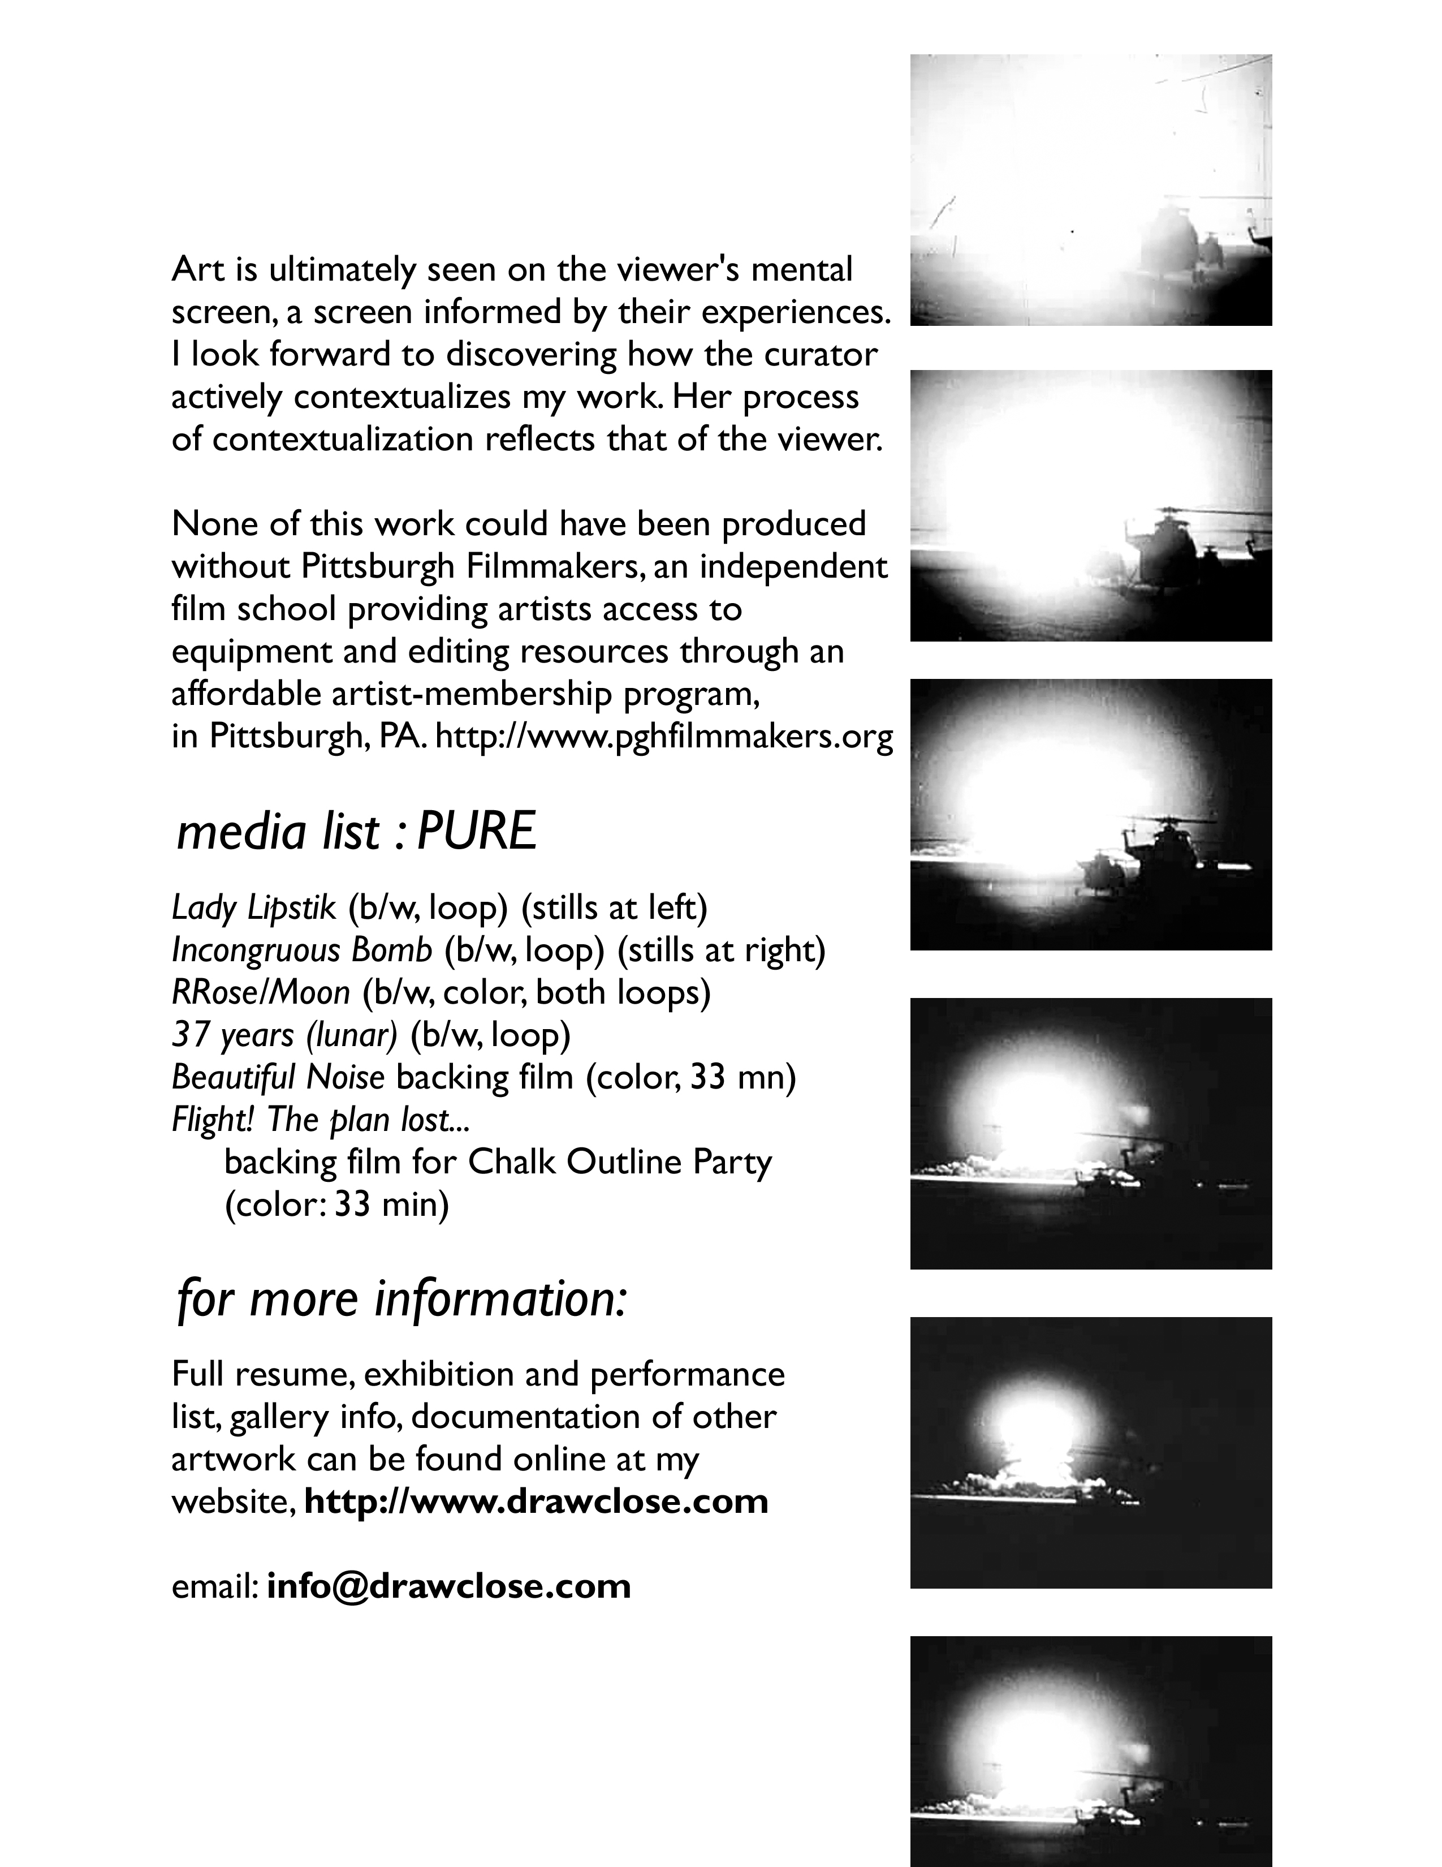
Joshua Pablo Rosenstock
www.joshuarosenstock.com

Joshua Pablo Rosenstock is a multimedia artist and musician. Although
presently based in Boston, in previous incarnations he has worked and lived in New Hampshire, Providence, Oakland, and Chicago. His current artistic obsessions include autonomous flocks of noisy robots, propaganda stencils, everyday objects that talk back to you, and video games for improvising musicians. He is a professor of Interactive Media and Game Design at Worcester Polytechnic Institute.

Sound Parasites, by Joshua Pablo Rosenstock with Marilyn Fontenrose.
These portable, wearable sound robots are designed to feed off the verbal energy of other performances or media works in the show, while disrupting their sonic and narrative integrity. They can be read as passive media consumers, unquestioningly digesting the information they receive and aping it back in incoherent form. On another metaphoric level they are "bugs", providing an endless, but glitchy and ultimately useless, stream of audio surveillance of their surroundings.
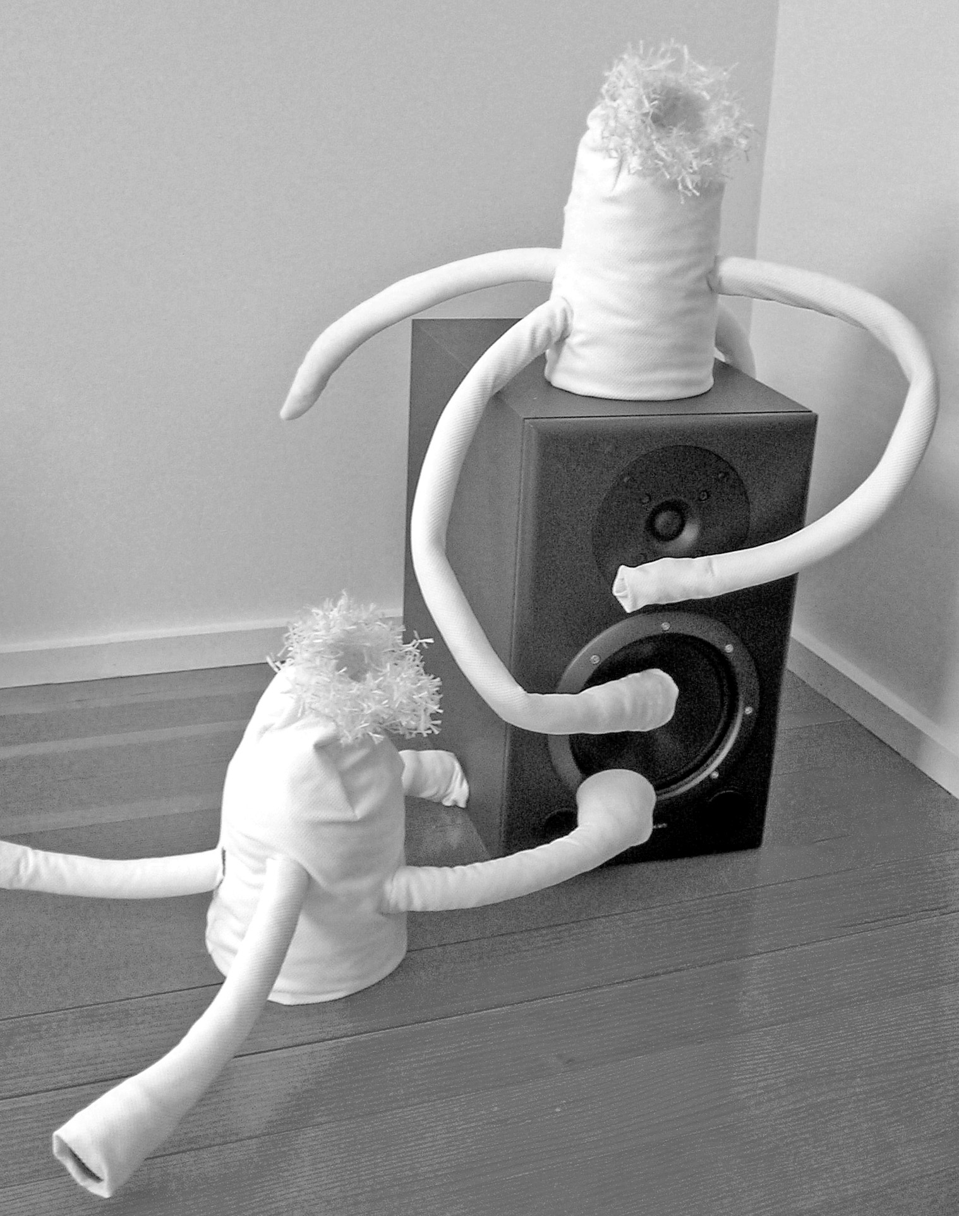

Judith Leemann
www.judithleemann.com

Judith Leemann is an artist, writer, and educator invested in creating objects, texts, and environments that interrupt habitual thinking. She frequently works in collaboration with others and with system-based methods of inquiry, poaching structures from outside of the arts in order to create things that don’t behave as proper art objects. She received a BA in Interdisciplinary Studies (’93) at the University of Virginia, where she also completed a Fifth Year Fellowship (’94), and a MFA from the School of the Art Institute of Chicago (’04). She has had recent exhibitions at the Betty Rymer Gallery and at the Lill Street Art Center, both Chicago, and taught as a visiting artist at the School of the Art Institute of Chicago.

I am contributing a prepared projection screen to the exhibition. Prepared with an abraded pattern of outward growth – characteristic of cities, bacterial colonies, curiosity. A species of cellular automaton programmed for me by Cosma Shalizi, formed by a stochastic process of constrained additions building out from a central point.

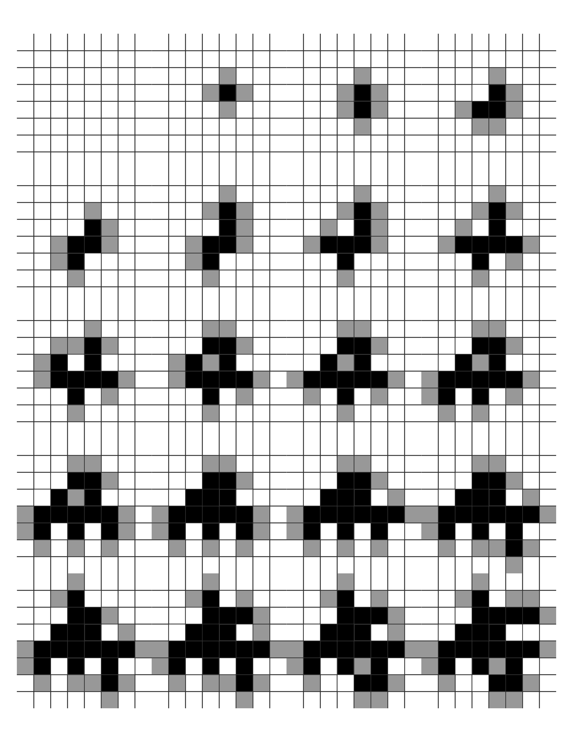
Judith Leemann, prepared projection screen, 2006
abraded black-out cloth and found object
60 x 50 x 12 in.
Juliet Schneider
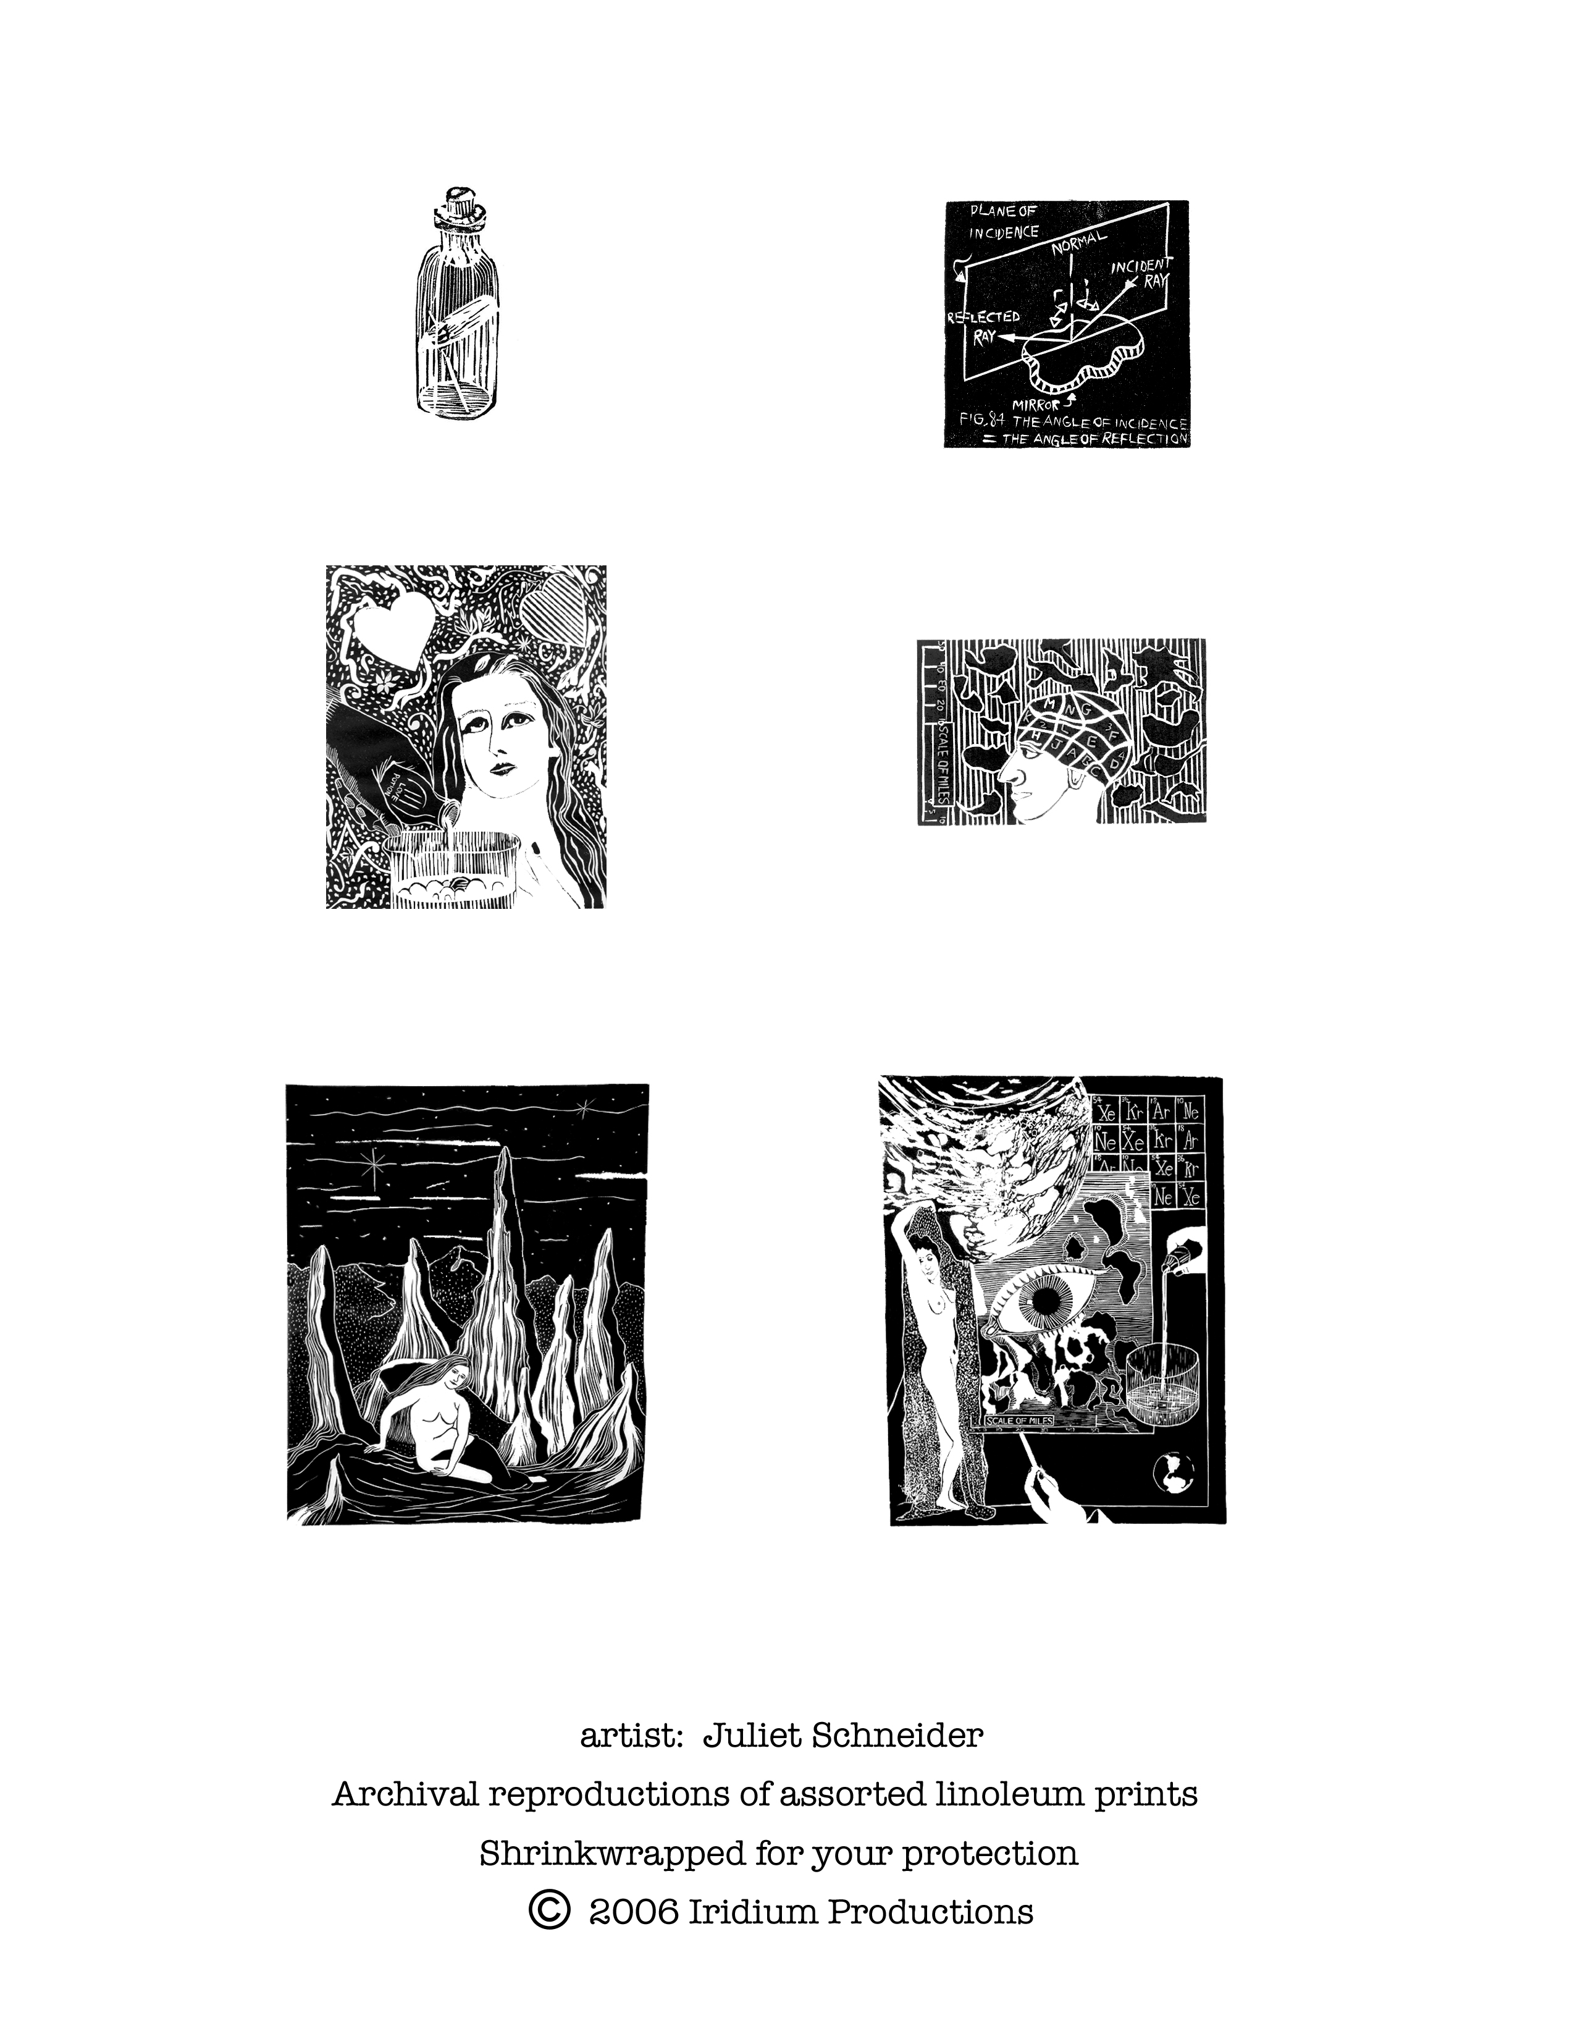

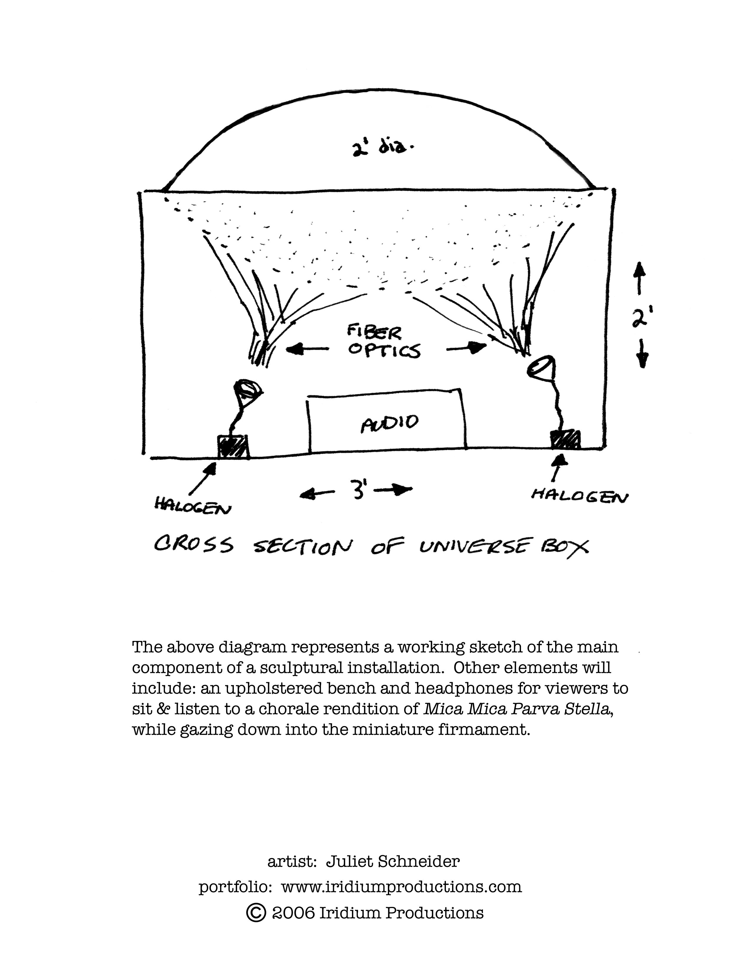

Karl Cronin
www.carlkronin.com

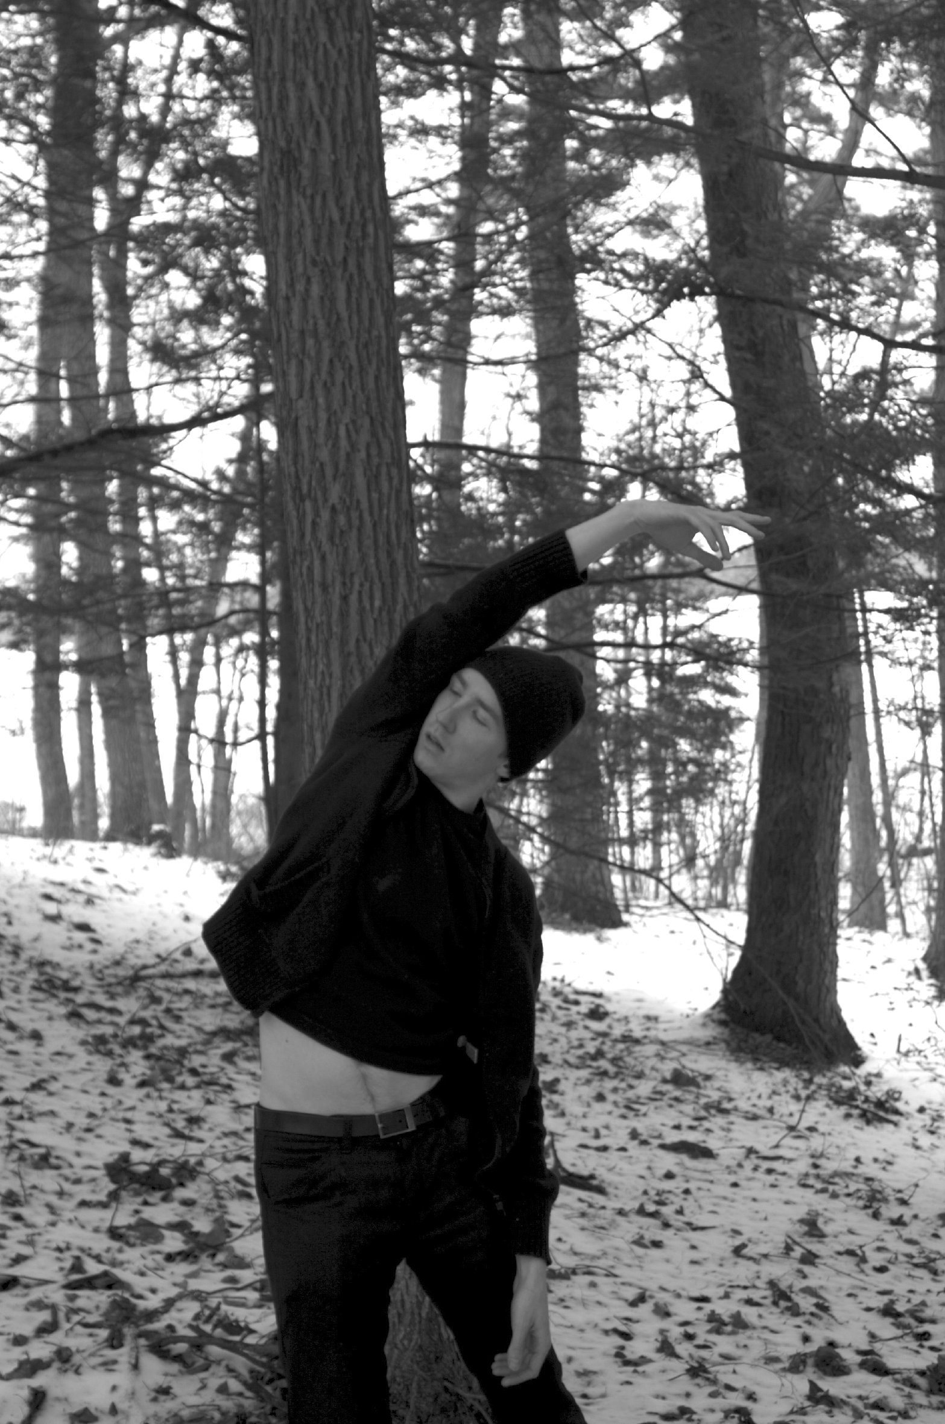
Excerpts from repeat after me

I was inspired to create this piece because I wasn’t sure exactly what the arts were learning from neuroscientists researching the neural substrates of music. I wanted to work on a piece that would require me to have more conversations with scientists about what they felt their work was telling us about the origins and cultural value of the arts. The central image in this solo is precise, deliberate movement that toggles between the scientific world of exact measurement and the dancer’s world of abstraction. How do we build our understanding of the world? How do our isolated conceptions of reality contain us? How do music and dance bridge the barriers between our solitary journeys to create connection? Repeat after me will performed in its entirety at the Institute for Contemporary Art on November 17 & 18.

Karl Cronin is a choreographer/dancer who creates solo and small ensemble dances. He believes strongly that the theatre is a place in which learning on the personal and communal scale can occur, and creates dances that explore the architecture of private and public experience.

Kate L. Pearce
katepearce@gmail.com
617.233.2810

Three forms, dense bulbs, their development suspended in sterility. They sit in wait for the sun and mire, radicals poised for growth.

Kate Pearce was born and raised in a rural community outside Detroit, Michigan. Many of her artistic influences were the natural forms revealed by hunting and agriculture.

Kate Pearce studied photography in Michigan with Glenn Rand, and worked as a commercial photographer there before moving to Massachusetts in 1999. She attended Massachusetts College of Art in Boston and received a BFA in Sculpture. She is currently enrolled in the colleges Teacher Preparation Program.

Her ceramic work combines hand building and molding techniques. She finds endless contentment in experimenting with form. In 2004 she received a scholarship to study ceramics in Japan. The trip has greatly impacted her aesthetic, and she is planning a return trip soon.

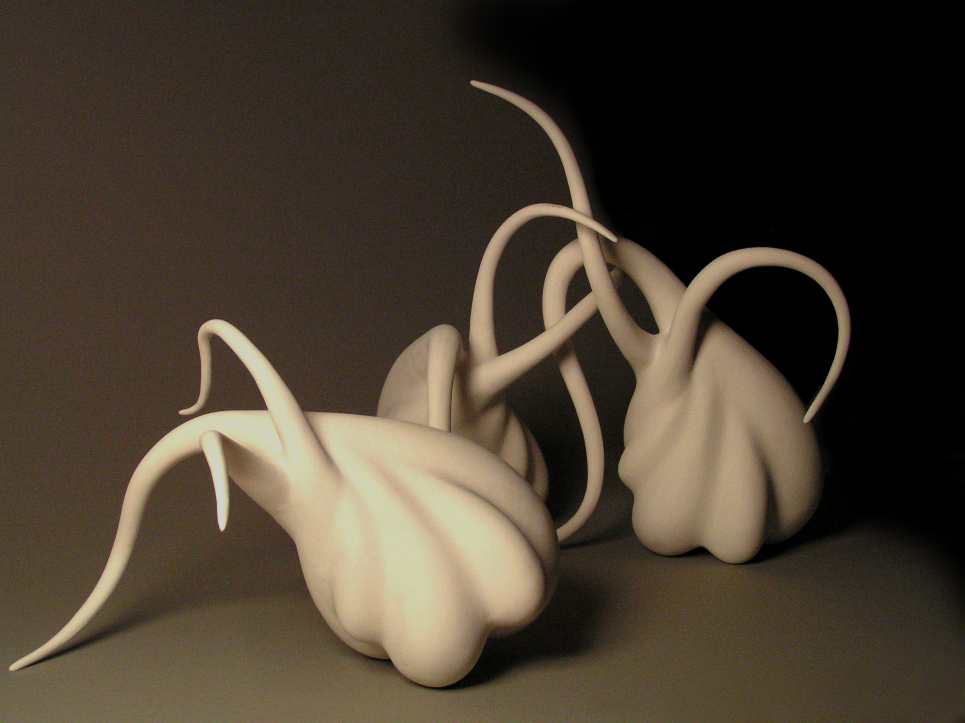

Untitled, 2005
Low fire white
11 ¾” x 24 ¾” x 13 ¼

Kevin Van Aelst

(860) 805-1294

kevinvanaelst.com

Subjects of my color photographs include every day foods and objects: bread, doughnuts, crackers, candy, floor tile, sweaters, and lint. These simple materials are arranged into shapes and patterns inspired by formulas found in science and mathematics, such as fractal geometry, chaos theory, biology and chemistry. The palette is informed by the colors of these mundane objects, so that colorful frosting finds its shape as the organelles of a dividing cell, or that bright gummy worms become the chromosomes on a chart of the human genome.

This work calls upon historical tenants of conceptualism and minimalism. Conceptual art has shown that the ideas behind a specific artwork can be more important than the aesthetics or visual appeal of the piece itself. The serial process, showing each successive permutation of a fractal pattern, refers to minimalism. Equally important to this body of work is humor—via odd juxtapositions of sophisticated content with banal subject matter.

This Body of work is about creating order where randomness is expected, defying natural probabilities, so that lint stuck to a sweater forms an accurate star chart of the summer sky over New England, and milk spills from its carton into a logarithmic spiral. I use common everyday objects and foods to illustrate timeless and lofty ideas. While the subjects of the photos are artifacts of modern culture, the content of the photos, such as the Golden Mean, are often ancient and revered notions. This work involves finding materials that bear a certain semblance to common scientific illustrations and visual displays—a common snack cracker having the shape of the fundamental unit of a three dimensional fractal, and an Oreo cookie having the same shape and colors as a yin yang.

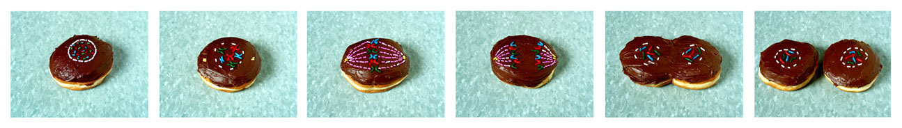
Donut Mitosis

Kevin Van Aelst was always told to never play with his food. He received his B.A. in psychology from Cornell University and his M.F.A. in photography from the University of Hartford Art School. He currently teaches at Quinnipiac University and is the Artist-in-Residence of the Milford Fine Arts Council in Milford, CT.

Lana Hermann

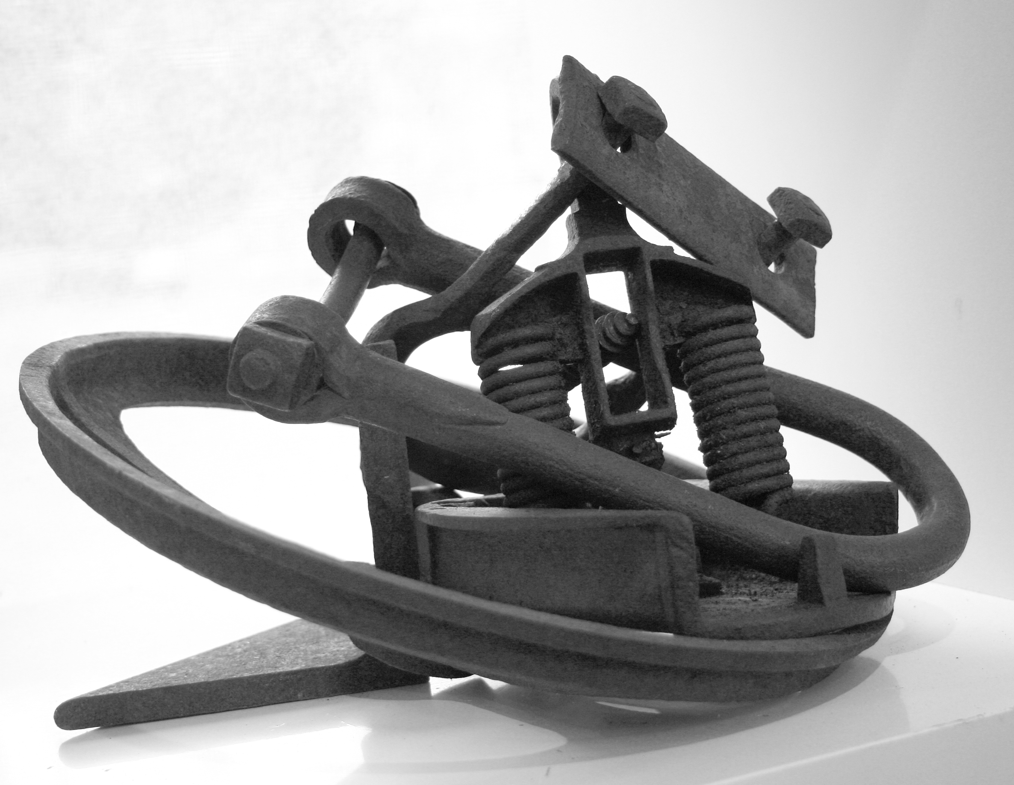

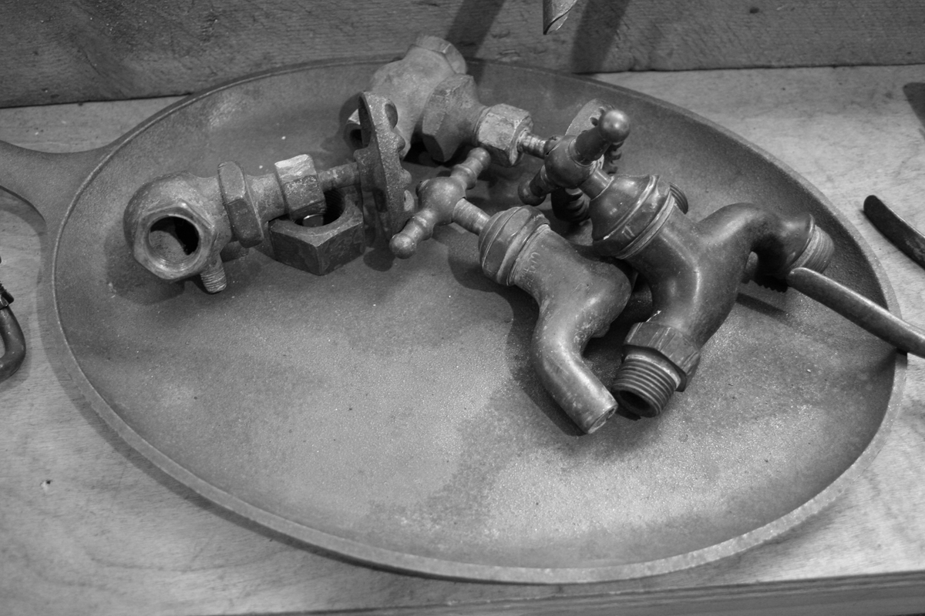

Laura Arena
www.deconstrukt.com patron@deconstrukt.com
617 417 3899
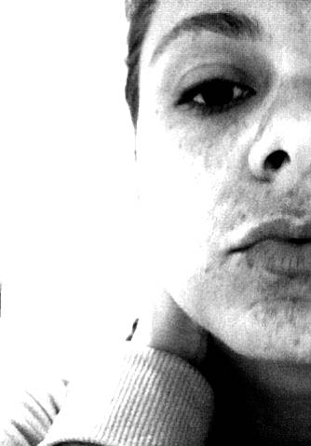

stats:
animal lover
artist
consumer
dancer
daughter
disc jockey
drinker
driver
drummer
entrepreneur
freelancer
friend
gallery
assitant
girlfriend
graphic
designer
idealist
obedient
employee
optimist
party planner
patron
photographer
printmaker
purist
roommate
sister
smoker
social director
student
teacher
tourist
volunteer
web developer
writer

results: yet to be determined

Laura Johnston
laura_johnston@mac.com

Laura grew up in Washington, DC where she spent a lot of time visiting the Smithsonian museums a child. This seems to have left her with a lasting interest in cataloging and collecting objects and creating specimens. She works in a variety of media, with a current focus on making objects and making images. She received her BFA from the School of the Art Institute of Chicago and her MFA from the School of the Museum of Fine Arts/Tufts University. In addition to creating her work, she currently teaches elementary school art in the Norwood, MA public schools. Her students are not allowed to chew gum in the classroom.

I began making these objects in response to the declining health of a family member. It is a reaction to waiting and an examination of contamination, both bodily and beyond. It preserves little moments of uncertainty that seem to multiply, much like malignant cells do. I see them emerging from a circle, echoing the diameter markings in a hospital clean-room that serve to indicate how close one (the contaminant) may approach the (contaminated) patient. By preserving the ephemeral, I seek to commemorate and record the triumphs and defeats, however small they may be, that would otherwise be lost or discarded through the decontamination process.

Leanna Sterios-Primiani
Composer/Conductor

Composer-conductor Leanna Sterios-Primiani is a native of California. She is a graduate of the Peabody Conservatory of Music of the Johns Hopkins University where she received a degree in flute performance and conducting. She holds a Master’s degree in conducting from the San Francisco Conservatory, a Master’s degree in composition from UCLA and is completing a DMA in composition at USC. She has studied with such noted composers and conductors as Leonard Slatkin, Peter Eötvös, Steven Stucky, Christopher Rouse, and Howard Shore.

Ms. Sterios-Primiani has received many awards and performances of her music throughout the United States and Europe. Recent premieres include Sirens for Large Orchestra and Chaconne for Orchestra by the USC Thornton Symphony, Poems Dugan for Voice and Piano, The Truman Project written with librettist Philip Littell and performed in Los Angeles as well as the Opera America national conference in Seattle. Performances and installations of her music include sound installations for Pure: A Multi & Mixed Media Exhibition in Brighton, Massachusetts, Parada at the Herrenhaus Edenkoben (Germany), performed by Ensemble Aventure Freiburg and recorded for the SWR (German radio), Variations for solo piano performed at the June In Buffalo New Music Festival, Paraklesis for women’s choir premiered by the USC Oriana Choir, Parada at the Aspen Music Festival in Aspen Colorado, Searching for M with Help from a Large Orchestra at the Cabrillo Music Festival in Santa Cruz, California and Heterotic E8xE8 and Type I Superstring for Small Ensemble and Live Electronics at the CCMIX (Centre de Creation Musicale Iannis Xenakis) in Paris, France.

As a conductor, Ms. Sterios-Primiani currently serves as cover conductor for the National Symphony for the 2006-2007 season. Before her appointment, she was one of four conductors selected from around the country to participate in The National Conducting Institute with the National Symphony Orchestra, and conducted that orchestra in May, 2006. She has served as music director of the Fort Worth Dallas Ballet in Fort Worth, Texas and has conducted many orchestras throughout the US and Europe including the Ensemble Aventure Freiburg (Germany), National Symphony, Fort Worth Symphony, Dallas Opera Orchestra, San Antonio Symphony, Santa Rosa Symphony, Pasadena Symphony and the Women's Philharmonic in San Francisco, among others. In addition to symphonic and ballet repertoire, Ms. Primiani is currently the assistant conductor for the USC Opera and has helped prepare such productions as Lowell Liebermann's Miss Lonelyhearts, Thomas Ades’ Powder Her Face, Stravinsky’s The Rakes Progress and Massenet’s Cendrillon.

Ms. Sterios-Primiani has received several honors including the prestigious USC Arts Grant two years running. Ms. Sterios-Primiani has participated in several prestigious festivals and master classes including the 2005 Workshop for Young Conductors and Composers (as both composer as conductor) sponsored by the Peter Eötvos International Institute. Other honors include the Susan and Ford Schumann Film Scoring Program and the Schumann Center for Compositional Studies, with a fellowship at the Aspen Music Festival, the Cabrillo Composer’s Project at the Cabrillo Festival for Contemporary Music, SYNERGY! Composer-conductor workshop sponsored by the Los Angeles Philharmonic, the Centre de Creation Musicale Iannis Xenakis Summer Intensive in Electronic Music in Paris, France, and the International Master Course in Symphonic Conducting with Neeme Järvi and was one of 10 participants chosen worldwide to participate in the Kiril Kondrashin Master class in The Netherlands. She also has the distinction to be the first female to receive a Ford Foundation Conducting Talent Grant.

She recently married and lives with her husband, Marc Primiani, in Santa Monica.

At Pure, she will be collaborating with Timur Bekbosunov to create the musical / sonic component of a group installation with photographer Dana Ross.

Lisa Lunskaya Gordon

is a collaborative effort of many individual organisms.

She is both pure and full of contagion.

Self Portrait of the Artist

Luca Zucchi, Anna Elisabetta Zucchi, Chiara Assi

Luca Zucchi holds a Phd in Philosophy of science (Università di Genova, 1999) and is a member of the Società italiana di Logica e Filosofia delle Scienze (SILFS), and the Società Italiana di Storia della Scienza (SISS). He is currently teaching Epistemology, and Didactics of contemporary philosophy to graduate students at the Università di Ferrara. He has published various articles and essays in international periodicals and collective volumes. The focus of his work is the function of visual representation in formulating and transmitting scientifc knowledge. His latest text: “Image, Language and Knowledge: Iconophobia and Iconophilia in the Epistemological Debate”, is available in Rescogitans.
Sito di filosofia applicata. (http://www.rescogitans.it/).

Anna Elisabetta Zucchi was born in Milan, Italy, in 1987; growing up she lived between Jacksonville, Florida, and Milan. She graduated from Choate Rosemary Hall in 2005. In 2005-2006 she attended the London College of Communication pursuing a BA in Marketing and advertising. She is now attending Central Saint Martins College of Art and Design working on a degree in Product Design. For the past three summers she has worked at an advertising and marketing agency, the Arnell Group, in New York.

Chiara Assi
Was (home made) in Robbiate, Italy in 1971. She holds a degree in Foreign Languages and Literatures. Since 1992 she has been working for companies in the steel, mechanical industry and petrochemical sectors. She holds a black belt in Tiramisu.

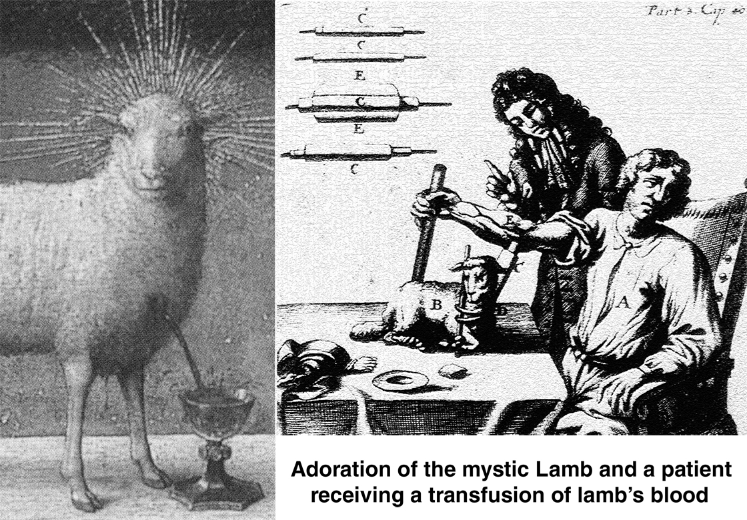

Lydia Eccles
PO Box 120494
Boston, MA 02112
617.482.0889

CLEAN:

Clean is a research inquiry:

Is cleaning motivated by a largely-unconscious and non-rational animal-brain instinct/drive, parallel to the sex drive?

Like the sex drive, is cleaning actively fueled by fascination, pleasure and desire? Does filth spark something?

Are we uncivilized?

Human animals like doing things without knowing they like doing them. And when they do them out of unacknowledged desire, they come up with reasons for doing them, unless they don’t notice they’re doing them at all.

The video is a human experiment:

There’s no rational reason to enjoy a video of banal and repetitive cleaning activities.
Unlike actual cleaning activity, imagery of cleaning behaviors serves no purpose, material or cultural.

Will the video arouse vicarious sensual pleasure?
Is it pornographic?
Cleaning that very last, that very tiny bit of dirt, rather than 99.9% of it. Is it necessary?

A Zamboni on the ice-skating rink, circling in to wipe the last inner swatch of frosted ice to glossy translucency. And if the machine misses a patch, even a sliver?

Pimples. Going back again and again to feel them. You imagine slicing them off, sanding your face. The expensive seduction of exfoliants.

Sunburn peels.

Onions, so special.

You clean your ears with a cue-tip (even when you’re not supposed to) and it comes out covered with orange gook.
You try again, but you can’t get anymore.

Stones rubbed into gems.
Souls hung out to dry.

Lydia Eccles is a test human/participant-observer for Universal Aliens, a transcendental phenomenological research outfit studding the human experiment. She is currently collecting samples for the I-pod inquiry. Previously she participated in a variety of studies, including: ‘What is Media?’ ‘Bad Sex (not as in naughty)’ and ‘Despair (I have no reason to live).’
Marilyn Fontenrose

Marilyn Fontenrose is a Boston based artist. She likes to work in collaboration with others as well as on her own. This work has included performance and installation art, costuming, props, graphic design and electronic music production, some of which has been shown here, in NYC, Barcelona and Budapest. Currently, she is focusing on sewing as a medium. Marilyn remixes ideas, objects and iconography common in daily life. By using performance, wearable props, sculpture and installation she reinterprets and investigates perceptions and ideas found the culture around her. She has been motivated by and has addressed questions regarding morals-as-ethics, social constructs, over-population and ecology. Much of her work has been conceptual, and she is always looking for a variety of interpretations which underlie the surface, always inviting those which are not her own.

Host Mother - A Pre-Natal Nanny
Host Mother is a person for hire, by an individual or couple, to care for their unborn child. Different from a surrogate mother, the fetuses grow outside the Host Mother's body. Different than the ethically challenging test tube baby the incubation and gestation of the fetus is not solely driven by machines, nor does it take place in a clinical setting. Host Mother (H.M.) carries the fetuses with her during regular daily activities. The fetuses receive biological feedback from the H.M. through intravenous tubes running from H.M. to the fetus, and by electrical and neurological signals running via sensory wire from the H.M.'s heart and brain. Many of these transmissions are biofeedback which result from her human interactions with others, reactions to music, thoughts while reading, or feelings in general.

After choosing this method of procreation, the future parent(s) interview and select a compatible Host Mother and Pediatrician. The pediatrician will make regular visits to H.M. and the mother to be, to monitor the growth and health of the baby. Medical supplies are delivered to the H.M. at home as the fetal needs change.

Couples or individuals who hire a Host Mother also pre-select sperm and the egg, using their own or by choosing from a catalogue of premium pedigree specimen. The contract is negotiated and the hours per day their fetus will be "nurtured," or carried, with the H.M. is decided. Those who choose H.M. know that key to optimal baby development, is the biofeedback component during gestation. The parent(s)-to-be know their Host Mother, or Pre-Natal Nanny, will give their future baby the best care and the human touch.

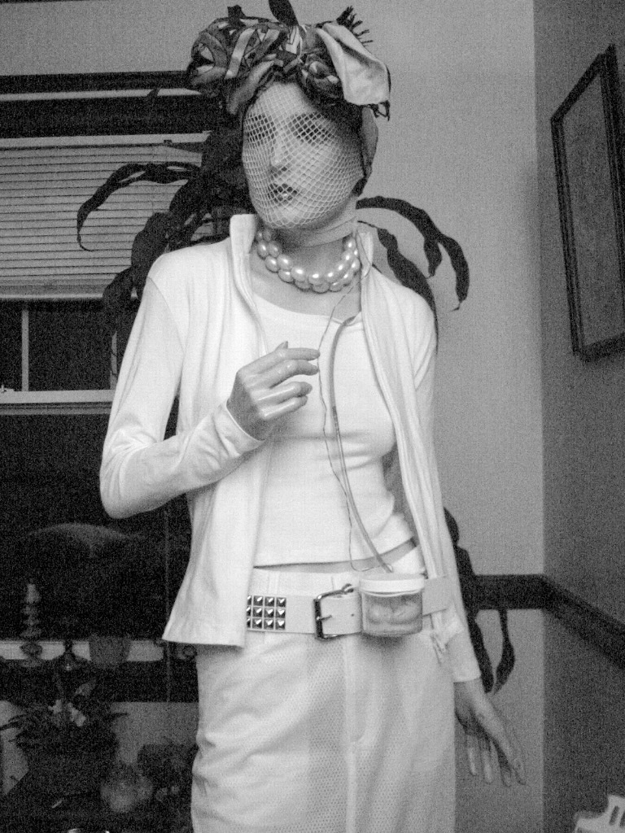

Markus J. Nechay
617-876-1929
markusnechay@yahoo.com

5'11"
170 lbs.

Age: Thirty-twelve.

"The Body and The Blood"
by Markus Nechay

We are spirits in the material world. The world is made of organisms that, like ourselves, are solely focused on preserving their ever-changing self. Yet, in the processes of respiration, digestion, and laceration, indeed by simply engaging in the process of existence, the inviolable organism that we are is exposed to other forms of life that are also, like ourselves, responsible for their own existence. From the moment we begin breathing, our precious bodily fluids have been corrupted by impurites....life's original sin.
Yet, there is a reformation taking place among the members of our being. Within the substance of our bodies, we have been endowed by our creator with internal cells of resistance. These inner Puritans made of the purest, whitest and most resolute substance flow into every crevice of our form and surround those agents of destruction that would dare trespass against us. They absorb the invading organism unto themselves, thus taking the sins of the world unto their own being, and casting them into that long, dark road, the excretory path to oblivion.

Markus J. Nechay didn't know how to draw a straight line. He studied straight line drawing (Cornell University, Boston Architectural Center, Cooper Union) and failed in the utmost degree. He has since become a dabbler, scribbler and babbler (painter, writer, performer). An active member and former resident of the Zeitgeist Gallery, he now resides in a Cambridge apartment funded by you the listeners, the Markus Surrealius Museum of Creative Chaos.
Unfortunately, his former eating habits (too many Little Debbies) caused him to develop arterial atherosclerosis. Since he rather painfully discovered the state he was in, he has cleaned up his act. There's nothing even partially hydrogenated about this customer. On Thanksgiving Day 2004, Markus vented his spleen turning him into a true bleeding heart.... down to the marrow.
An occasional conformist (Roman Catholic, Episocpal and Orthodox) he has exhibited several drawings, paintings and assemblages addressing the Christian Religion. These include the "Iconoclasm" exhibit at Harvard University, "Relics of the Lost Cities of Man" and "Lifelines" at the Zeitgeist Gallery, and his "Inventions" at the Old Schwamb Mill Museum in Arlington.
He has acted in the role of a Puritan Governor and unbaptizable Wampanoag in Ian MacKinnon's play "Awannoa"; a bishop in Warren Lynch's movie "Eyes of the Forest" and in Damian Kolody's film "Ill Generation" an angel-headed hipster burning for the ancient heavenly connection to the starry dynamo in the machinery of night.
He is currently working on a future publication "Illustrated book of dreams".

Maura Cunningham
maura_cunningham@comcast.net

Perception and Truth are often at odds. This work is about the aspect of purity or innocence that resides in the unknown.

Maura Cunningham, Massachusetts College of Art 2006; B.F.A. Sculpture - Jury’s Pick Award, All School Show ; Vietnam Travel Scholarship ; Foundation Auction Award • The Carving Studio and Sculpture Center - Adalin Wichman Scholarship • Emerson College 1994 B.S. Mass Communications/ Film - East Cambridge Scholarship 1990-1994

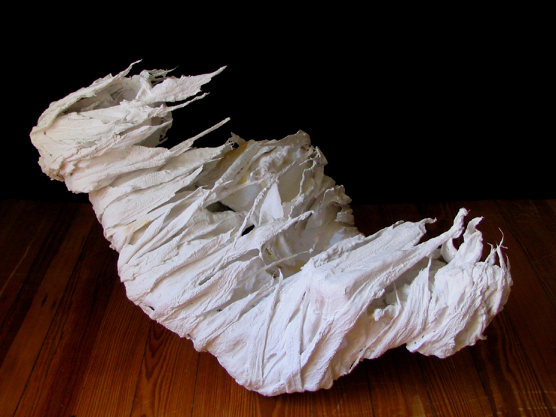
Chrysalis

Melinda Kate Cross
Melinda.cross@gmail.com
Melindakatecross.com

Eye Teeth
Through the process of experiencing various kinds of orthodontic torture over the last ten years, my teeth have become part of my identity. Dental records can identify a corpse, which is damaged beyond recognition, but I am referring to a living identity. I have become acutely aware of the impact teeth have on identity. In a culture that stresses whitening, adjusting, straightening, removing, and adding until the perfect combination of pearly whites is achieved little emphasis is placed upon it in daily conversation. The ideal reaction is no reaction to dental work. I have removable teeth, every time I eat I have to take out my retainer with my falsies. The attention that is drawn to them gives them life, and in thinking about this concept, I began to think about the molds created at dental offices. They are as personal as a fingerprint and yet disturbing standing alone, in groups and with eyes, they take on a menacing personality. While teeth can be associated with a smile they can also be a sign of aggression. In this piece I hope to explore the disconnected identity each set of teeth takes on when grouped to several other sets.

Melinda Cross creates works which deal with the relationship between art and science. She is especially interested in pre-photographic scientific documentation. She graduated in 2006 from The School of The Museum of Fine Arts, Boston in conjunction with Tufts University with a BFA and Diploma. Her work has been exhibited in Boston, Chicago, Columbus Ohio, Atlanta, and Edinburgh, Scotland. One of her large marbled pieces has recently been acquired by the Boston Public Library. Melinda currently lives and works in Columbus, Ohio.
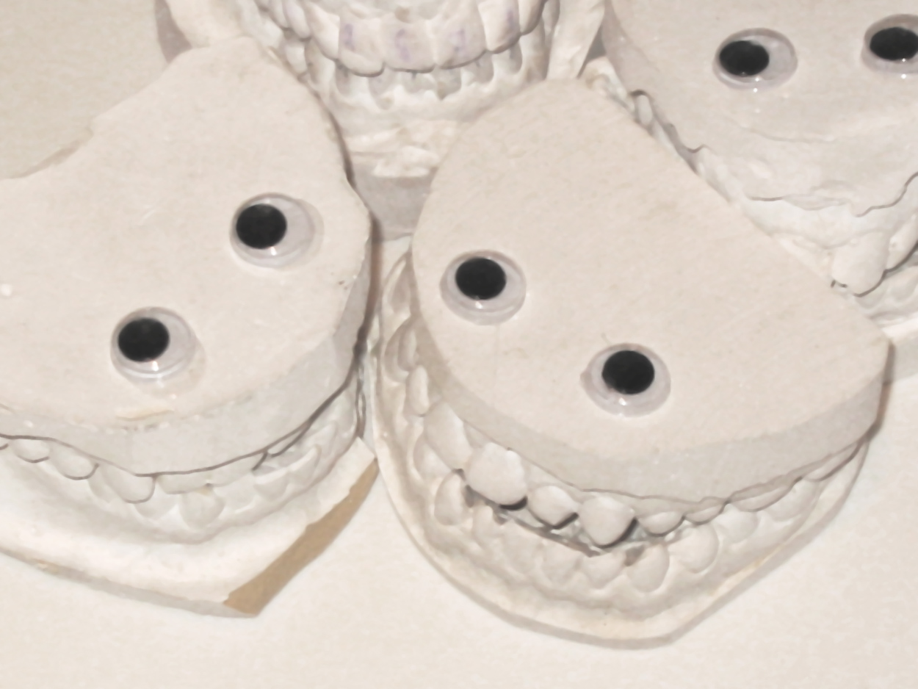

Naomi Sultanik
nsultanik@yahoo.com

Naomi Sultanik makes mixed media paintings, drawings and objects. The images are nature oriented often coming together in textual though non literal installations, the juxtaposition of material and image implying an intuitive knowledge of the whole. Her work has been shown in one person and group exhibitions during the '80's in The Netherlands (Museum de Kruithuis, Fodor Museum , Bonnefonten Museum , private galleries) and since in the U. S. at Maryland Art Place, SUNY New Palz, Sage College, Lichtenstein Center for The Arts and gallery venues.

She has given interactive art workshops addressing issues of homelessness and illegal immigration (Project Street Corner Werk, NL) and taught drawing and movement at Orange County (NY) Community College.

100 Spools Of Thread, A Roll Of Tape, A Quiet Day

This piece is a simple act. It is the unwinding of a quantity of sewing thread; 100 domestic spools, 2 industrial ones. The process, a pattern of random, necessary movements that loop, bind, contain and weave the material throughout the space suggests a ritual with dual meaning- one of introspective " cleansing"; the other a perception of the inevitibility of change.

"Birds fly, feathers fall;
Fish swim, the water gets muddy."

Master Man Gong

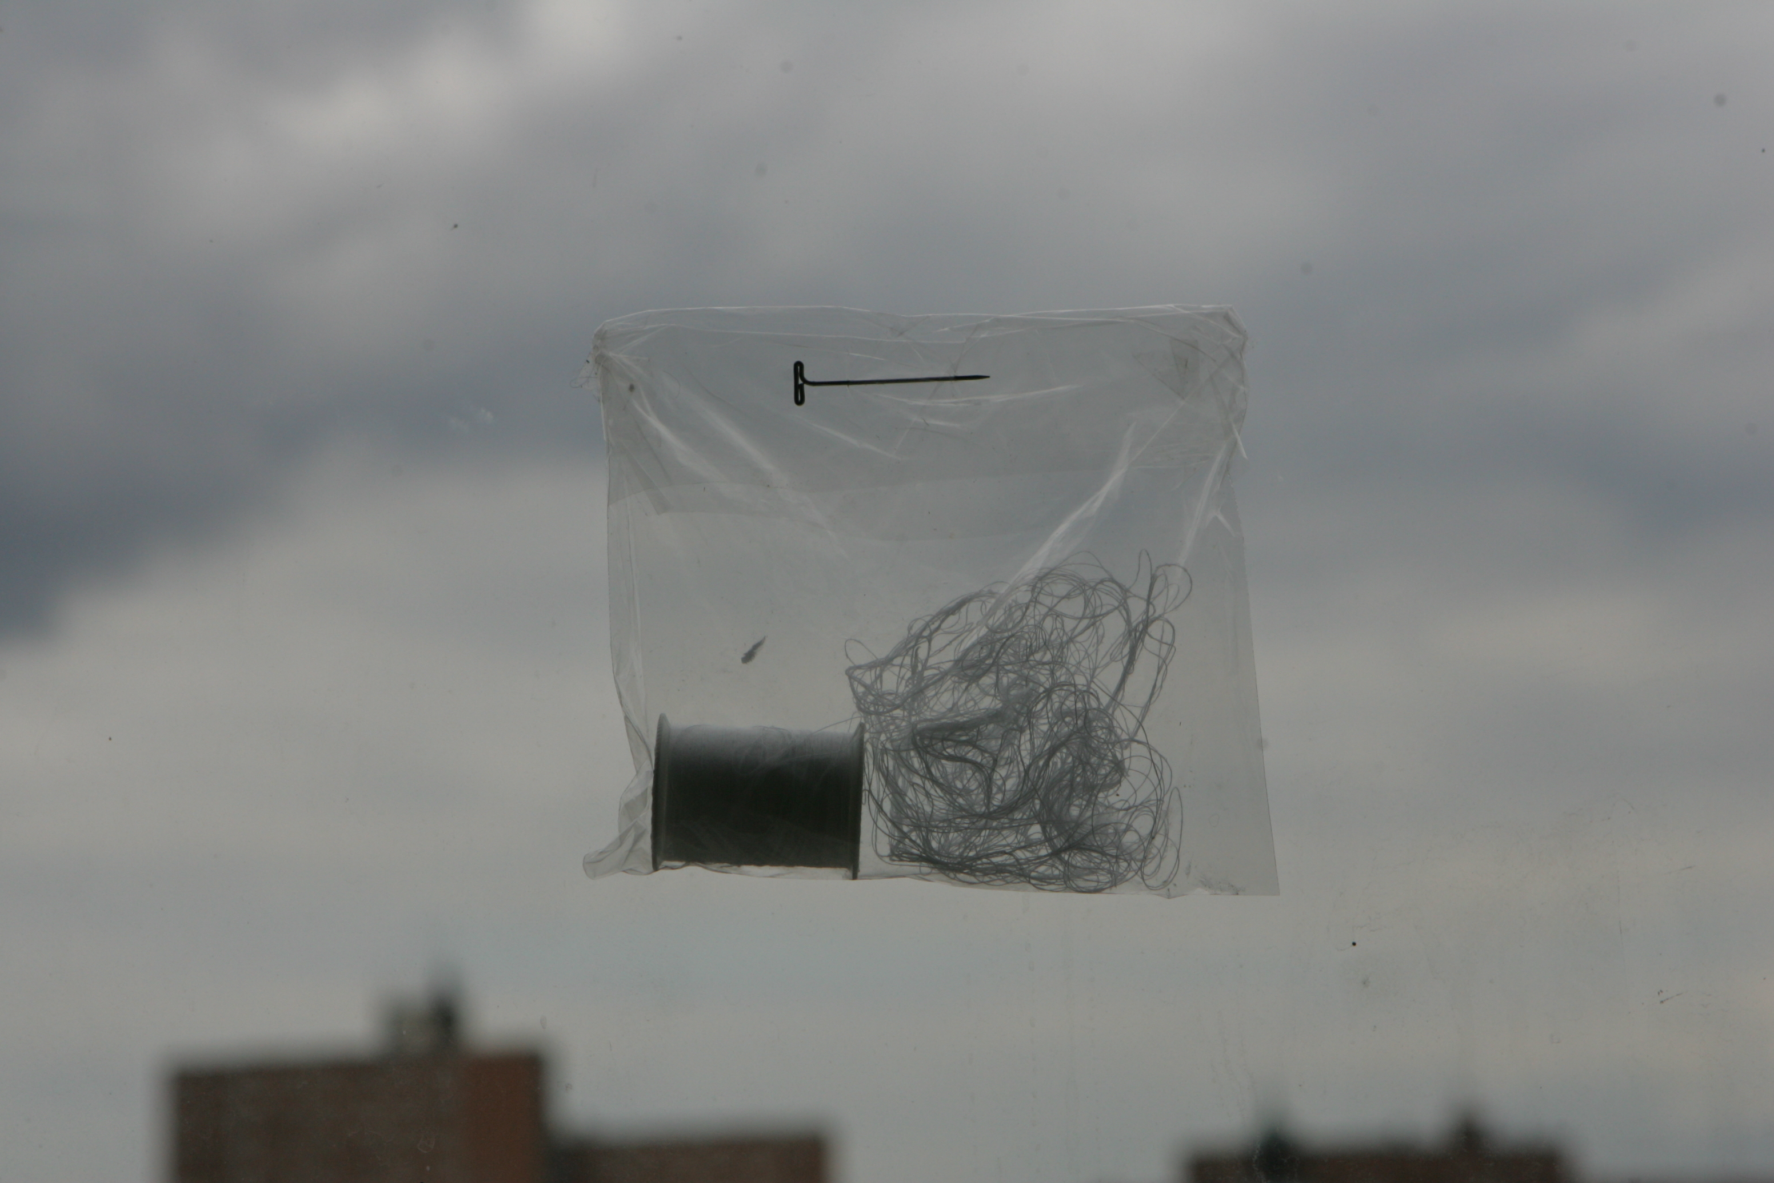

par-don
par-don.com

par-don is a collaboration between
piotr parda & lisa lunskaya gordon

projects span a variety of media often including a performative element. the collaboration is entering into its 4th year.

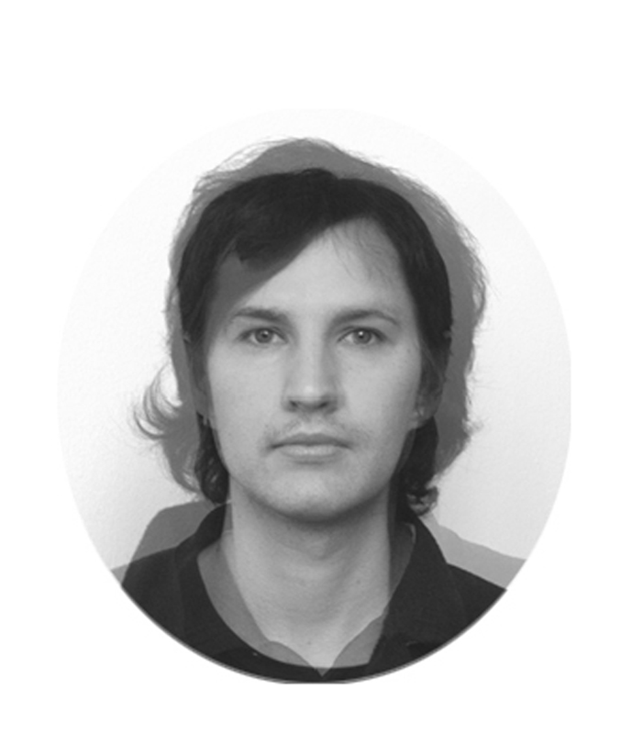

Pauline Lim
lim@paulinelim.net

I try not to think too hard about what I’m painting; I just try to free my mind and make paintings that I like to look at myself.

Lately I have been inspired by medieval religious art where it looks like they were just starting to figure out realism, but things still look somewhat cartoonish, while retaining their earnestness.

Born in Clarinda, Iowa, in 1966. Graduated cum laude 1984 from Phillips Academy, Andover, MA. Graduated A.B. magna cum laude from Harvard College, 1988. Lives and works at the Brickbottom Artists Building in Somerville, MA. Shows at Tristan Gallery, Provincetown, MA.
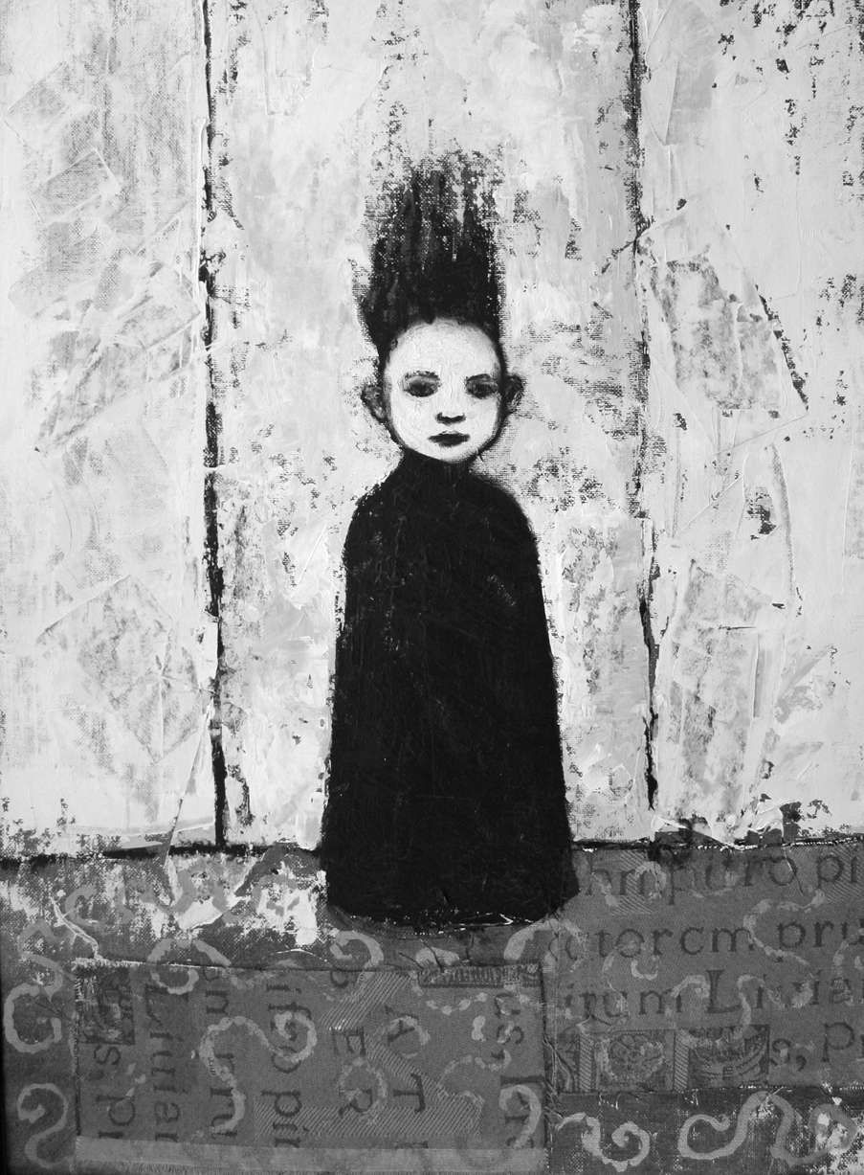
Figure in Black
Piotr Parda
piotrpar@par-don.com
www.par-don.com/piotr
617.230.5862

I'm approaching the idea of "Pure" from three completely different points of view.

First one examines purifying as a removal. Cleansing or disinfecting involves nothing else but condemning and then eliminating the unwanted until the satisfying minimum is reached. To sufficiently, and maybe even drastically, convey the idea of elimination of the unwanted, I built the replica of a sterile execution chamber - the ultimate tool of elimination.

The second approach is about examining the potential of the "blank". In my object called "Reel-lax", a toilet paper roll becomes a reel-to-reel audio tape broadcasting all the noises of its uneven surface.

Third approach is about translating the language of pure energy technologies into the language of art. Graphite drawings of the surface of solar batteries that I prepared specifically for the show, aren't simply imitation. What brings them together is the idea of usage and exploitation of the pure energy. The energy of the sun rays is here replaced by the energy one invests in order to create a pencil drawing. The friction of the pencil against the surface of the paper and the usage of the graphite, couldn't be used in any practical way, but could be easily measured. But there is also the idea of absorption. The viewer's attention devoted to the "solar drawings", will then become a new pure energy to be absorbed. The "Solar Drawings" will also be situated near the electrical outlets used by other artists to power their work.

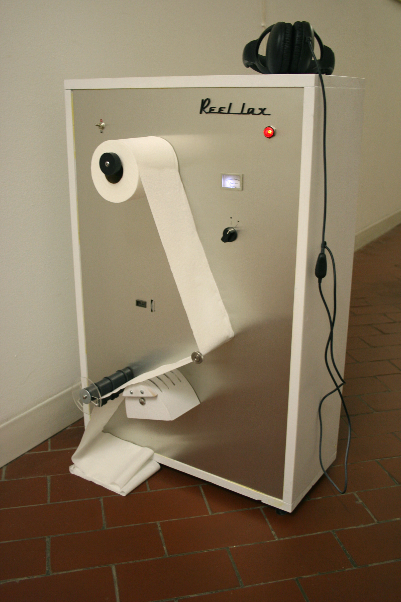
project ruori
ruori.org

project ruori is a ubiquitous agency spinning eddies apparently rooted in the communist methodology. We assemble federal holiday and moment-of-silence concertos, tricky static, postpunk klezmer ballads, approved portable electronic devices, and many various random green ideas to envelop jurers with an underwhelming mental experience. (In a playful shade of bleak.)

project ruori's first undertaking was a multimedia performance-art opera in 28 acts. Since then, we have given performances at the 2005 and 2006 electro-music festivals in Philadelphia. Our latest production is a freely-downloadable self-help video for those who struggle with French class or any of life's other major existential challenges.

For increased detail, visit our website at http://ruori.org/

Project Description/Philosophy

A clear Machine hangs in the center of three Cocoons. The Machine inputs white balls, with the help of a human Operator, and outputs differential events altering an ambient soundscape, with the help of three Musicians inside the Cocoons. The Operator eventually tires of his task and replaces himself with a machine that will inevitably exhaust the supply of white balls, leaving the Musicians to abandon their stations in frustration.

The Musicians leave the Cocoons open, revealing the devices by which they controlled the soundscape and leaving these devices visible and vulnerable to whomever may happen upon them. The soundscape is left in operation, subject to the whims of whatever individuals discover the controls and their power.

"Creativity" is a modern buzzword. As with most buzzwords, its essence is vague and generally poorly-understood. It is viewed by some as one of the characteristics most unique to humans, yet it has always required the use of inanimate objects. We crave products purportedly inducing and enhancing "creativity," but these products' availability is limited to that which is viable in the marketplace. Even internally, creativity is little more than the stochastic firing of neurons in the brain. Yet we choose to pursue it anyway in the hope that we can understand it better, or at the very least, keep ourselves occupied.
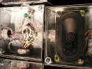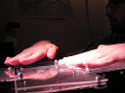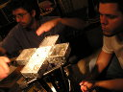

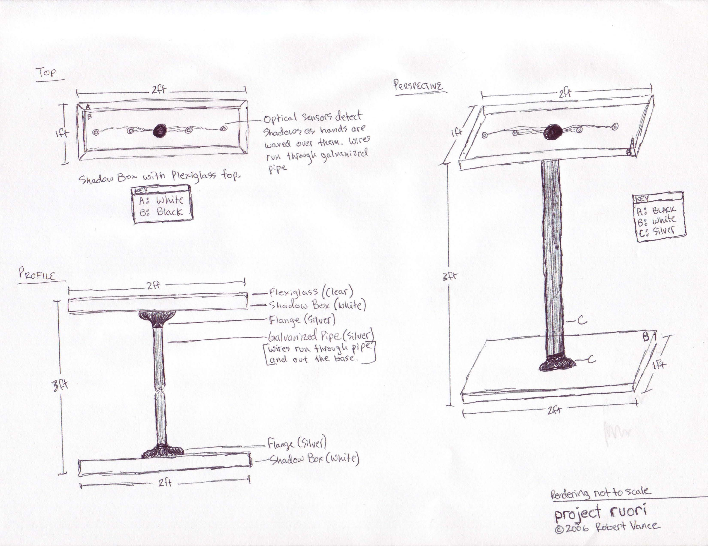
Sanna Sevanto
ssevanto@smfa.edu
617.943.1027

One of the traditional arguments for separating humans from animals is based on our ability to feel and show empathy towards others outside our immediate family or tribe and even to creatures very different from us. In her art Sanna Sevanto creates pieces that she hopes will call upon this sympathy in the viewer creating a dialogue between the object and the observer. She examines and emphasizes basic emotions using simple gestures, by exaggerating and/or simplifying shapes and by creating tensions in composition. Using both figurative and abstract approaches to drawing, painting and sculpture she studies the relations of our inner and outer worlds, conscious and unconscious aiming at provoking more questions than answers.
This is quite contrary to her daily work as a scientist trying to find answers to various questions about the functioning of the universe. Her career as an artist started much later than the one in science, but as a current student at the School of Museum of Fine Arts, Boston, the devotion to arts shows an increasing trend whereas the time spent in science stays constant (Fig. 1). This increase in the amount of time spent in arts is made possible by a reduction in the amount of time spent in sports, the other fascination of hers. This indicates that the career as an athlete is past. However, the sports curve shows slight stabilization and if it takes a form of a wave function, further increase is to be expected. Where the time for that might be taken remains unclear, but based on the current trends arts will pass science by year 2010 and since the number of hours in a day is not increasing, something has to happen. Currently, as a publishing scientist in the field of biological physics Sanna often studies themes related to science and philosophy in her art, and the analytical search for purity of the statement and form is a unifying feature across her pieces.
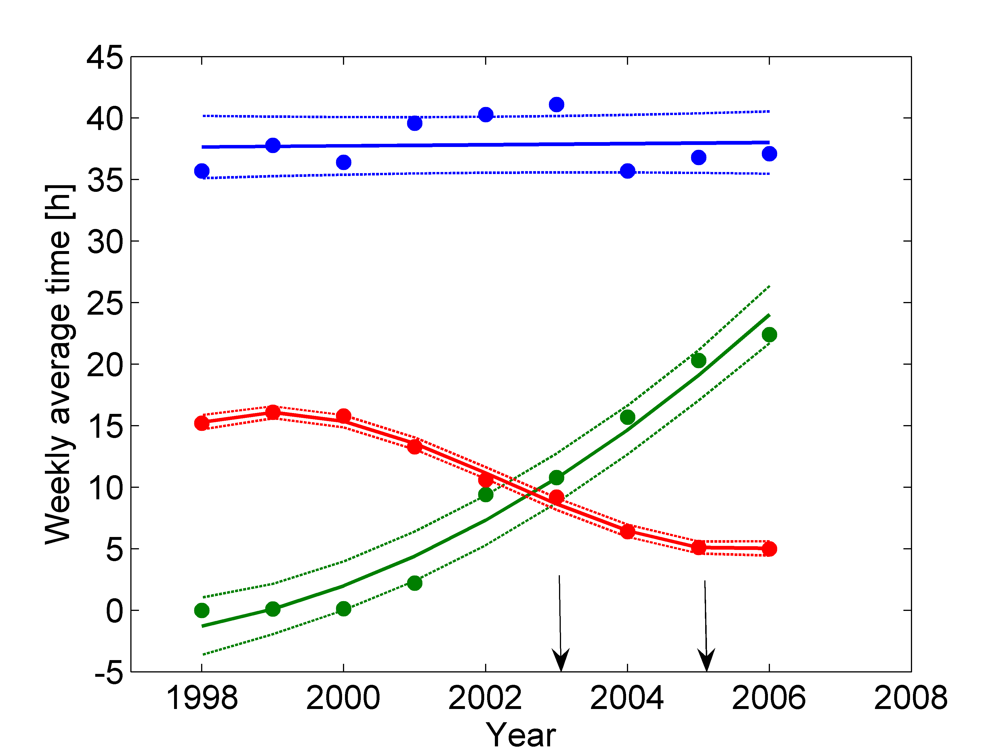

Figure 1. Average weekly time spent in science (blue), arts (green) and sports (red) as a function of time since 1998 (beginning of graduate studies). The curves are fitted using least-squares method and the dashed lines indicate 50% confidence intervals. The first arrow points the time of graduation (PhD in Physics, University of Helsinki, Finland) and the second the beginning of studies at the School of Museum of Fine Arts, Boston.

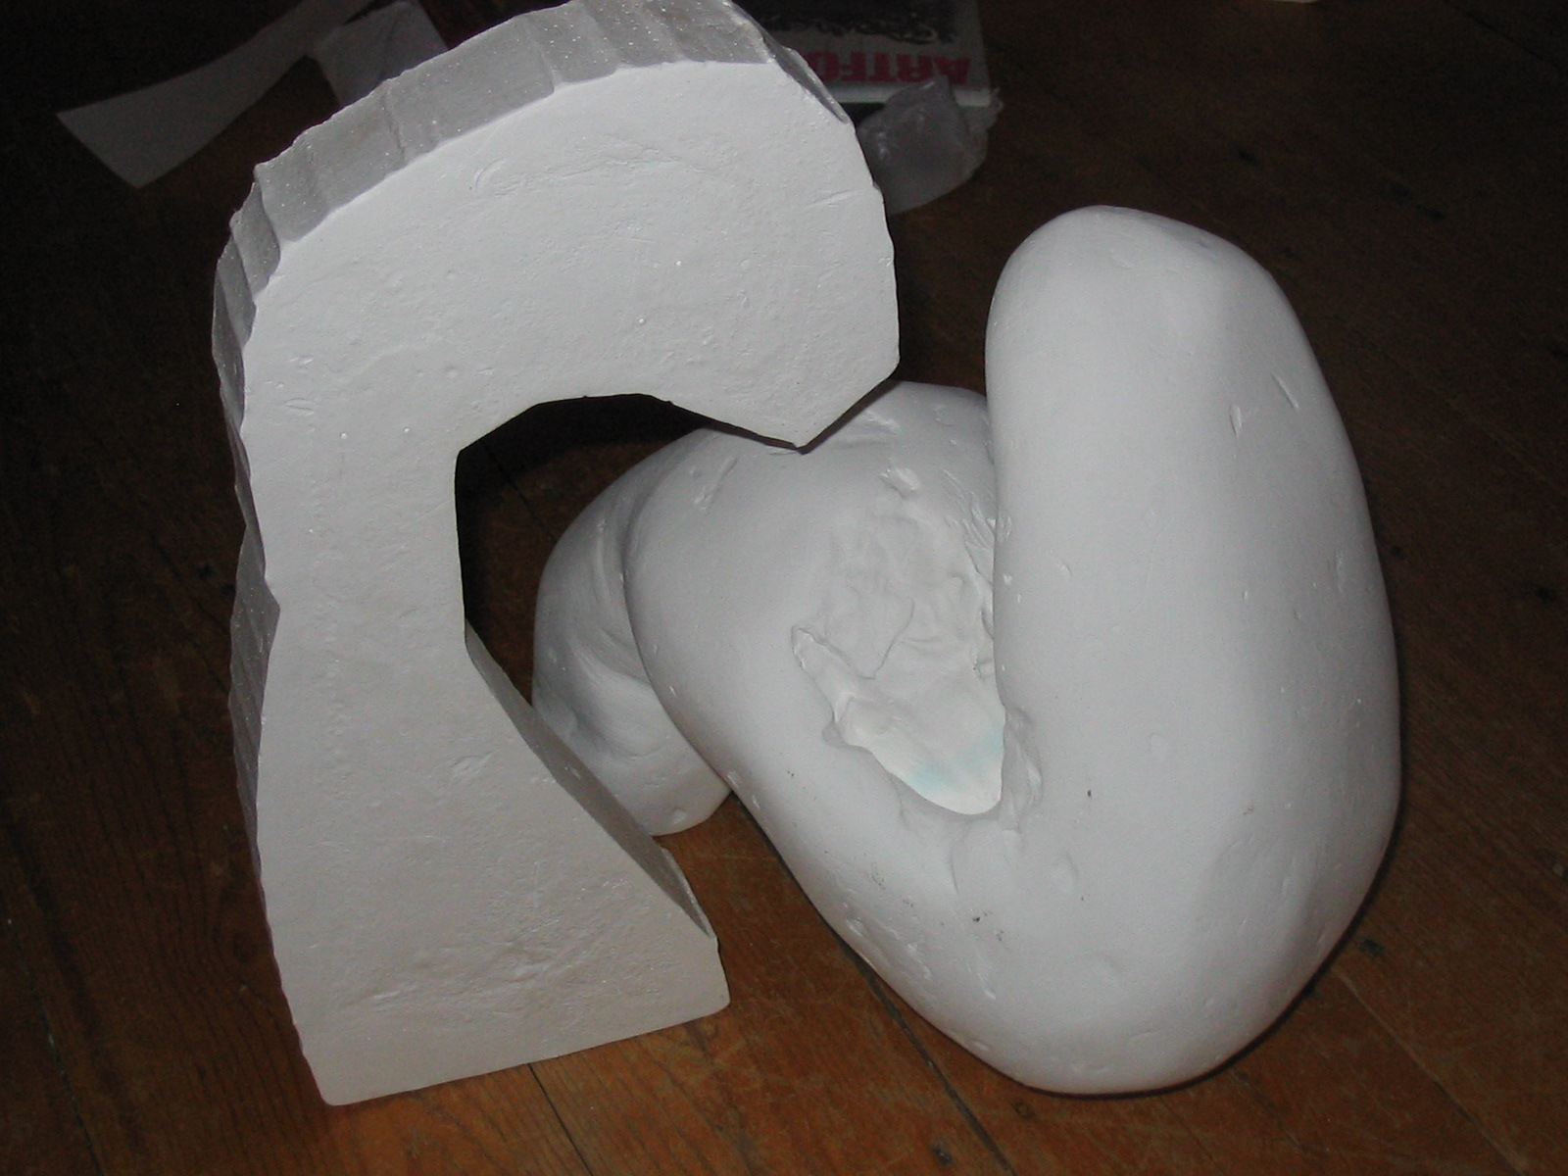

Sarah Pearlstein
www.malleablejangle.netfirms.com/issue4.htm
617-782-2087
spearlstein@comcast.net

Sarah Pearlstein is a 31 year old poet from Brighton, Mass. She writes about the politics of the body, and is never afraid to over-state her "case". She can be found on-line in Malleable Jangle.com, an Australian e-zine.

No Mediation

All is perfect in your world.
The cakes you bake
Rise into
Many-layered tiers.

You curl your sentences
Into appropriate irony
Using an iron,
You do the same
To your hair.

Nothing falls flat
For you, while I
Mysteriously
Turn curly haired
At thirty, still a girl.

Drip, drip go
The transmitters
Which decide
Who is happy
And who
Is not.

Consuming Beauty

(a poem based on the David Foster Wallace story,
Westward The Course of Empire Takes Its Way).

Bamboo limbs with straw thorns, cacti fronds
I prayed that someone would scream, it is my love you are cheating on:
Though I am not an anarchist, or one given to intimate barter and piracy,
Privacy is a granted gift, wished for eyes on the ground
Be those whiskey eyes, instead of an addict,
or an eye so ridden with seeming sores
From staring at cameras, other peoples
demanding eyes, neon of all kinds
A rose a red is a red is a rose is an ineluctable sign,
I love but only
When I’m alone, neon I cannot contend with when I am to charlar along
My idiom I am cheating on, oh my cheating tongue,
Though I am not an anarchist,
I am begging for themes from the castle,
The gargoyles scare noone,
and noone hopes for them.
The castle once brought hope from far away,
Attracting travel brought dangled shoes
With no life to fill them up with
But the impregnable, the castle
Is no good no more, I know that, but though
I prefer this IV drip of seretonin to sweet honey
Though I am not one, be an anarchist,
Embrace history as an intolerant past,
Foam at the mouth with the sick parade,
All you carnivals so many legends down
Until you are a peasant bound and round assed
Again, when you know how to learn my tongue,
Again, when you form the most beautiful sounds with
Your friends and not just your lovers, just to hear the sounds,
Sing without singing the lovely curvy iiii yyyy eee ylle yodely
Sound of the round gigantic ground down into pouwnds of clowns
Noses sniffing we were not, but we saw naked young bodies,
In flight temporary and soaring jock-strapped girls and boys
Bouncing on a trampoline straight edged eating macaroons
Stay up all night just to make the sounds,
Though I am not one, though I am sounds, though
I may be breath-biased and not breath-based,
I elude it nonetheless, Nonetheless
Be an anarchist for me,

Anger at the change in seasons enough to travel
At the head of the cold, or dare it into a pile of snow you call
Home, an igloo, or a night spent ice fishing,
Bite the heads off roses when they don‚t
Smell like raspberries, yes,
Eat the roses when you may,
and note the knobbly
knuckles of age,
passing

PATIENT MEDICAL HISTORY

Name: Tatiana Gelfand Phone: (732) 500-7772
Address: 2684 John F. Kennedy Blvd, Apt 16 Email: tatiana.x@gmail.com
Jersey City, NJ 07306
Current Diagnosis: "Moments in the O.R."
History of Present Illness: Patient has exhibited unusual interest in peeking inside the living body; In exploring the physical and mental boundary formed by the human skin. Most are not allowed to and do not cross this boundary. The few that gain regular access to the "other" side must go through extensive training and regular sterilization.
Symptoms: Patient's symptoms began to emerge while patient was photographing in the operating room of the Beth Israel Hospital, Boston, MA. Current illness ("Moments in the O.R.") shows the work of the elite professionals, the surgeons, who are allowed to manipulate what is inside of us.
Medical History: 25 year old female, Tatiana Gelfand, has studied both fine art and biology. Her interests continue to encompass both- she strives to merge the two when possible as they are not mutually exclusive, but rather fuel each other in both in discipline and creativity.
She currently works in a protein research lab, is collaborating on a documentary film about Therapeutic Horseback Riding.
Immunizations:
Elementary School: School #147, Moscow, Russia. Vaccine schedule terminated after
1 year, 1989
Middle School: Bartle School. Immunization completed 1993
High School: Rutgers Prep. Immunization completed May 1999
College Series (BS & BFA): Administered at SMFA and Tufts University.
Immunization completed May 2004

Treatment: Identify and quarantine infectious agent to prevent further spread of disease. No currently known treatment.

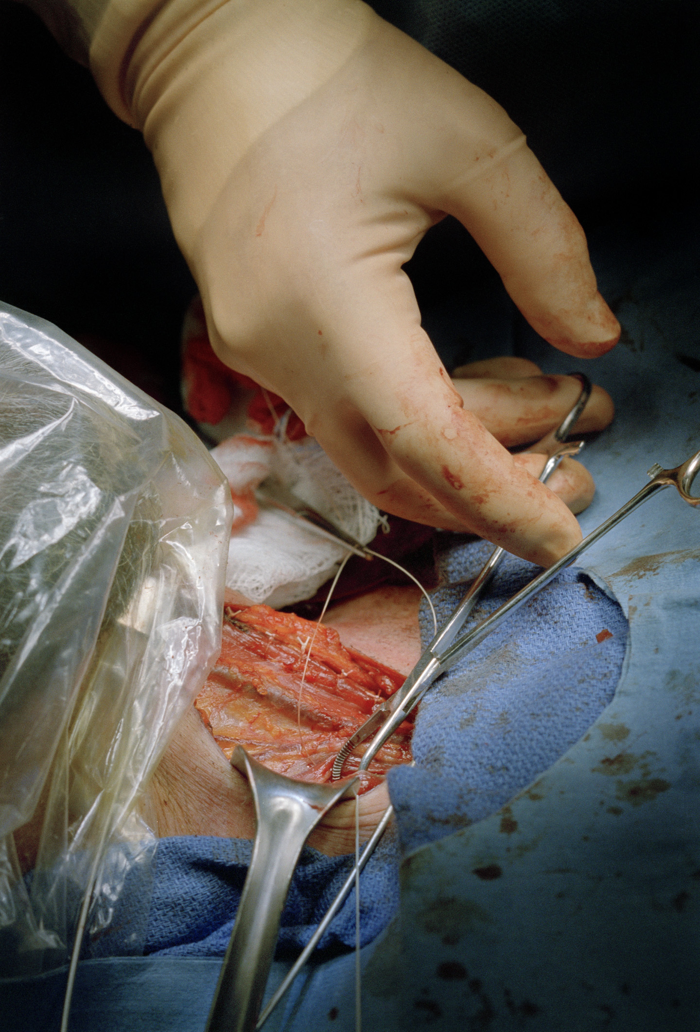

What Will Your Shadows Be?

PRESENTER: | College of Dreams
 | Doctoral Candidate
 | Terra Friedrichs
 | 978 266 2778
 | Rm 401c

BACKGROUND:
Terra has worked in the arts for decades in a variety of design/production roles, most recently developing music-based short art film/stage pieces. Her last piece, Chrysalis, developed with the band "What Time Is It Mr Fox" (www.whattimeisitmrfox.com), is a stage performance cum art film. She's worked with many Boston-based bands, performance art collectives, and stage companies. In the last few years, her original work has been shown at studios, galleries and artspaces such as Pan9, the Zeitgeist, RedTail Collective, Oni Gallery, and the Middle East. Artists that she’s worked with here in Boston include Reanimation Studios (KumaLisa and Piotr), Cynthia Von Buhler, KittyCam, Warren Lynch, Amanda Palmer of the Dresden Dolls, Michael Pope, and the Boston Rock Opera, among others.

ARTIST STATEMENT:
I have a fascination with "organic abstraction"; and the ability of movement to mesmerize. I enjoy exploring dreamstates as dimension for experiencing/exploring complex relationships and developing solutions for waking life. My early work with magicians and other movement oriented artists such as Marcel Marceau, as well as touring dance companies and stage shows gave me a passionate appreciation for timing and illusion. More recently, I’ve become obsessed with the abstract movement of people and other organisms. I attempt to develop art using simple techniques. I believe that if I can’t create art using simple tools, then I shouldn’t bother creating at all. My work is increasingly focused on finding organic shapes and experimenting with simple video FX to enhance, without loosing the beauty of the simplicity. Developing abstract videos footage helps me focus my mind, and work towards a purity of spirit.

Do you...Dream?

The Cloud Collective
is Blake, Ryan, Eartha & Ashanti
cloudcollective@yahoo.com

The Cloud Room

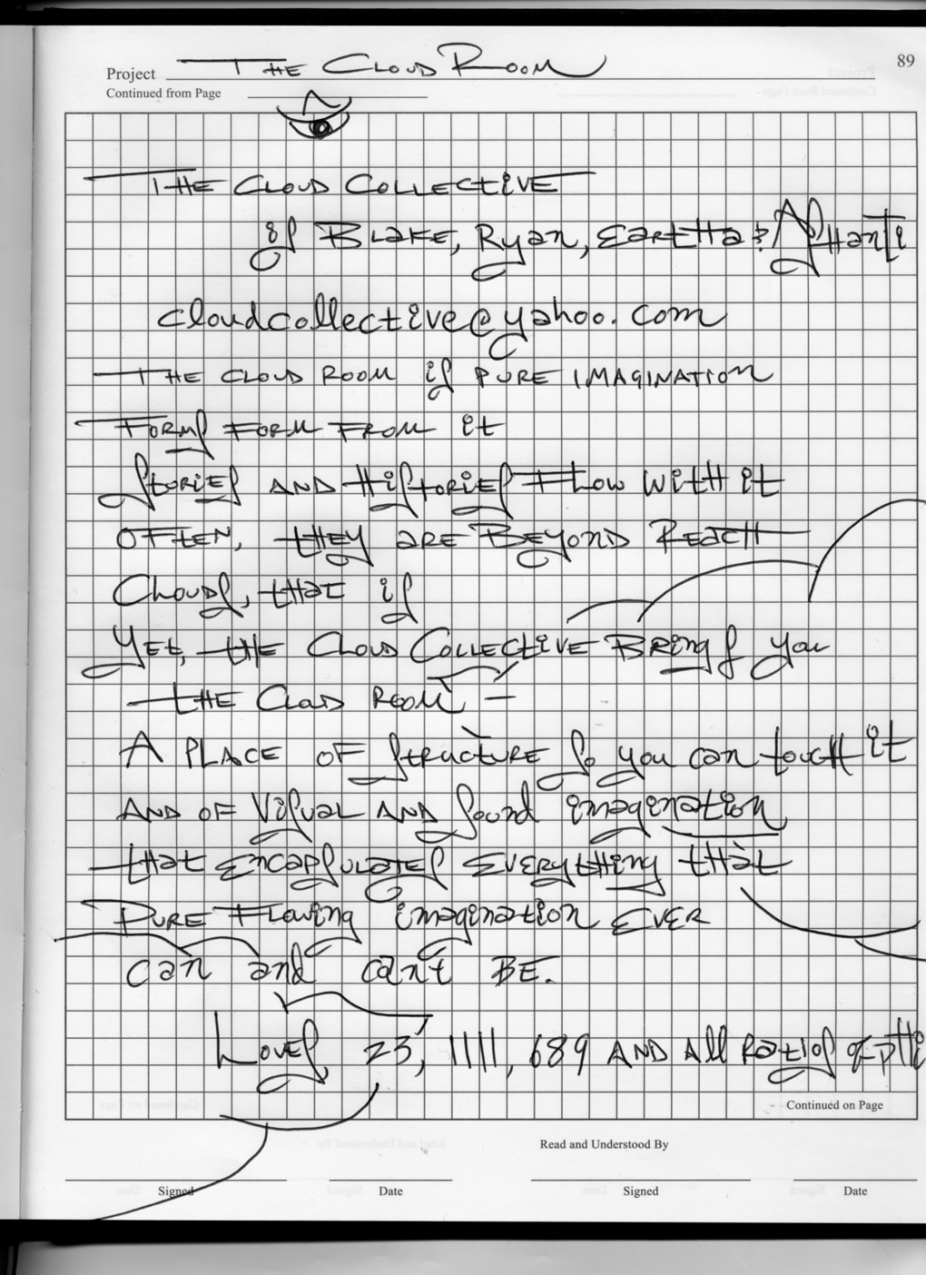Timur Bekbosunov
www.bekbosunov.net

Originally from Kazakhstan, Timur Bekbosunov appeared with many opera and theatre companies including Artishock, the post-modern mime troupe in Kazakhstan (Cabaret-Moralitè), Opera Boston (Nixon in China), Harvard University’s Lowell Opera (Eugene Onegin) and Bakersfield Symphony (Fidelio). He premiered the revised version of Jeffrey Brody’s Jabberwocky with the Salem Philharmonic and the tenor part composed by Evan Ziporyn of Bang on a Can, at the American Repertory Theatre’s production of Oedipus, directed by the renowned Robert Woodruff. He portrayed Tom Rakewell in USC Thornton Opera production of Stravinsky’s The Rake’s Progress, directed by Ken Cazan. Last summer, he performed at the International Laureates Festival in Los Angeles and was chosen to open a season at the Beverly Hills Public Library Sundays@Two series with a recital of Russian romances. As a featured artist at the Hawaii Performing Arts Festival, he portrayed the role of Macheath in the production of Threepenny Opera, directed by Angelina Reaux (2006). He will perform the role of Electrician in the Los Angeles premiere of Powder Her Face by Thomas Ades (November 2006).
A founder of The Chamber Opera of USC, an organization dedicated to bring contemporary music to the general public, Timur successfully produced the world premieres of works by composers Daron Aric Hagen (Broken Pieces) and Geoffrey Pope (The Stone House), resulting in publication of musical scores by the Carl Fisher Company. He is a recipient of Samuel Ramey Development grant and recently was awarded a USC Student Arts grant for his theatrical multimedia fantasy of The Szymanowski Project (September 2005), which he wrote, directed and produced.
Always striding to establish an innovative balance between his abilities as a singer and a producer, and to connect his passion for opera as an all-encompassing art form with multifarious aesthetics, he serves as a visionary director of the Art of Opera foundation, a non-profit organization. Art of Opera was established with a goal to promote known and unknown works for opera, ballet and theatre within the classical Western tradition while also showcasing artistic cultures from around the world. Art of Opera is also committed to communicate social causes to young people through their opera productions, thus encouraging their involvement in society and engaging them in critical debate and inquiry. As its first project, Art of Opera is producing an updated multimedia staging of Mozart’s Il Re Pastore (The Sheperd King).
Recently he collaborated on a theme song for an independent feature film Mostly Unfabulous Life of Ethan Green (Summer 2006). In works are albums of vocal cycles by Szymanowski and Janacek, and songs of Vadim Kozin (2007-2008). He translates the plays of Velimir Khlebnikoff, Russian avant-garde playwright of the early 20th century and listens to The Dresden Dolls. For more information, please visit his website: www.bekbosunov.net

Timur will be collaborating with Leanna Sterios-Primiana & Dana Ross to create a mixed media installation at PURE.

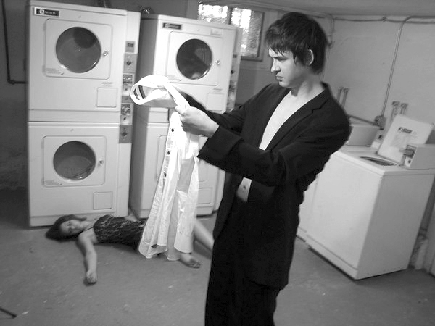

Ven Voisey
189 Beaver St. Studio 206, North Adams MA 01247
(530) 575-1440
voicepaper 4 (run-on sentence)
www.v---v.net
ven@v---v.net

Ven Voisey is a multi-disciplinary artist currently residing in North Adams, MA. He studied Conceptual Art and Electronic Media at San Francisco State University and first began his path as an artist through the medium of sound, being drawn to its inherent temporal qualities. Though continuing to work on sonic compositions, the scope, medium, and concept of the work began to expand. His work has taken on a variety of formats, from environmental installations & site-specific artwork (structures, mechanisms, gestures, meditations) to public actions & interventions, all of which are offered as tidbits of visceral knowledge & points of re-orientation. He lives with his two cats Izzy and MinaMeeshka.

Voicepaper 4 (run-on sentence). The white box is a state of legitimacy; it is a document of acceptance. The forty blank pages which make up the face of 'voicepaper 4 (run on sentence)' are lined up in an orderly, almost militaristic row and function as potential documentation of this ongoing quest for validity, waiting for what's happening next. They are an audience of observers who applaud for the actions which take place before them.

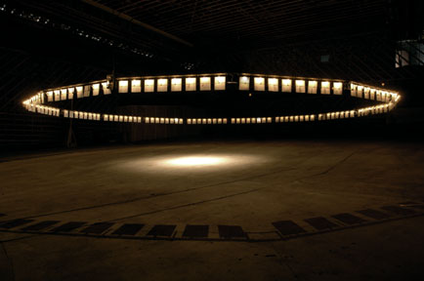

Véronique d'Entremont
www.artVeronique.com

Véronique d’Entremont (1983 – Boston, Massachusetts) has a BFA in sculpture from Massachusetts College of Art. Since 2003, Véronique has been an executive board member of the Iron Guild, renegade team of iron casters that tours New England, producing fire-art/iron casting performances, as well as demonstrations in traditional iron foundry. She is the 2005 recipient of the Dondis A. Dondis Travel Fellowship, and recently completed an AIR residency at the Berwick Research Institute.

A Formal way of Dealing with a Difficult Subject was a series of forms I constructed out of plywood and nails. Care was taken to construct a finished-looking object, although my materials were rough, usually found construction materials.

As part of a performance, I pour molten iron into these plywood forms. The iron causes the plywood form to erupt violently in flame; the laminate in the plywood causes a roaring fire to develop as soon as the iron enters the form. Molten metal fills every crevice of the interior and gradually the plywood burns away, destroying the original sculpture.

Construct/Destroy/Rebuild was a performance that took place in the evening. In the morning what I came back to was a pile of cast iron rubble buried in ashes. Sifting through the ashes, I found partial structures and shards of cast iron that I could piece back together.

The resulting objects make up a series I call Home Lightly. They are fragile, unpredictable forms, born out of precise, sturdy objects.

Home Lightly
Identification: Vittorio Mezzano
Description: Photographer
Origin: Italy 9/5/62

Bianconero
vittmezz@yahoo.com
www.mezzano.org

William Thomas Porter
wtporter.com
contact@wtporter.com

Sustainable Living Series: Shared Breath
2005-6
Active Ingredients:
Organic:
Living plant
Living person
Water {H₂0}
Carbon Dioxide {CO₂}
Oxygen {O₂}
Inorganic:
Plastic
Vaporizer
Fluorescent light
Tubing
Plexiglass
Aluminum
Mechanical parts

It is all too easy to classify modern interactions as being “mediated”, that is, filtered in some way, structured artificially, the component parts intentionally taken from their original context and reconfigured for desired results. This ideal modern relationship was greatly formed by The Scientific Method: a process of finding only what you are looking for, not necessarily what it really there to be discovered. It is this mediation of experience that ultimately leads to an unavoidable gap, a distance between subject and observer, an “unknowing” of the truth.
Shared Breath proposes a mediated relationship: human and plant. The problem set of the experience centers on the breath. The constant: intake of Oxygen {O₂} and exhalation of Carbon Dioxide {CO₂} on the part of the human, and the inverse inhalation of Carbon Dioxide {CO₂} and exhalation of Oxygen {O₂} on the part of the plant. Water vapor {H₂0} acts as mutually beneficial substrate to deliver nutrients to both subjects.

Observations
- Inherent symbiosis of the breathing cycle between human and plant.
- Any impermeable barrier between the subjects leads to mutual suffocation
- In any closed system, lack of natural interference leads to stasis and
stagnation
- There is no mention of spiritual union in this exercise

William Thomas Porter was born in Albany, NY but has spent the majority of his life living and working in the Boston area. Having taken a deep interest in the arts from an early age, Thomas has pursued varied experiences including studio practice, gallery direction and independent curation, arts organization, and small business enterprise. Thomas received his BFA and Studio Diploma from the School of the Museum of Fine Arts, Boston, has studied at L’Ecole Superieure Des Arts Decoratif de Strasbourg, and exhibits in the US and France.
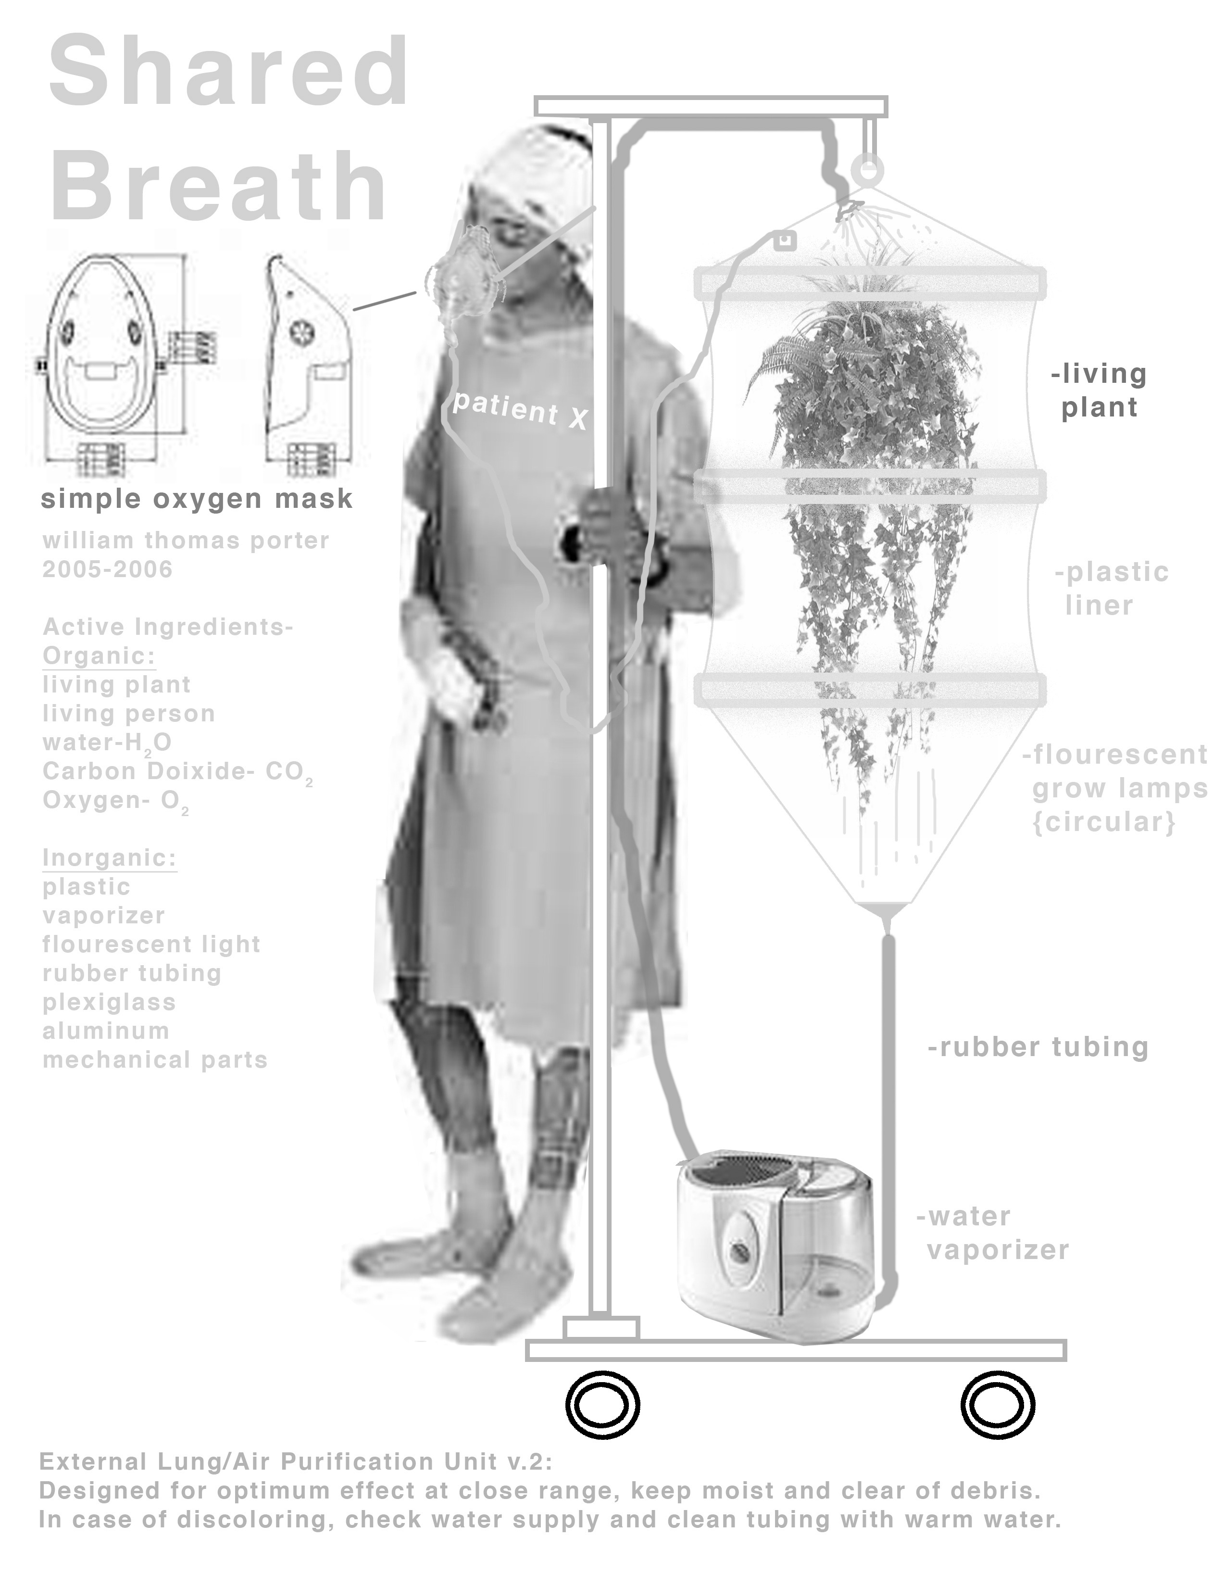
APPENDECIS
APPENDIX A:
A study of the biometrics & behaviors of Purists by Andrew Anselmo, PhD

Data requested from PURE Artists. Not all data given by all respondents.

Sex
Height
Weight
Shoe Size
Age
Blood Type
Hair Color
Eye Color
Vision
Resting Heart Rate
Shoe Pairs
Own a Car
Miles on Car
Bicycles Owned
Keys on keychain
Floor you live on
Number of Housemates
Daily Commute Time

Interesting response curve; good initial response, then a tailing off.

BMI = Body Mass Index =
(Weight in Pounds / ( Height in inches ) x ( Height in inches ) ) x 703

Note difference in strength of correlation between women and men; far more correlation in the male population.

Do we own more shoes as we get older? (N=23)

A few long term owners, but peak frequency of average mileage is around 50-75K.

For respondents who answered both heart rate and bicycles owned question; and heart rate and “floor lived on” questions. Do people who own bicycles have lower resting heart rates? Do people who live on higher floors have lower resting heart rates? Correlations are low.

N=26; some respondents have mixed myopia types.

 | Height, in | Weight, lbs | Age | Resting Heart Rate | Shoe Pairs | Keys On Keychain | Housemates
Min | 63 | 100 | 25 | 50 | 4 | 2 | 0
Max | 75 | 230 | 50 | 78 | 100 | 30 | 3
Mean | 68.6 | 148.8 | 35.0 | 65.3 | 21.6 | 8.3 | 1.5
σ | 3.7 | 32.6 | 7.2 | 9.2 | 23.7 | 6.5 | 1.0
N | 24 | 24 | 22 | 13 | 23 | 24 | 20

Table of information for respondents. Some respondents did not answer all questions; N=25.

Daily one-way commute times, in minutes. Relatively flat distribution between 0 and 40 minutes.

Here, heights are shown without sex differentiation.

As to be expected, heights of men are greater than heights of women. N too small to see typical bell curve distribution.

Blood type in the PURE population. In the world, O is the most prevalent blood type, but this is highly dependent on geography and ethnic background.

